Aqua Culture Swim Team

Ages 4 – 18
June 1st – July 24th
AM and PM Practices available
Most 3Bs can participate with great success, all levels above are sufficiently skilled. Email Admin@AquaCultureSwimSchool.com if you would like to confirm they are equipped

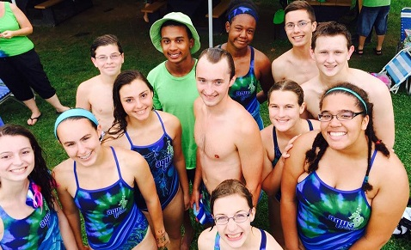

Online Registration begins 3/14/2022
Suit Try-on April 3rd and 10th from 3 – 7PM
Annual Suit order will be made immediately following these try-on events.
Full Season: $175.00
(No multi-swimmer discount)

Swim Team Sundays: $50 for 4 weeks
May 1, 8, 15, 22

For questions, please email info@ACSwimTeam.org
For more information, please visit the “Summer Team” tab at ACSwimTeam.org

