1) Login into the HP Lesson Information site.
Link to site: http://highpointswimclub.com/swim-lessons/

NOTE: Review registration instructions and other important information

2) Click link to shopping site link and login into the shopping site.

3) Click the link “Register for Swim Classes”. NOTE: Registration Start and End dates
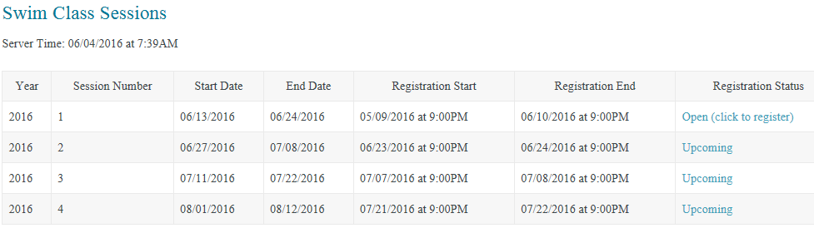
SAMPLE

4) Click Session Number – Registration Status “Open (click to register)”
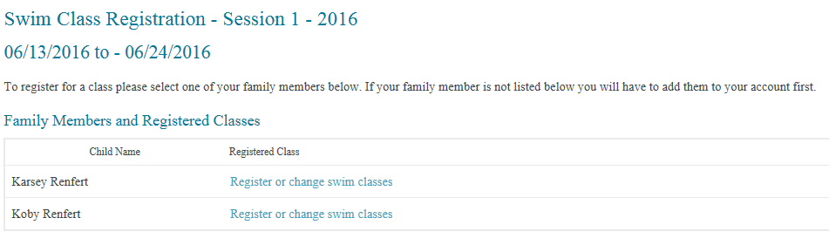
Donald
Minnie
5) Click on the desired class and time slot to register. The first number in each time slot represents the number of children already registered for that class. The second number represents the total number of children that will be able to register for class. NOTE: Sign up this year is first come, first served – no alphabetical rotation.
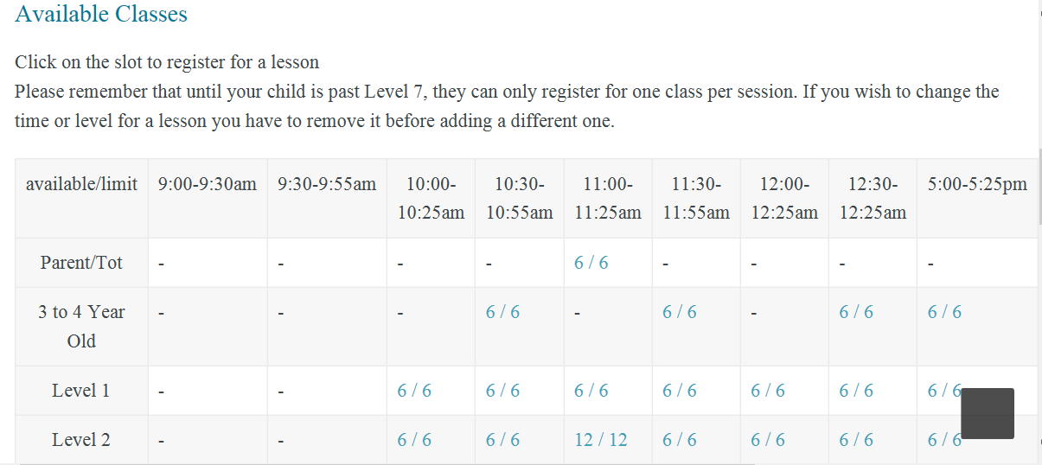
SAMPLE

6) "Please enter any notes to be provided to lesson coordinators:"
Examples: Add child to “Wait List” for 5:00 to 5:25PM”, or “My child will miss Monday – Wednesday classes the first week because we’ll be out of town”.
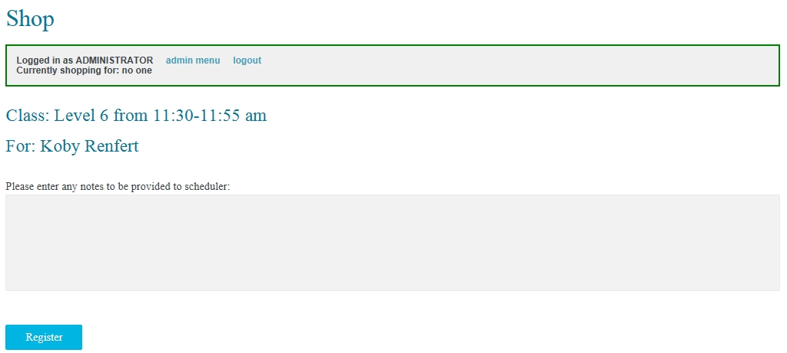
Minnie

7) Click "Register".

8) Repeat for each child that will be taking lessons for the session.

9) After the registration window closes the lesson coordinators will review all the registrations and make any necessary changes to the schedule. For example, parents may be contacted with suggestions on a different level and/or time for your child based on your child’s skills and/or class availability. Also, additional sessions maybe offered based on demand and instructor availability.

10) A confirming e-mail with your child's session level and time will be sent out after the coordinators complete the rosters.

