Clear your clutter!
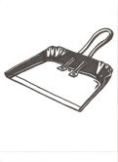 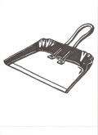Assist Burnsville High School Boys and Girls Swimming
with a donation to our
GOODWILL Donation Drive

When: Saturday, August 29, 2015
Time: 9:00am to 4:00pm
Location: The trailer @ BHS Parking Lot (front corner near Portland Ave & Hwy 13)

Drop off the following items at Burnsville High School Parking Lot:
Clothing | Games | Décor
Electronics | Toys | Housewares
We CANNOT accept . . . automotive materials, baby furniture and equipment, bikes with tires under 24”, building and plumbing materials, fluorescent light fixtures and bulbs, carpeting, computer monitors and televisions, consumer product recalled items, exercise equipment, gas-powered lawn mowers, household chemicals, large appliances, refrigerators, freezers, air conditioners, microwaves, mattresses, box springs, frames, water beds and sleeper sofas, weapons and ammunition

Please donate all items in good or excellent condition

If you have any questions about the event date or location, please contact me.

My name: ________________________________________________________________
Contact Phone Number: _____________________________________________________

We thank the community & GOODWILL for all the support!

