EHS Boys Swim
& Dive Team
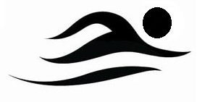
Who: All Edwardsville High School boys, regardless of previous swimming or diving knowledge/expertise, are welcome to try out for the swim and dive team.
Where: Chuck Fruit Aquatic Center
When: Tryouts will be held on Monday November 28th from 2:15-4:15 pm at the Chuck Fruit Aquatic Center. The first 20-30 minutes of try outs will be used for an informational meeting (All athletes).
What: Swimmers and divers should bring their own swim suit, a pair of goggles, a swim cap (optional) and a towel.
Practice Schedule:
All athletes: Swim: Monday-Friday 2:15-4:15 pm, Saturday 8:00-10:00 am
Dryland 4:30-5:15pm, Saturday 10:15-11:00am

What to expect:
The EHS Boys Swim and Dive Team is a competitive swim team competing in IHSA swim meets including the Sectional Championship and the State Championship. Practices will range from 3,000-6,000 yards. We will be focusing on stroke technique, race strategy, competitive training, goal setting, dry land training and various other aspects of the sport.

**Contact Coach Christian Rhoten (crhoten@ecusd7.org) with any questions or concerns

