EHS Girls Swim
& Dive Team
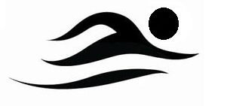
Who: All Edwardsville High School girls, regardless of previous swimming or diving knowledge/expertise, are welcome to try out for the swim and dive team.
Where: Chuck Fruit Aquatic Center
When: Tryouts will be held on Thursday August 9th from 2:30-4:30 pm at the Chuck Fruit Aquatic Center. The first 20-30 minutes of try outs will be used for an informational meeting (All athletes).
What: Swimmers and divers should bring their own one piece swim suit, a pair of goggles, a swim cap (optional) and a towel.
Practice Schedule:
Varsity Practice: Monday-Friday 2:30-4:30 pm, Saturday 7:00-9:00 am
*Tuesday and Thursday 5:45-7:00am
Junior Varsity Practice: Monday-Friday 2:30-4:30 pm, Saturday 7:00-9:00 am

What to expect:
The EHS Girls Swim and Dive Team is a competitive swim team competing in IHSA swim meets including the Sectional Championship and the State Championship. Practices will range from 3,000-6,000 yards. We will be focusing on stroke technique, race strategy, competitive training, goal setting, dry land training and various other aspects of the sport.

**Contact Coach Christian Rhoten (crhoten@ecusd7.org) with any questions or concerns

