EHS Girls Swim
& Dive Team
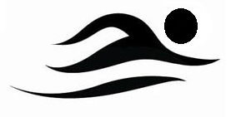
Who: All Edwardsville High School girls, regardless of previous swimming or diving knowledge/expertise, are welcome to try out for the swim and dive team.

Where: Chuck Fruit Aquatic Center

When: Tryouts will be held on Monday, August 9th from 2:30-4:30 pm at the Chuck Fruit Aquatic Center. The first 20-30 minutes of try outs will be used for an informational meeting (All athletes).

What: Swimmers and divers should bring their own one piece swim suit, a pair of goggles, a swim cap (optional) and a towel.

Practice Schedule:
All athletes: Monday-Friday 2:30-4:30 pm, Saturday 7:00-9:00 am
Year round athletes dryland: Monday-Friday 4:30-5:30pm, Saturday 9:00-10:00am

What to expect:
The EHS Girls Swim and Dive Team is a competitive swim team competing in IHSA swim meets including the Sectional Championship and the State Championship. Practices will range from 3,000-6,000 yards. We will be focusing on stroke technique, race strategy, competitive training, goal setting, dry land training and various other aspects of the sport.
**Contact Coach Christian Rhoten (crhoten@ecusd7.org) with any questions or concerns

