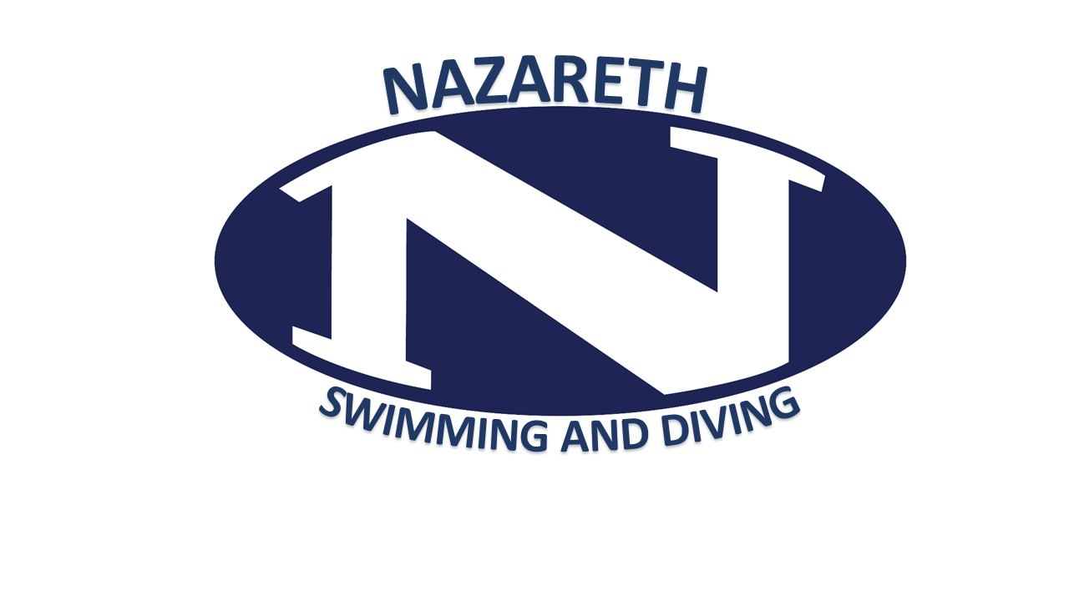
Nazareth Swimming & Diving Booster Club
Meeting Agenda of January 16, 2019
Call to Order
Reading of the Minutes – from 11/21/18
Captains’ Report
President’s Report
Senior pictures- Thanks Jeanine!
Parkas – Names – done
Diving Meet- What can we do better?
Flapjack fundraiser scheduled for January 19, 2019 at 8:00 AM
-numbers called in
-reminder out to school community through Stasa
-Practice perks for kids who work
-Waivers
Party hosts:
-Pasta party: Haskell and Godin-Bleir- January 28th at Godin-Bleir’s House
-Senior Poster Party: Miyo Holt -Februrary 3rd at Holt’s
-Hair Dying Party : Lisa Serafin
SENIOR MEET:
- Flowers: Byrne? Snell? Flowers for Stroudsburg? (they got them for us last year)
- Presents, underclassmen parents to run
- Senior questionnaires need to go out soon for Senior programs.
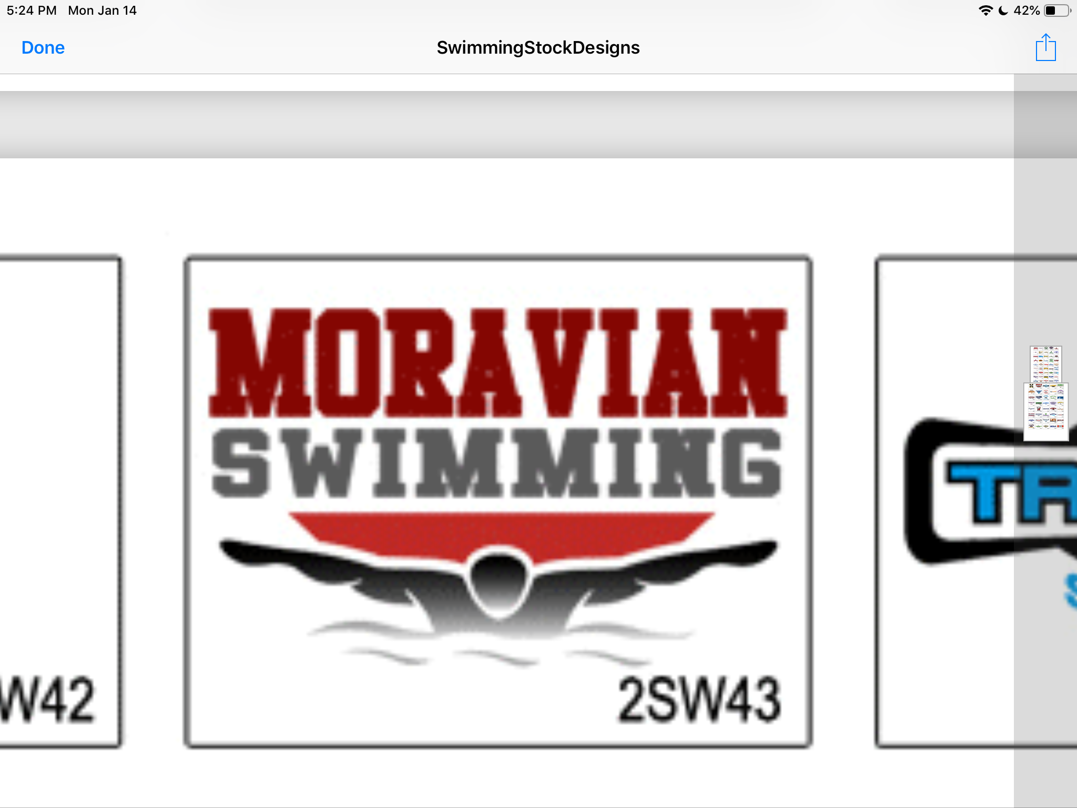
Board Election at Banquet: need to fill positions; Banquet Post season T-Shirts: Decided on Logo – Shirt colors boys/girls
I’m taking a back seat to Jim for last few home meets.
Monthly Treasurer’s Report
Coaches’ Report
We have touch pads!
Computers: BLUE has purchased software for computers
Printer in office! Coach wants thoughts on getting a long ethernet cable and rolling cart.
Standing Committees:
Banquet & Awards: James West
Snack Stand: Donna Szczucki
Fundraising: This committee is chaired by the officers.
- Applebee’s Flapjack Fundraiser: Anne Millham
Communications: Nancy Laslo
Additional Committees:
Seniors/ Senior Night: Lisa Serafin
Districts Shirts: Kerry Livermore, Deb Alvino
Bulletin Boards: Jeanine Wasson, Jim West
Apparel & Parkas: Kerry Livermore, Deb Alvino
Photography: Miller; Fitzgerald; Wasson
Programs: Bob Mc Bride
Decorating:
New Business
Adjournment: Next Meeting -Wednesday, February 20, 2019 in NAMS Health Room

