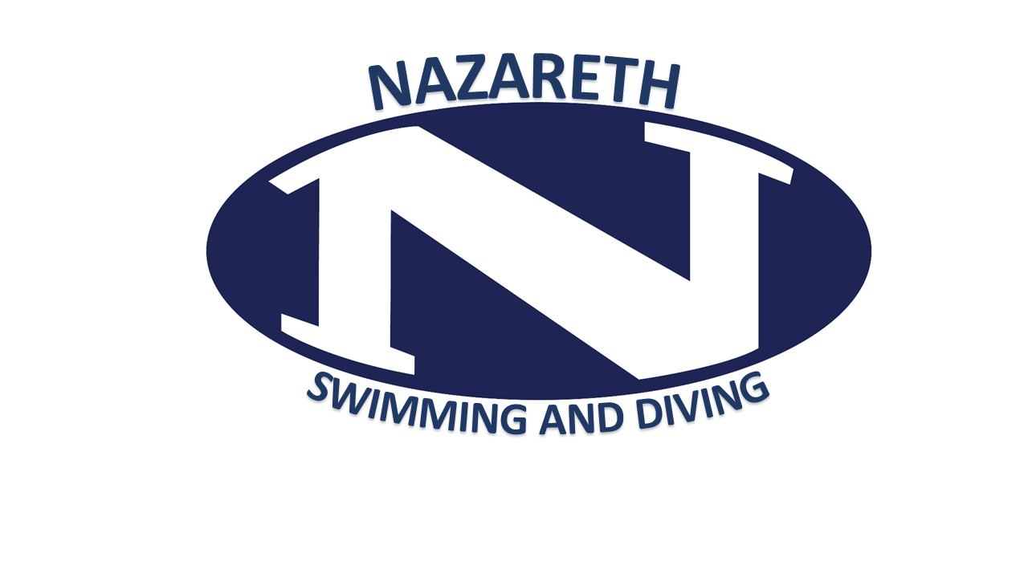
Nazareth Swimming & Diving Booster Club
Meeting Agenda of March 20, 2019
Call to Order
Reading of the Minutes – from 1/16/18
Captains’ Report
President’s Report
Senior Meet recap
-Questionnaires for Senior brochure need change?
-Opposing team done ok
-Gifts, T-shirts, decorating? (cars, houses, pool)
Flapjack Recap: $953: Moving later in season has helped. 50/50 helps. Other improvements?
Food Drive Recap:
Party hosts:
-Hair Dying Party: Lisa Serafin
Snack Stand recap?
Thanks to Jay Gittleson for getting the motivational speaker.
50/50 should keep it up next year?
Board Election at Banquet: Report on call out for nominations;
-someone not running should collect
Banquet deposit paid: April 28, 2019 Holy Family Club
Post season:
Districts/States T-Shirts: ordered
Tammy handling Districts Tix.
States: Miyo jackets. Towels!
Tammy S.. reimbursement for States Poster
SFYS Snack stand: Offered again – Need someone to run it.
Monthly Treasurer’s Report
Coaches’ Report
Standing Committees:
Banquet & Awards: April 28, 2019 Holy Family Club James West
Snack Stand: (NEED REPLACEMENT FOR SFYS)
Fundraising: This committee is chaired by the officers.
- Applebee’s Flapjack Fundraiser:
Communications: Nancy Laslo
Additional Committees:
Seniors/ Senior Night:
Districts Shirts: Kerry Livermore, Deb Alvino
Bulletin Boards: Jim West
Apparel & Parkas: Kerry Livermore, Deb Alvino
Photography: Grohotolski.; Fitzgerald.
Programs: Bob Mc Bride
Decorating:
New Business
Adjournment: Next Meeting -Special Meeting for Election Only, April 28, 2019 at HFC. May meeting TBD by new board.

