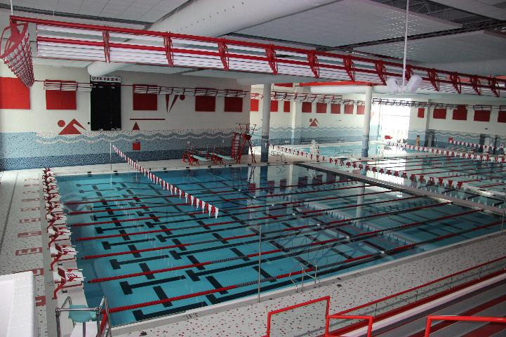  - WEDNESDAY, August 14  Swimming Call Out Meeting  Meeting Topics  - Off-season conditioning – starts September 4th  - Dates and times of practices  - Requirements and team apparel  - Physicals  - Questions???? | 2:30 PM  ____  Meet in room M104  ____  Everyone interested is welcome!  ____  Bring a friend  ____  For returning and new athletes  Contact Coach Lord in room M125 if you have questions!

