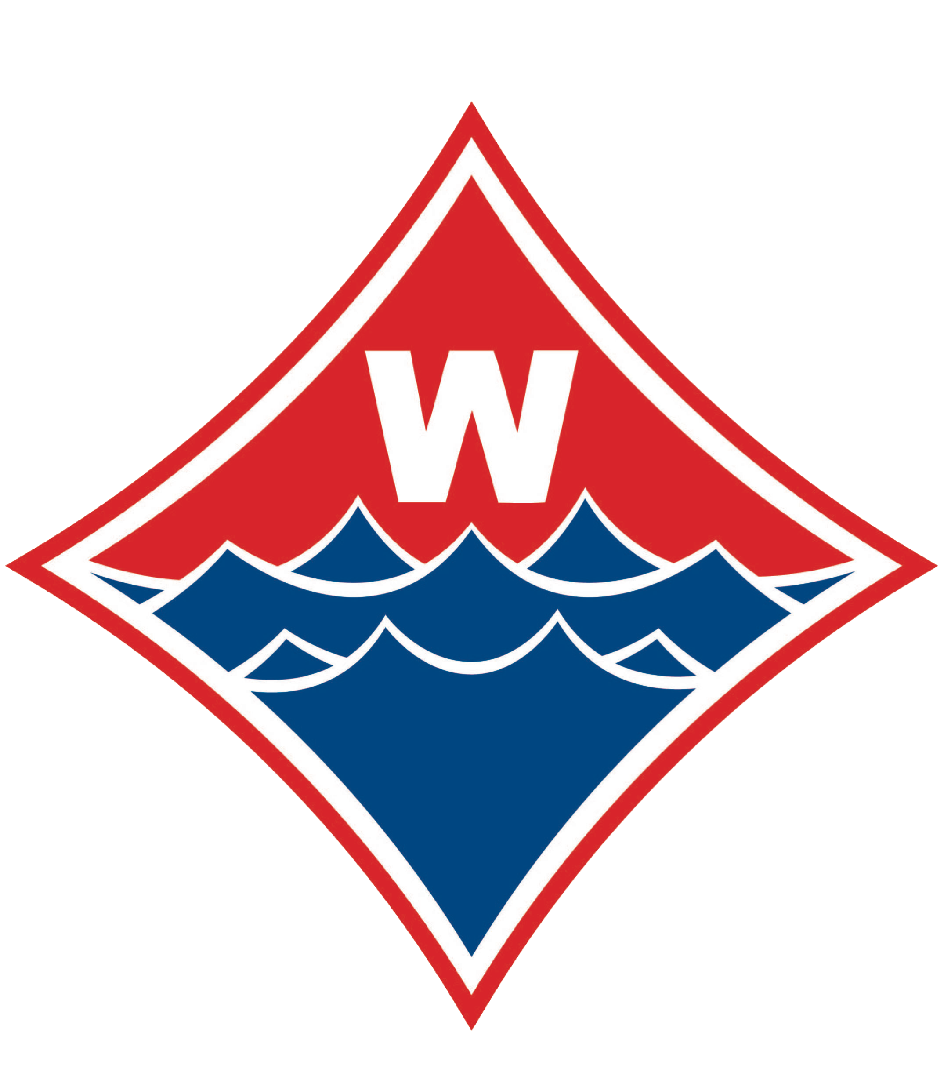OCTOBER IS CANCER AWARENESS MONTH
THE WALTON S&D TEAM HONORS GRACE BUNKE AT OUR
AMAZING GRACE INVITATIONAL MEET

Since 2009, the Walton Swim & Dive program has hosted a meet to raise money to cure cancer. The tradition began with former coach Sharon Loughran planning an event to honor her late friend Margaret Gilbert.

For 8 years the Annual Margaret Gilbert Memorial Invite Meet was held every December at the Cobb Aquatic Center in Marietta, GA. The meet was dear to the hearts of our past coach, Sharon Loughran, our team and to all who have been touched in some way or another by the horrible disease of cancer.

Although this meet is held during the first weekend in December, it carries on the importance of cancer awareness!

From the beginning this meet has been a fundraiser to help cure cancer and while it began in memory of Margaret Soulen Gilbert, in 2017 and 2018 our team was so impacted by a brave young lady that we have changed the name of the meet to the Amazing Grace Invitational.
Grace’s Story:
In August 2014, Grace, a competitive youth cross-county/track and soccer athlete, was diagnosed with metastatic osteosarcoma (which is bone cancer) at the age of 11. The cancer was found in her left femur and both of her lungs. She underwent 18 rounds of in-patient chemotherapy, a partial and unique leg amputation called rotationplasty, and 2 lung surgeries.
Her initial treatment concluded in April 2015. In an attempt to get back into shape, Grace decided to try swimming and joined one of Swim Atlanta's swim teams. Although prior to her cancer diagnosis, she had not swum a single lap in a pool, Grace immediately fell in love with swimming.
She has continued to swim through her original cancer relapse in October 2016 that required a third lung surgery to remove a tumor; she continued to swim through an antibody clinical trial from November 2016 - February 2017; and she continues to swim now.
Unfortunately, her cancer returned again in July 2017, but that time in her spine. Goals of possible treatments changed from being focused on a cure to being focused on the quality of Grace's life. In order to continue swimming and stop the tumors on her spine from growing, Grace completed 2 sets of 13 radiation treatments this fall. She also began an oral chemotherapy regimen. However, the chemotherapy interfered with Grace's desire to swim; and as a result, she decided to stop the treatment in September 2017.
Several weeks after stopping the treatment, Grace swam a mile in open water in Lake Lanier, made the Walton High School swim team, and has continued to improve her performance in the pool. Soon after, Grace learned that her cancer had spread to both of her lungs. Grace decided to restart oral chemotherapy in hopes of slowing down her cancer so that she could continue to swim for as long as she possibly could.
As Grace said, 'I think I found running; but swimming found me. And I plan to just keep swimming until I can't swim another lap.”
Another one of Grace’s swimming goals was to be part of the incredible Walton High School Swim Team. She could not have been more proud than to wear the ‘W’ on her swimsuit and swim cap and to be a Walton Raider!
Moving forward we invite you to join us as we honor our team mate and friend as #weraceforgrace at the Amazing Grace Invitational.
Please be sure to come and support this worthy cause and see your local high school athletes competing at an amazing level of athleticism. Your support is truly appreciated by all who have been affected by this horrible disease.

Go Raiders!

