Good Day Members-
Let’s pretend it did not snow this week-
Picture this instead:
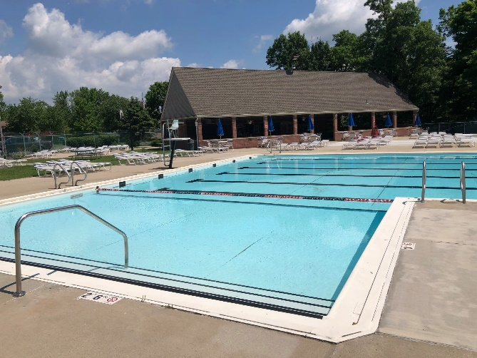

This is going to be another long message. I know you love me

Pool Opening (repost):
WHOA- the info changes daily it seems. COVID info that is. We are keeping our eyes glued to the loosening of the restrictions. As we get closer to opening day we let everyone know what this year will look like at the Club. More to come on this
The Club will open on schedule. Memorial Day weekend. First day: Saturday May 29th (12-9)

Registration:
Good news- no increase to memberships this year. I can hear the applause
Click here to be taken the registration page. There are directions on that page.
Season membership fees: $455
New members are assessed a $250.00 registration fee – we do have some memberships available. Please note there are not a ton left. If you have a friend interested, I recommend they go ahead and register to ensure their spot.

New update- Thank you for your patience as the limited membership was not included with the last communication. Limited memberships are still available. Follow the same steps in the directions and choose limited in the drop down when prompted for membership type. *There are rules surrounding limited memberships. Please reach out with questions. Fee: $195.00

Important note surrounding memberships –
Those included in a membership are individuals that live under the same roof. If other people are found to be listed on a membership that are not part of that household the membership will be reviewed for termination. Please note this is being taken very seriously. We have already had this conversation with a couple registrations this season. We appreciate your understanding of our membership policy and welcome any questions.
*You are allowed to have a nanny/babysitter listed on your membership. We can walk you through how to document this on your account.
**Guests will be allowed as they were last year. There will more than likely be limitations to guests. More to come on this.

Swim Club Updates-
(personnel):
We have a new assistant pool manager!!
Julianne Ford is her name, being awesome is her game and here is her claim to fame:

She has worked at Lakota Hills since she was 15. Four years as a guard, one year as a head guard. She ventured outside of LHSC for one year as a pool manager with Swim Safe. She is extremely excited to be back at Lakota Hills this year. She joined Lakota Hills swim team at age seven and swam through her senior year of high school. She is an Early Childhood Education major at Miami University. She lives in college house, named Texas, with 10 roommates. She lead Young Life at Lakota West High School. She LOVES teaching and cherishes her great memories teaching the LHSC youngster how to swim via swim lessons.

Welcome Julianne!!

Who do you know??
The Club is hiring!! Who do you know that would make a great addition to our team?
We are still looking for a few lifeguards. Spread the word – the open positions wont last long!
An application can be found on the website. Click here for application page.

(operating hours):
This is some exciting stuff right here!!
We are extending the Clubs open hours. Yes, you saw that right.
On Saturday and Sunday we will now open at 10 am!! WHOOT WHOOT!!
All hours:
Saturday and Sunday: 10am – 9 pm
Monday – Friday: Noon to 9 pm

(physical):
The Swim Club grounds are weeded, trimmed, mulched and ready for members/guests! The concrete work is done. Our swim team does not need to fear while on the blocks anymore (yay-safety first).
Check it out:
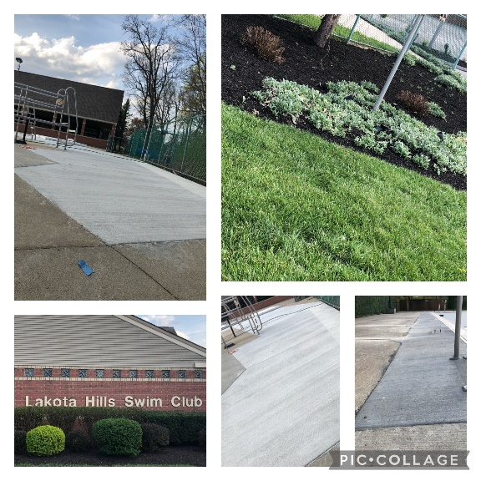

(Swim Lessons):
We are hopeful that we will be able to offer swim lessons this season. The Club is in the process of confirming with the health dept. if these will be allowed. More to come.

All things Social (not media):
We are still not clear on what the season holds for events and parties. Stay tuned! We are committed to doing our part to make fun things happen. We just need to be sure we follow all state and county guidelines.

Other things Social (yes, media):
Did you know we have a Facebook page? Email is our official mode of communication. Social is also used to keep you informed of club happenings. Currently there is a post about our hiring needs. Please share!
Be sure to like and share all the posts. It warms our heart-
Click here for FB page-

Wavemakers (swim team):
Who are the Wavemakers?
The Wavemakers swim team is open to swimmers ages 5-18 that are members of Lakota Hills Swim Club. Beginners are welcome and encouraged to join! For safety reasons, we ask that members can swim at least one length of the pool in any fashion. Our team has so much fun learning the sport of swimming, bonding with teammates of all ages, and cheering each other on. We kick-off our season on May 23rd with a “Meet the Coaches” event from 4-7 at the pool. We will have more information on this event soon but weather permitting, the team is invited to participate in a special free swim following a brief meeting.

What does swim team entail?
Starting May 24 ^{th} , practice is offered Monday-Friday after school, transitioning to morning practice after Memorial Day. Practice is a time for swimmers to learn the strokes, starts, turns, and perfect their technique, strength and speed. Attending as many practices per week as possible is encouraged. More information on our weekly meets will be coming out soon. The Championship Meet may be held a little differently this year but will be from July 22-25 ^{th} . All swimmers are encouraged to participate in the fun and excitement of championships.
Parents are required to volunteer at meets as part of team membership (or be charged $150 at the end of the season). Most opportunities for volunteering require no experience. Officiating, however, requires certification and the team is always looking for parents to assist as officials. Please contact us if you are interested.

Why join?
Become a stronger swimmer, stay in shape during the off-season of other sports, have a summer routine, make new friends and have fun
If you have any questions or concerns, please contact us at LakotaHillsWavemakers@gmail.com
Learn more at wavemakers.org

Rules:
There are pool rules people. I know, what the heck? Rules?? Who made those?
You know what the 2nd one is?
All injuries should be reported to the staff immediately. All injuries involving bleeding must be reported immediately.

Click here to see them-

Board Members (for compliments only) LOL - JK tell us anything you want:
*except about Amy’s bad spelling – she already knows
President: Bob Heinecke
president@LHswimclub.com
Operations Manager/VP: Bob Sanders
vicepresident@LHswimclub.com
Treasurer: Jeanne Brauns
Treasurer@LHswimclub.com
Social: Kara Feist and Tammy Peters
Social@LHswimclub.com
Secretary: Debbie Mann
Secretary@LHswimclub.com
Membership: Marshall Moreland
Membership@LHswimclub.com
Swim Team Liaison: Eric Ford
Communication: Amy Swan
Communication@LHswimclub.com

Every year 3 board positions are up for election. If you are interested in running for a board position please reach out Bob (president) for more information.

Amy Swan

