Date: July 3, 2017
To: All Division V Swim Team Reps, Coaches, and Officials
From: Woodridge Swim Club, Kathryn Hammer - Meet Director
RE: Division V Championships 2017
Location: | Woodridge Swim Club, 12320 SE 14th Street, Bellevue
Date & Time: | Saturday, July 15, 2017; 9:00 a.m. start
Entries:  Action Required  By Wednesday 7/12 at 5pm and Thursday, 7/13 at noon; please request volunteer swaps ASAP. | E-mail entries to Laura Landau, laura.landau@live.com, no later than Wednesday, July 12 at 5pm. (Fees were paid to Midlakes at the beginning of the season.) Volunteer names are due to Kathryn Hammer, kathryn.hammer@mac.com Thursday, July 13th at noon. **Please bring a meet entries report from Team Manager to the meet on Saturday.**
Warm-Ups: | 7:45-8:05 Woodridge  8:05-8:25 Newport Yacht Club  8:25-8:45 High Woodlands  Please note: The pool will be cleared of all swimmers at 8:45 a.m.
Timers:  Don’t forget: each club provides digital stop- watches for their timers. | Each club will provide a minimum of 8 to 9 timers and other volunteers as listed on the volunteer assignments list. Signup sheets will be circulated (separately) at all clubs. Timers must have timed at two dual meets during the season, and will need to have their own digital stopwatch (clubs provide these for their own volunteers). Lane assignments will be made ahead of time; timers should check in with the volunteer coordinator for their club to receive a nametag and lane assignment.
Meetings: | Scratch: 8:00 a.m. Officials & Timers: 8:30 a.m.
Coaches: | Seating will be reserved for coaches on the south side of the pool deck. Heat sheets and hospitality will also be provided. Please check in on the pool deck to receive these items.
Team Areas: | Limited seating on the pool deck is available for meet spectators. Spectators and teams are also invited to view the meet from the hill overlooking the baby pool. “Tent city” will be available in the gravel parking lot. Spectators may wish to bring padded seating for the hill, as well as chairs and shady cover for the tent city area. Even though this meet is in the morning, it may be very warm.
Concessions: | Heat sheets will be available for $3.00 and results will be available online via the Midlakes website. We will also be using Meet Mobile and we encourage all participants and families to do so as well via the downloadable app. available for all iphone and android users. Midlakes Championship T-shirts will be available for purchase (price TBA). Concessions including breakfast foods and snack items will be available, and Division V will provide hospitality for coaches.
Parking: | Parking is very limited. The pool parking lot will be used for spectators only. Street parking is available. Parking for officials and coaches will be along the north side of SE 14th Street and will be clearly marked.

Directions to Woodridge Pool
12320 SE 14th Street, Bellevue (corner of 123rd and SE 14th)
425-746-7030

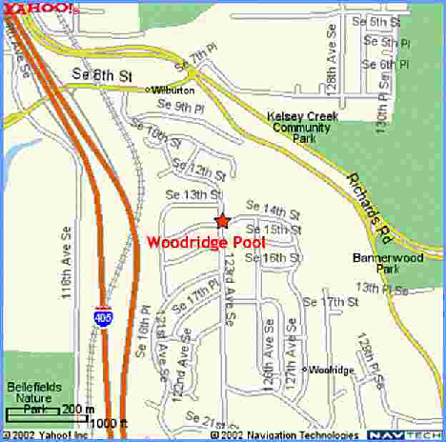

From Seattle:  Take SR-520 to I-405 southbound, then follow the directions for coming from the north.  or  Take I-90 to I-405 northbound, then follow the directions for coming from the south. | From the East:  Take I-90 to I-405 northbound, then follow the directions for coming from the south.
From the North:  - Take I-405 South  - Exit at SE 8th Street  - Turn left at the end of the off ramp onto SE 8th Street and go under freeway (heading toward large wooden train trestle)  - Turn right onto 121st Street SE (first street after the trestle)  - Continue up hill; street turns into 123rd Avenue SE  - Pool will be on your left hand side | From the South:  - Take I-405 North  - Exit at SE 8th Street  - Turn right at the end of the offramp onto SE 8th Street  - Go under train trestle, and turn right onto 121st Street SE (first street after the trestle)  - Continue up hill; street turns into 123rd Avenue SE.  - Pool will be on your left hand side.
The gravel parking area to the east of the pool will be used as “tent city.” Participants are asked to park along neighborhood streets, taking care not to block driveways.
These directions are also available online at http://www.woodridgeswimclub.org

