Date: June 28, 2017
To: All Division IV Coaches and Team Representatives
From: The Plateau Club Coordinators, Jessica Fernandez & Erin O’Neil
CC: Cindy McGee, MidLakes Communications Director
RE: MidLakes Division IV Championships on July 16, 2017
Due Dates:
Requests to swap trained volunteer jobs | erin.oneil@hotmail.com | July 5, 8 pm
Volunteer signup sheet returned | erin.oneil@hotmail.com | July 12, 8 pm
Entries | brookeflaten@gmail.com | July 12, 12 pm

Location: The Plateau Club (see map below)
Meet start time: 9:00 am
Entries: Submit entries no later than Wednesday, July 12, 2017, 12pm to brookeflaten@gmail.com. All swimmers must have a time in their entries or the system will not create the meet. Additional information will be sent to the coaches directly.
Warm Ups: 7:00 – 8:30 am Each team will be assigned one lane and can decide how/when they want to warm-up their swimmers.

Meetings: Coaches Scratch – 8:00 am All shifts of Officials and Timers – 8:30 am
Volunteer Duties: The Plateau volunteer positions will be split among the 4 Div IV pools. This is usually 6 or fewer volunteers total. This will offset the extra volunteer requirements of hosting the division champs.
B Champs has 3 scheduled shifts which are 1 1/2 - 2 hours long. The third shift completes at the end of the meet. Please advise your volunteers that this shift may be longer or shorter than stated.
All shifts of Officials and Timers must attend the 8:30 meeting for special B Champs instructions.
2nd and 3rd shift Timers and Officials will be called to the announcer table 10 minutes before the shift change to make the transition as quick as possible. Please make sure you volunteer coordinator is there to ensure all your volunteers are checked-in.
Volunteers make it possible for our children to compete. Thank you for your willingness and hard work!
Team Coordinators: Please provide meet information to your families so they know what to expect.
Remember your stop watches and award boxes! Deliver the boxes to the awards table.
Each team will be required to provide one volunteer coordinator per shift or you can choose to use the same person throughout the entire meet. Volunteer coordinators are expected at the check-ins. We need your help tracking down any volunteers who miss the announcement. We want the meet to move quickly. So, please help us make the shift changes efficient.
Clerk of Course: Swimmer check in is located at the entrance to the pool closest to the baby pool. Clerk of Course opens at 8:45 am. Please have your 8 and under relays gathered to check in at that time. To minimize wait times, only 8 heats will be staged at one time.
Coaches: The side closest to the entrance of the pool is reserved for coaching staff and officials. Meals and heat sheets will be provided for the coaches of each pool. Please send the names of your coaches with your entries.
Parking: Parking in the lower lot is reserved for the Plateau swim team, coaches, and officials only. All others will be required to park on the street outside of the Plateau Club. You may pull in to the clubhouse to drop your swimmer off. Parking will be along the street leading up to the club. We will have golf carts helping to shuttle people to the pool area. No parking is allowed in the area marked for Plateau Members (see map below).
Team areas: We will have marked off areas in the upper parking lot and grass for teams to sit together.
Spectators: The side furthest from the entrance of the pool is open to spectators. Bleachers are available for temporary viewing. No other awning/tent space or long-term seating is available on the pool deck.
We encourage cheering, however, loud noisemakers are considered a nuisance. Also, the block area and deep end spectator area need to remain as calm as possible to avoid false and late starts. In particular, please discourage relay-exchange roars for this meet.
Concessions: Breakfast and lunch will be available for purchase. Midlakes Champs T Shirts (price TBD) and Sweatshirts (price TBD) are also available. Heat Sheets will be sold in the morning for $3. Checks may be made out to The Plateau Club. Cash or checks only. We do not accept credit or debit cards.
Directions:
Directions from I-90 Eastbound  - Exit #15- Lake Sammamish State Park  - Left onto 17th ave NW (will turn into SE 56th St) - follow for 0.9 miles  - Left onto East Lake Sammamish Parkway SE - follow for 1.3 miles  - Right onto SE 43rd Way (will turn into 228th Ave. SE) - follow for 3.5 miles  - Right onto SE 8th - follow for 1.5 miles  - Right onto E. Main Dr.  - Follow for 0.5 miles, club entrance will be on your right | Directions from 520 Eastbound  - Exit at SR 202 / Fall City-Redmond Way  - Right off exit onto SR 202 - follow SR 202 for 2.5 miles  - Right onto NE Sahalee Way (Grey Barn Nursery)  - Follow Sahalee Way for 4.6 miles (Sahalee Way turns into 228th)  - Left onto SE 8th - follow for 1.5 miles  - Right onto E. Main Drive  - Follow for .5 miles, entrance to Club on right-hand side

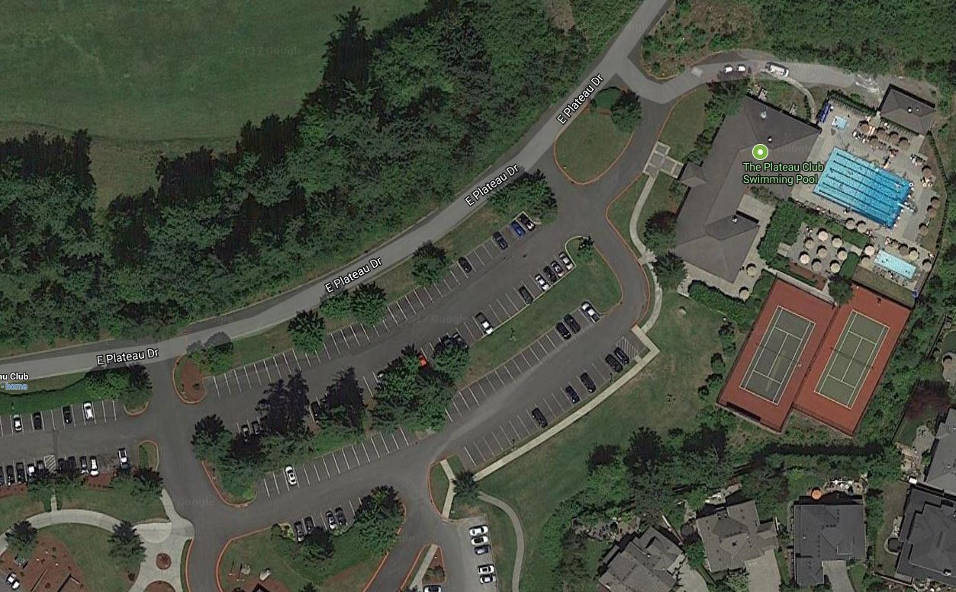
Area reserved for swimmer set-up of chairs & tents
Club Member parking only – no swimmer parking
Club Member parking only – no swimmer parking
Swimmer Staging
Coach set-up
Spectator viewing
Swimmer drop-off circle
On-site parking reserved for plateau club members, coaches and officials.

