**Mountain Hi Swim League**

Official Guide on How to Use:

Hy-Tek Meet Manager 5.0 for Windows

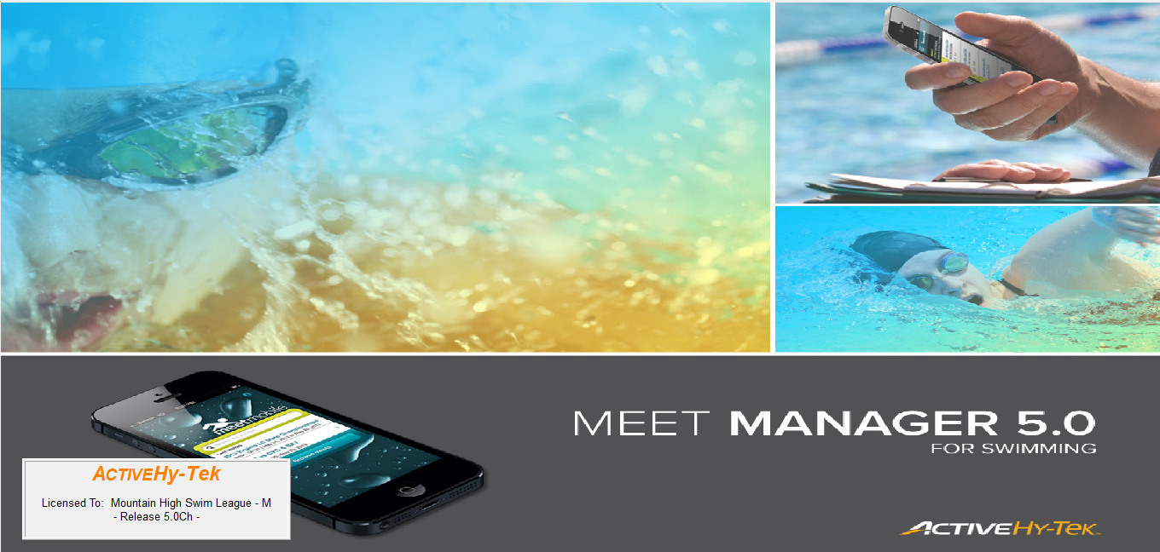

Version A

5 May 2014

*Tables of Contents*

1 INTRODUCTION 5

1.1 Acknowledgements 5

1.2 Meet Manager Loading and Maintenance 6

1.3 What You Will Need to Run Meet Manager 6

1.4 Additional Information 6

1.5 File Set-up 7

1.5.1 Directory Locations 7

1.5.2 Database Set-Up 7

1.5.3 To Install the League Database from the Web 8

1.5.4 To Install the League Database from a disk or USB drive 9

1.5.5 Database Naming 9

2 MEET MANAGER OVERVIEW 11

2.1 *Meet Manger* – The Big Picture 11

*2.2 Meet Manager Checklist* 12

3 INDIVIDUAL MEETS 13

3.1 Meet Set-up 13

3.2 Athlete/Relay Preferences 14

3.3 Seeding Preferences 15

3.3.1 Standard Dual Meet 15

3.3.2 Lane Assignments 16

3.4 Report Preferences 17

3.4.1 Header Footer 17

3.4.2 Report Formats & Punctuation 17

3.5 Scoring 17

3.5.1 Entry/Scoring Preferences 18

3.5.2 Entry Limits 18

3.5.3 Scoring Set-up 19

3.5.4 Events 19

3.6 Records and Time Standards 20

3.6.1 Import All-star Times 20

3.6.2 Import League Records 21

3.6.3 Import Team Records 22

3.7 Import Entries 24

3.8 Import Roster Files 26

3.9 Seed the Meet 26

3.10 Create Session 27

3.11 Print Deck Card Labels 29

3.12 Print Reports for Meet Officials 30

3.12.1 Athlete Rosters 30

3.12.2 Meet Program 32

3.12.3 Entry Lists 34

3.12.4 Entry Lists *(for Swimmers)* 35

3.13 Timeline 36

3.14 Create Backup and e-mail 36

4 RUNNING THE MEET 37

4.1 Deck Changes 37

4.1.1 Add Swimmers 37

4.1.2 Scratch or Delete a Swimmer 39

4.1.3 Change a Swimmer’s Events 39

4.1.4 Declare an Athlete as an Exhibition Athlete 41

4.1.5 Adjust or Declare Swimmers in a Relay 41

4.1.6 Change a Heat/Lane Assignment 43

4.2 Enter Event Results 45

4.2.1 Enter Event Times 45

4.2.2 Verify Results 48

4.2.3 Modify an Entry Time 48

4.2.4 Create Periodic Backups 48

4.3 During the Meet 49

4.3.1 Score the Meet 49

4.3.2 Print Event Results 49

4.3.3 Records Set 49

4.4 Special Situations 49

4.4.1 Entering Lead-Off Times 49

4.4.2 Entering Intermediate Distance Times 50

4.4.3 Swim-Offs (during Prelims) 52

5 TIMING AUTOMATED SYSTEMS 53

5.1 Standard practices for dealing with timing discrepancies 53

5.2 Selecting Timing System 54

5.3 Dolphin Timing 54

6 CLOSING OUT THE MEET 57

6.1 Create a Result File for Team Manager 57

6.2 Create a Backup for Away Team 58

6.3 Send Results to Division VP and Webmaster 58

6.4 Print Ribbon Labels 60

6.5 New League Record Submission 61

***Meet Manager 5.0 for Windows***

1. INTRODUCTION

Welcome to *Meet Manager for Windows. Meet Manager* is the software program used by the Mountain Hi Swim League (MHSL) to score all swim meets. *Meet Manager for Windows* is user-friendly software that makes maintaining meet records and scoring easy. *Meet Manager for Windows* is menu driven – select a menu option with your mouse or keyboard and *Meet Manager* will route you to the appropriate data entry screen or report.

The MHSL Policies and Procedures Manual (P&P) Section 14.15 describes the recommended staffing and responsibilities for the scoring table area. Each Division may modify the recommendations to meet their specific needs.

The host team for each dual meet will be responsible for the operation of the *Meet Manager* software. A database of swimmer entries and a team roster from *a Meet Manager compatible software (ex. Team Manager or Team Unify)* will be imported into *Meet Manager* for each team.

*Meet Manager* is the software you use to:

Prior to the meet:

* Set up your dual meet format (file will be given to you by the league),
* Enter league records and All Star qualifying times (file will be given to you by the league),
* Import swimmer entries and rosters from teams,
* Seed the meet and print deck labels and reports.

Day of the meet:

* Handle deck changes,
* Enter results,
* Score the meet,
* Print ribbon labels and results,
* Create file to export to *Team Manager.*

All of the above actions are easily performed and are described in this document.

* 1. Acknowledgements

Our sincere thanks to Todd & Joanie Grundman for the creation of the original version of this document several years ago, Don Novotny, Rob Mitchell, Linda Eaton and Megan Hultgren, without which this training would not be possible!!!

* 1. Meet Manager Loading and Maintenance

First, load the program into your computer as instructed on the software. Follow the instructions on the screen and use the default folders to save the program to your hard drive. After the program is fully loaded and operational, remove the program disks and store them away for safekeeping.

The program will place an icon on your desktop. To open the program, double click on the icon. When the program opens, it will open to a colorful background and a title that denotes the version of the program that you are using (bottom left corner, e.g., “Release 5.0Nn” where Nn is a release update designation).

During the season, the league will periodically agree upon which upgrade we load. Once the season begins, do not load new updates without verifying with the Scoring Committee that the update is being accepted by the league.

To find the latest version available, establish a connection to the internet. Launch the *Meet Manager* program. Click the “Check for Updates” banner. *Meet Manager* will verify which version you currently are running and conform if you are current. If an update is available, you will be asked if you would like to download it. Follow the on-screen instructions to download and install the update.

If a Firewall is preventing the “Check for Updates” process from completing, go to the Hy-Tek [Download Center](http://www.hy-tekltd.com/downloads.html), click on “Update” next to MEET MANAGER 5.0, and **Save** the MEET MANAGER 5.0 Service Pack update file to your hard drive (to c:\Hy-Sport for example). Then start MM 5.0 and click on **File** / **Install Update** and follow the prompts.

NOTE: We will begin the season with a certain version and use only that version throughout the course of the season. Please do not upgrade **during** the season unless told to do so by the league. You should verify that you are on the same version as stated on the MHSL web-site on a weekly basis.

* 1. What You Will Need to Run Meet Manager

*Meet Manager* for Swimming requires an Intel or AMD based computer of at least 500 MHz (preferably 1 GHz or faster) with at least 1 GB of RAM (preferably 2 GB of RAM or more) and either Windows NT, Windows 2000, Windows XP, Windows Vista, or Windows 7 or Windows 8. It is strongly suggested that the machine have internet access, at least one USB port and a CD drive.

* 1. Additional Information

*Meet Manager* places a complete copy of the Hy-Tek User’s Manual on your hard drive when it is installed on your computer. If you selected the default drives and folders for the install, the Hy-Tek manual is located in:

C:\Hy-Sport\SwMM5\MeetManager5.pdf

Hy-Tek periodically updates their manual. You can check for updated manuals and download them at:

[www.Hy-TekLtd.com](http://www.Hy-TekLtd.com)

* 1. File Set-up

File set-up begins with the installation of the league database. This database holds generic information that is needed for all meets. It will then be customized by you for each individual meet. Below are the steps to install the league database and then the steps to create individual databases for each swim meet.

* + 1. Directory Locations

You can change the location of your DB and file, Select **Set-up / Directory Preferences**.

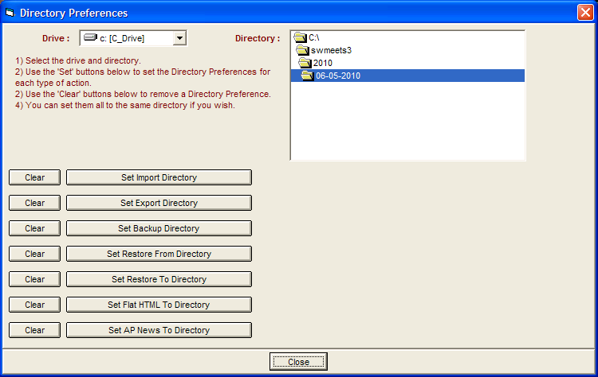

* + 1. Database Set-Up

The league databases contain the events, the All-Star times, the league records for both yard and meter pools, and certain generic settings. Once the league database is installed, a copy of it will be used for each home meet. It should then be customized for your pool.

There are four generic databases, each setup for specific pool configurations.

* 25 meter 6 lane pools (S6)
* 25 meter 8 lane pools (S8)
* 25 yard 6 lane pools (Y6)
* 25 yard 8 lane pools (Y8)

**If your pool is different (i.e., you only have 5 lanes available that weekend), you will have some changes to make**.

Go to: **Setup / Options / Global -** Select **Change Number of Lanes** and enter the correct number of lanes for that meet in both “All Prelim” and “All Final” rounds.

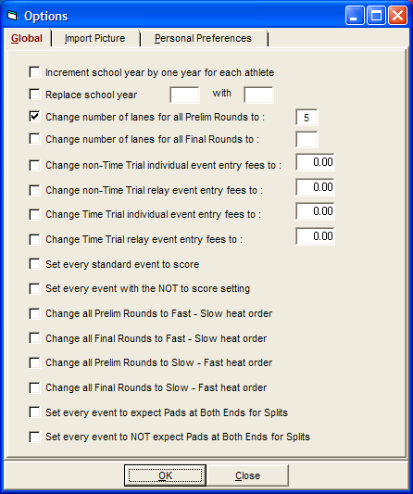

* + 1. To Install the League Database from the Web

Go to www.mhsl.org. Click on “Documents”, then on “Computers”. Look under Computer Data Files for the “zip” file that matches your requirements. Save the appropriate file to your hard drive under C:\swmeets4 (C: being your hard drive).

Once this master file is saved, un-zip the file using *Meet Manager* or Windows, **File / Unzip**. This will save the file to a new folder, likely C:\ZipTemp

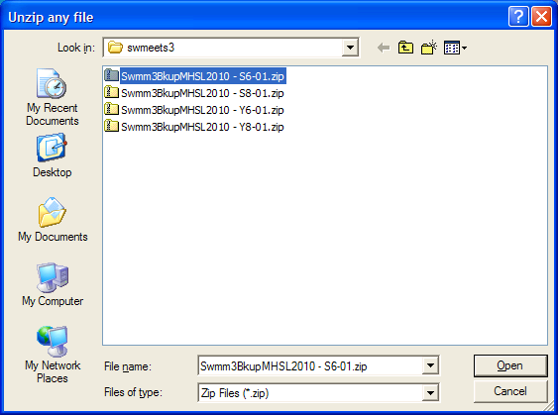

**Open Database:** After unzipping the DB, go to **File**,/ **Open** and select the unzipped DB from the temp folder.

* + 1. To Install the League Database from a disk or USB drive

Put CD into the drive or insert USB drive into port. If Windows Explorer does not automatically open to show the files, Right-Click on “Start” button, then click on “Windows Explorer”. This opens up a window with all your drives and files. Click on the drive in the left window. Files on that drive will appear on the right. Look for the “zip” file that matches your requirements. Save the appropriate file to your hard drive under C:\swmeets (C\: being your hard drive).

Once this master file is saved, un-zip the file using *Meet Manager* or Windows. Follow the above instructions for unzipping and open the database.

* + 1. Database Naming

Create separate folders for each home meet you will host. This facilitates organizing the databases, the entries, and any other data created for each swim meet. The default folder that *Meet Manager* stores the databases under is C:\swmeets4. Create the individual swim meet folders in this folder.

Note: You may create sub-folders to help organize your meets. It is especially useful after a few years to consider adding “year” folders, e.g., C:\swmeets4\2010\06-05-2010.

In Windows Explorer, highlight the folder “swmeets4”. Click on “File” on Menu Bar. Move cursor to “New”, then Click on “Folder”. Create and name the folder as suggested below. Hit “Return” to save your change. Repeat the process to create a folder for each home meet.

Click on the master file you previously selected from the MHSL site. Copy the file into each new home meet folder you created. Right-Click the master file. Click **copy** on the tool bar. Click **paste** for the number of copies you need. Rename each database copy with the same date as the folder name. Drag each copy into its home meet folder.

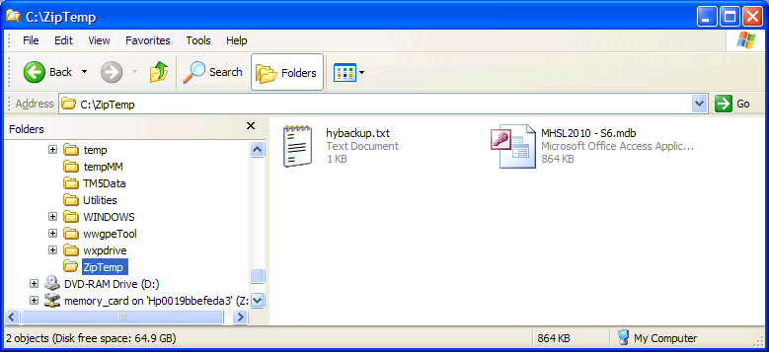

The following names should be used as a guide for the folder and database names. Each Division may establish their own guidelines for exact format, but the name must include the date the meet was originally scheduled. After naming each folder with the names below, you will need to open each of these folders to see the contents.

|  |  |
| --- | --- |
| **Suggested Folder Name** | **Suggested Database Name** |
| 06-09-2012 | 06-09-2012 away team @ home team |
| 06-16-2012 | 06-16-2012 away team @ home team |
| 06-23-2012 | 06-23-2012 away team @ home team |
| 06-30-2012 | 06-30-2012 away team @ home team |
| 07-07-2012 | 07-07-2012 away team @ home team |
| 07-14-2012 (Championships) | 07-14-2012 div# @ home team |

We can now close Windows Explorer.

1. MEET MANAGER OVERVIEW
   1. *Meet Manger* – The Big Picture



* 1. *Meet Manager Checklist*

|  |  |
| --- | --- |
| **Meet Setup** | **Completed** |
| * Create Meet from template |  |
| * Import Team Roster(s) & Entries |  |
| * Confirm Setup Preferences |  |
| * Seed the Meet |  |
| * Print Meet Program & Entry Labels |  |
| * Back-up Meet |  |
| * Send back-up to Away Team(s) (MM backup file) |  |
|  |  |
| **Run Meet** |  |
| * Make Deck Changes |  |
| * Enter Results |  |
| * Score Meet, Post and Announce Results |  |
| * Take Periodic Back-ups |  |
|  |  |
| **After Meet** |  |
| * Send MM Results to Team Manager contact(s) for all participating teams |  |
| * Send Score to Division VP and WebMaster *(by Sunday evening per P&P)* |  |
| * Print Award Labels |  |
| * Send New League Records to Scoring Committee *(by Sunday evening per P&P)* |  |
| * Print reports |  |
|  |  |

1. INDIVIDUAL MEETS
   1. Meet Set-up

Start the *Meet Manager* software. Several steps are required to prepare for a meet. These includes meet set-up, importing swimmer entries from *Meet Manager compatible software*, importing the roster from *Meet Manager compatible software*, seeding the events, printing deck labels and printing reports required for the meet. The master files should be correctly set-up for the generic selections, but it is good practice to verify before you host a meet or even seed it. These steps should be followed for every meet you set up.

At the *Meet Manager* main screen click **File.** Click **Open**. A window will open listing all of the individual meet folders you created above. Click on the appropriate folder for the swim meet you are setting up. This will highlight the folder. Click **Open.** This will open the folder. Now click on the database to highlight it. Click **Open**.

From the main menu bar click **Set-up.** Click **Meet set-up.** Under this menu item you will specify several things that need to be set for your meet.

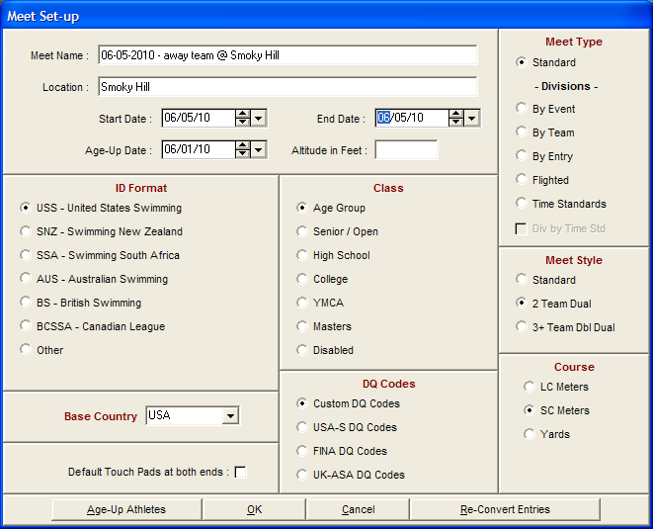

*These three items require adjustment for each meet.

**\*Meet Name** - Type name of meet. (i.e., Piney Creek vs. Sundance).

**\*Facility Name** - The name of your home pool.

**\*City** - The city your pool is located

**\*Postal Code** - The postal code for your pool

**\*Country** - **USA** should be selected from the drag-down box.

**\*Host LSC**: - **CO** should be selected from the drag-down box.

**\*Start/End Dates** - Type date of meet.

**Age-Up Date** - Always 6/1 of the current season year, even when the 1st swim meet is prior to 6/1.

**ID Format** - The **USAS-USA Swmming** radio button should be selected.

**Base Country** - **USA** should be selected from the drag-down box.

**Class** - The **Age Group** radio button should be selected.

**Course** - The radio button corresponding to the type of pool should be selected.

**Meet Type** - The **Standard** radio button should be selected.

**Meet Style** - The **2 Team Dual** radio button should be selected.

Click **OK.**

* 1. Athlete/Relay Preferences

Click **Set-up.** Click **Athlete/Relay Preferences.**

The **Enter ages, Enter Birth Dates**, **Enter Competitor numbers**, and **Auto Increment Competitor Numbers** should be checked. The other items are not used by MHSL. **Click OK**

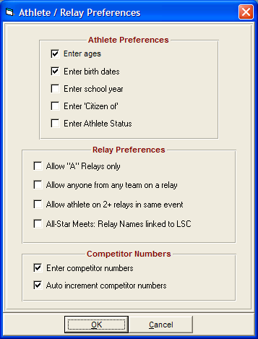

* 1. Seeding Preferences

Click **Set-up**. Click **Seeding Preferences.**

* + 1. Standard Dual Meet

This menu item allows you to control the seeding.

**Number of Preliminary Heats to Circle Seed** should be 3.

**Standard** radio button under the **Timed Final** category should be checked.

**Seed Exhibition Athletes Last** should be checked.

**Course Order** should be **YSL** for a yard pool and **SYL** for a meter pool.

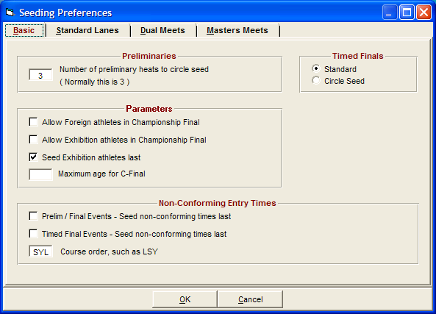

* + 1. Lane Assignments

**Use Lane Assignments Above** box under the **Dual Meet** tab should be checked. If the lane assignments are not completed, enter the **away team in the even lanes** and the **home team in the odd lanes**. Either type the MHSL team code in the box, or click on the drag down box, and the team code will appear. Select the “home team” and drag to the **Odd lanes**. Then select the “visiting team” and drag to the **Even lanes**.

Note: You can also double click on the team to assign to the next available. All other options available on this menu are not used for dual meets. Click **OK.**

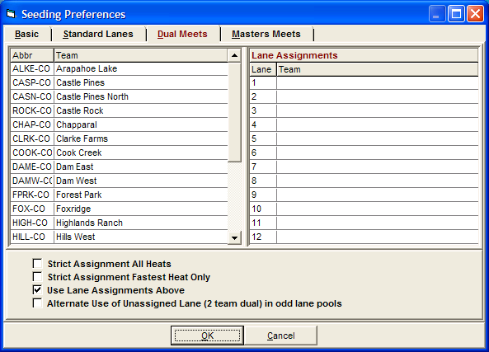

* 1. Report Preferences

Click **Set-up**. Click **Report Preferences.**

* + 1. Header Footer

This menu item controls the titles printed on the reports, the contents of the reports, the format of the reports and where the report is printed. There are two entry fields for titles that will be used on the top of all reports. Type in the appropriate information.

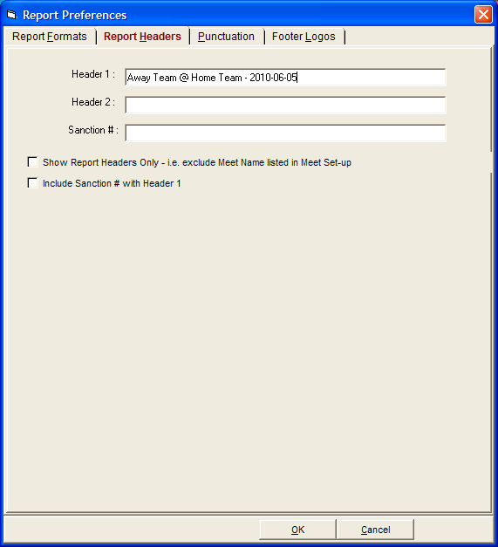

* + 1. Report Formats & Punctuation

The check boxes and radio buttons under the **Report Formats** and **Punctuation** tabscan be set for your teams preferences. *Meet Manager* checks for the print drivers installed on the computer and makes those options available in the drop down box under these categories. The printer options might change when moving the database between different computers and should be reviewed when this is done (i.e. if you are using an internet computer and a different computer on meet day). Click **OK.**

* 1. Scoring
     1. Entry/Scoring Preferences

Click **Set-up**. Click **Entry/Scoring Preferences.**

Under the “Scoring/Awards” tab, nothing should be checked.

**Maximum scorers per team per event** should be 3 for individual, blank for relay.

**How many for award labels**, enter how many of the top swimmers will be receiving individual ribbons and how many of the top relays will be receiving ribbons. Usually this is determined by the number of lanes.

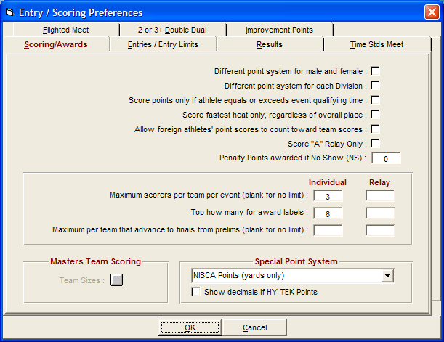

* + 1. Entry Limits

Under the “Entry Limits” tab,

**Maximum Entries per Athlete including relays** should be 5.

**Maximum individual entries per Athlete** should be 3.

**Maximum Relay Entries per Athlete** should be 2.

**Warn if entry limits exceeded** check box should be selected.

Nothing else here needs to be entered. Click **OK.**

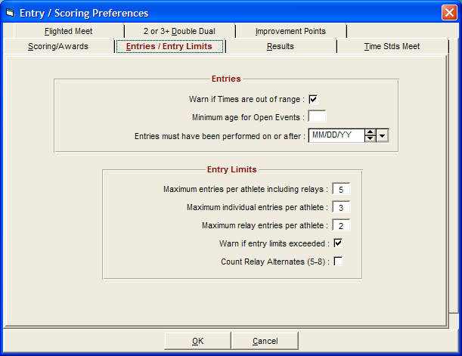

* + 1. Scoring Set-up

Click **Set-Up.**

Click **Scoring Set-up / Standard**

This sub-menu should not need modification for Dual Meets. It was set-up in the League database to conform to MHSL scoring rules. Individual points are 6-3-2-1 and relays are 8-4.

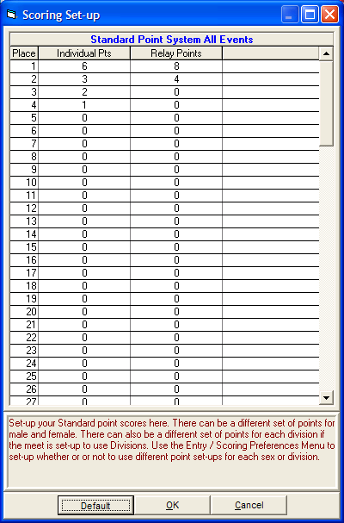

* + 1. Events

Click **Events.** Make Sure **Each Event** is setup for the # of lanes in your pool. If you have anything else you will have to change this event-by-event.

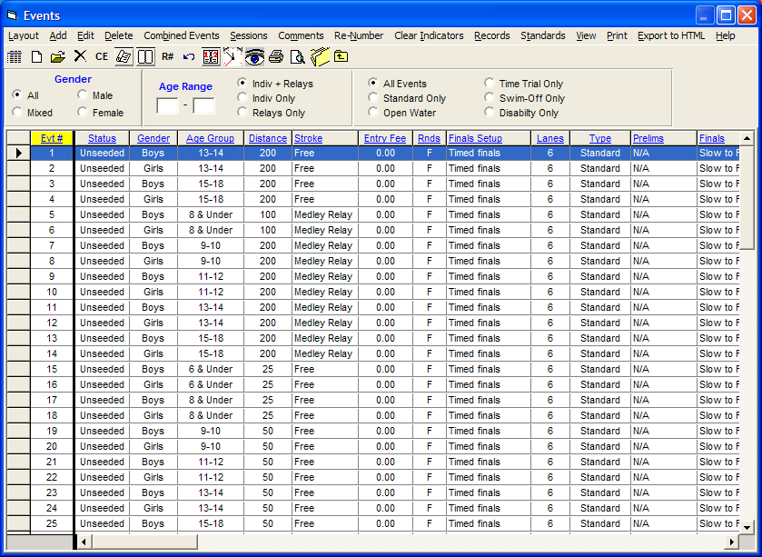

* 1. Records and Time Standards
     1. Import All-star Times

If the All-star times are not in the DB, obtain an export file from the league web-site, AS1x.ST2.

**File / Import / Time Standards**.

Under Time Standards select **Import**

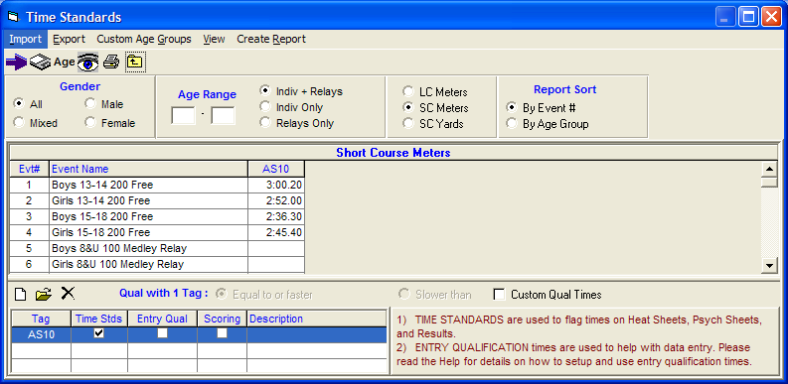

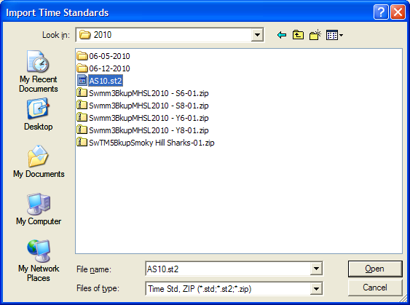

Ensure file is the latest version

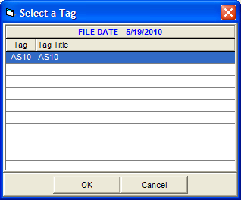

* + 1. Import League Records

Obtain an export file from the league web-site, MHSL10A-s.rec (for meters) MHSL010A-y.rec (for yards). Follow a similar process as with All-star times.

**File / Import / Records**.

Under Records select **Import**

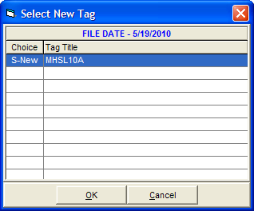

* + 1. Import Team Records

Obtain an export file from your *Meet Manager compatable software* that has your team’s records. -- *In TM make sure you select the meter or yards records file.*

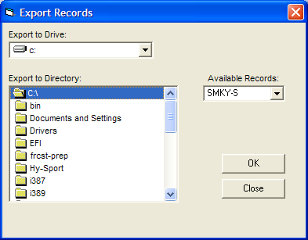

Back in MM

Use **Import** / **Records** to bring those records into your meet database.

Then under Records - **Import**

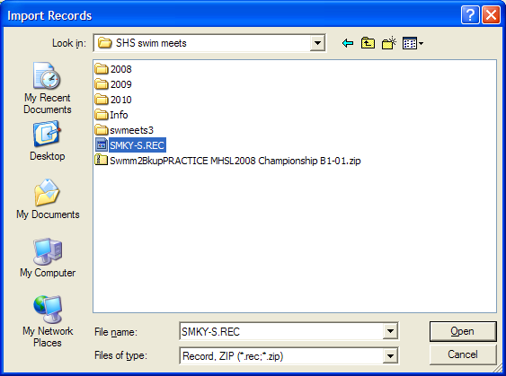

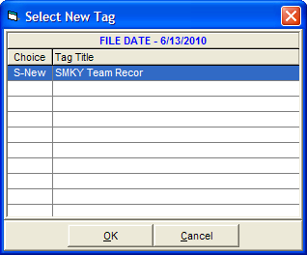

The Team Records will be displayed, based on the “Tag Name”

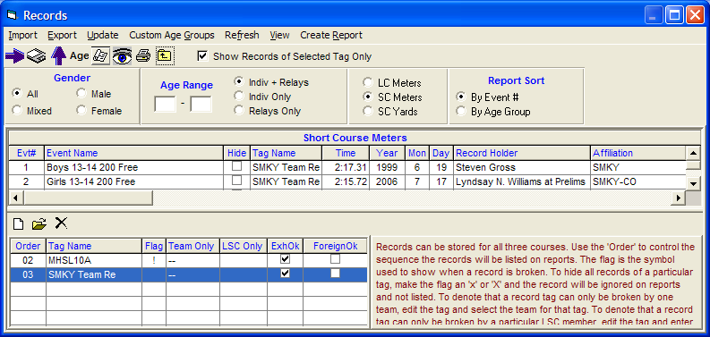

* 1. Import Entries

Both the visiting and home teams will be using *Meet Manager compatible software* for meet entries. *The Meet Manager compatible software* will build a file and this file will be sent to you. The file can be e-mailed to you or provided via USB Drive. The files received from each team should be stored in the folder created for that particular meet (i.e., 06-05-2010, 06-12-2010, etc.).

After you have saved the entries into the proper folder, you will be importing them into the meet database. This is done by performing the following steps:

1. Start the *Meet Manager* software

2. Verify you are working with the correct database for your meet

3. Click on **File** from the main menu bar

4. Click on **Import** from the pop-up menu

5. Click on **Entries** from the pop-up menu

*Meet Manager* will ask you the location of the import file. Select the correct folder. Select one of the *Meet Manager compatible software* files. Click **Open**. *Meet Manager* will ask you to verify the import. Once you confirm that you wish to continue, *Meet Manager* will offer various filter options.

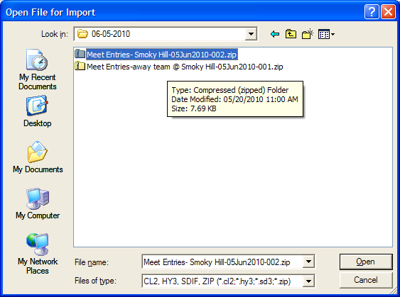

Check the boxes **Include Entries with No Times (NT) and Match on Event numbers.** The other boxes should be left unchecked. **Click OK.** A window will appear telling you the import is finished. Click **OK.**

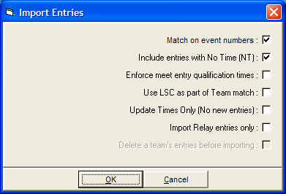

If there were any problems with the import file, *Meet Manager* will indicate this. An Exceptions Report will appear indicating the entries it could not import and the reason why. Print this report. Typical problems are: too many entries for a swimmer, no swimmer names for relays, swimmer’s gender doesn’t match event, or swimmers entered into the wrong age events.

Some of these errors can be fixed in *Meet Manager*. Sometimes you will be required to contact the team to see what the intentions are. If the errors are numerous, it will be faster to have the *entry* person redo the import file and retransmit it.

**Repeat this procedure for the other team file**.

* 1. Import Roster Files

Import the Roster files from each team.

* Select on **File** from Main Menu bar
* Select on **Import** from the pop-up menu
* Select on **Rosters Only** from the pop-up menu

Find the roster files and import the rosters from each team.

* 1. Seed the Meet

Once the entries are complete, you are ready to seed the meet. You should have specified the home team will be seeded in the odd lanes and the visiting team will be seeded in the even lanes in the Database Set-up/Seeding Preferences section. Verify that this has been done by clicking on **Meet Set-up** and clicking on **Seeding Preferences**. Verify that the Use Lane Assignments Above button is checked.

**Seed the Meet:** Click on **Seeding** from the main menu bar. The seeding options will appear down the left side of the screen and the swim meet events will be displayed on the right. From the options on the left side of the screen, click on **Select All**. This will highlight all of the events in the swim meet. Then click on **Start Seeding**. This will seed all of the events.

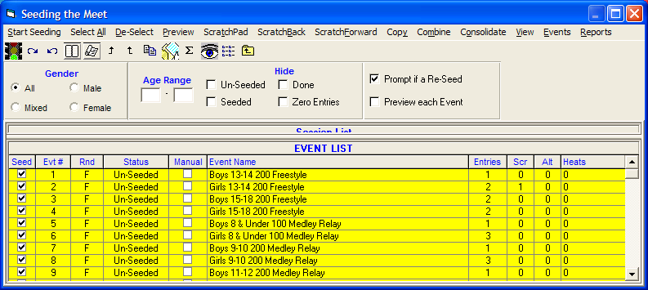

All swimmers (except 6&U swimmers), no matter what heat they swim in, are eligible for points. Each team, however, is only eligible to win **three places** in each event. Seeding is set up to comply with the even-odd seeding until one team runs out of swimmers. It will then begin filling in all lanes from the remaining team. See P&P Manual, Section 17, for more details on how the meets are scored.

The heats for each event can be reviewed from this menu. Click on the event you want to check to highlight it. Then select the **Preview** button on the top of the screen. This will display the heats and the swimmers for that event. A swimmer can be moved from a heat by dragging the swimmer from the heat down to an empty lane in another heat. If there is not an empty lane in a lower heat, a new heat will need to be created by selecting the **Add Heat** option on the left side of the screen. This action will open up new heat.

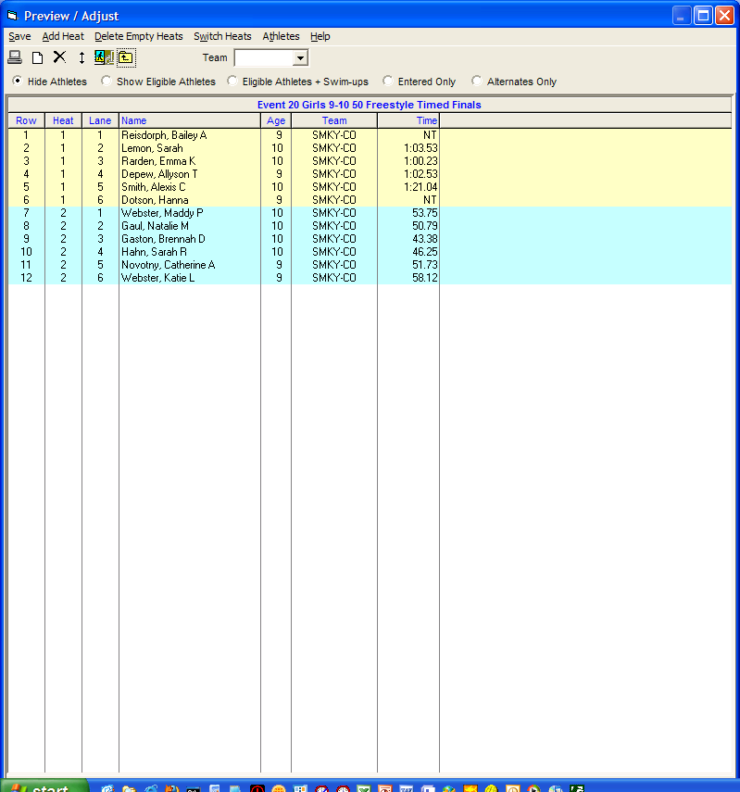

At this time you can also check the other heats and make adjustments. If any modifications are made to the event, the **SAVE** button must be selected prior to closing the screen. If the screen is exited prior to the **SAVE** button, the modifications will not be recorded and the seeding will remain unchanged. You must then select the next event and repeat the above procedure.

* 1. Create Session

After Seeding the Meet, optionally you can create a Session, if one is not already created. This allows you to have the meet timeline in the Meet Program report.

Click on **Events** from the main menu bar. On the toolbox select **Sessions**. From the options select **Add**

Session # - Use Default

Session Title - enter value

Start Time: - enter home location start time

Interval: - recommend 25 seconds, backstroke 45 seconds

Click **OK**

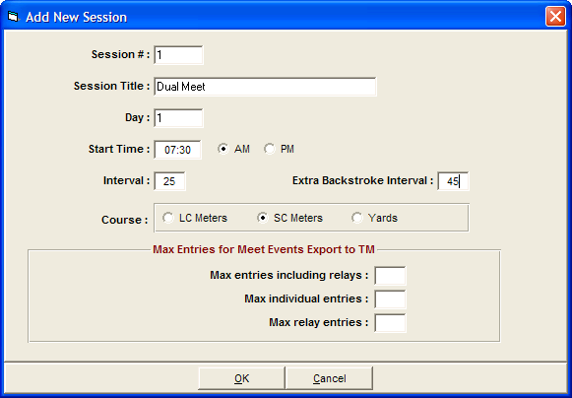

Click cancel if only one sessions (for dual meets).

Click on **Move All**. This will highlight all of the events in the swim meet and move to the highlight Session column. Then click on “X” to close the window.

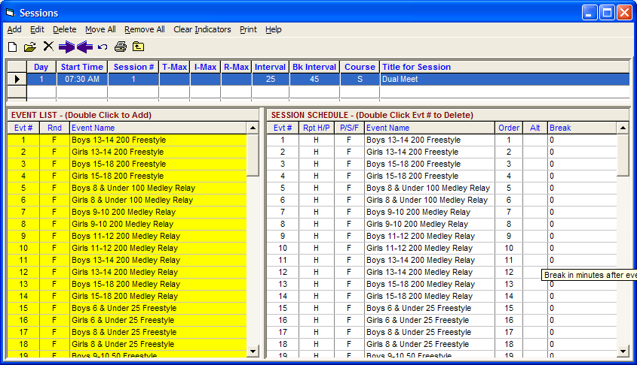

* 1. Print Deck Card Labels

After seeding has been completed, deck card labels need to be printed. The deck cards used by MHSL are designed to accept the Avery 1-inch labels (also referred to as 3x10, 3 across and 10 rows on a sheet – labels are 1” high x 2 5/8” wide).

To print the labels, select the **Labels** menu from the menu bar and then **Entry Cards/Labels** option. This will bring up a window that gives you several options for printing.

**Team** leave blank; it will then print for both teams.

**Age Range** leave blank; it will then print for all age groups.

**Sex**, we recommend you print the labels for one sex first and then the other. It is easier to stick labels to one color card at a time, rather switching back and forth between different colored cards.

**Event** select **All Events** and print the labels for the entire meet.

**Individual**, we recommend printing out individual entries then relays

**First Set of Labels– Blue Cards**

Gender – select **Male**

Individual – select **Indiv only**

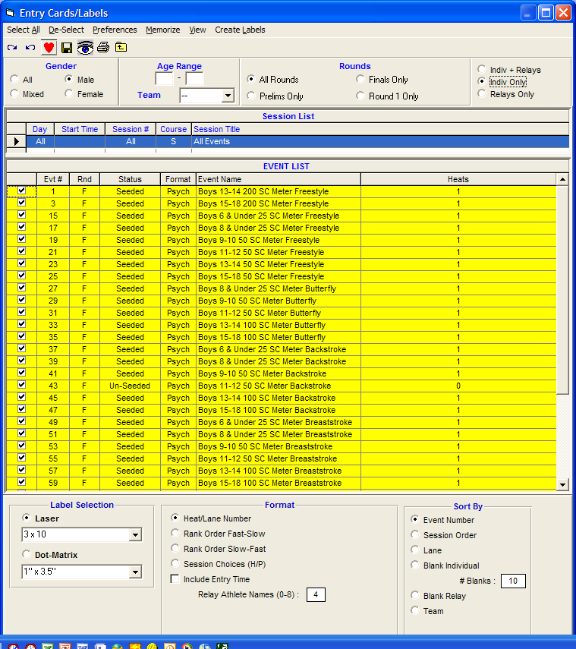

When ready to print labels, click on **Create Labels**. A preview of the labels will appear on the screen. Hit the printer icon on the tool bar to send the labels to the printer.

**Second Set – Pink Cards**

Gender – select **Female**

Individual – select **Indiv only**

**Third Set – Green Cards**

Gender – select **Male**

Individual – select **Relay only**

**Fourth Set – Green Cards**

Gender – select **Female**

Individual – select **Relay only**

There may be times were you will need to print the labels for just one event. Click on the event or events you need to print labels for and *Meet Manager* will print for just those events. For **Label Selection,** select 3 x 10. For Format select **Heat/lane number**. For **Sort By** click on **Event**.

The labels need to be delivered to the volunteer responsible for putting the labels on the cards. Suggest you provide a meet program with the labels in case any questions arise.

* 1. Print Reports for Meet Officials

The last step for preparing for the swim meet is printing the reports for the meet officials. These are printed by selecting **Reports** from the menu bar. The following reports are needed by the listed officials:

NOTE: These are preferences to be used just as a guideline - you can do yours however (and how many) you like.

* Parent Delegates – 2 copies of program (heat sheet)
* Home/Visiting Team Coaches’ packets– per packet: 4 heat sheets; 1 timeline; each team’s athlete roster with entries for the meet
* Stroke & Turn Judges, Deck Referee, Meet Referee, Starter, DQ Scribe, DQ Communicators – 10 heat sheets, 3 timelines
* Clerk of Course – 1 heat sheet
* Heating Area Coordinators – 4 heat sheets
* Scoring Table – 1 heat sheet
* Announcer – 1 heat sheet
* Concessions Stand – 1 heat sheet, 1 timeline
* Extra – 1 copy (at least!)
  + 1. Athlete Rosters

Check the following-

“Athletes & Relays”

check boxes with “include athletes with no entries”

“include competitor #”

sort alphabetical

team blank

both sexes

blank age range.

*This report goes to the scorer’s table only.*

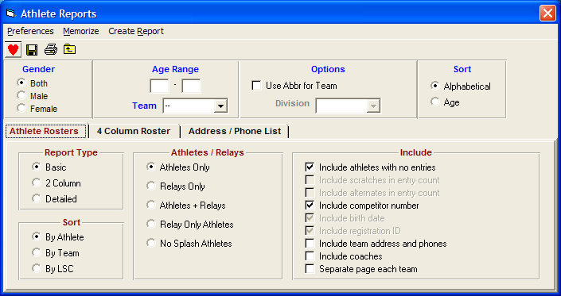

* + 1. Meet Program

Check the following-

“Columns-Triple”

“Athlete ID-None”

“Relay Athlete Names-4”

“Time Stamp-None”

“Format-No checks”

Dual Meet – Highlight (this will place projected start times on the Meet Program)

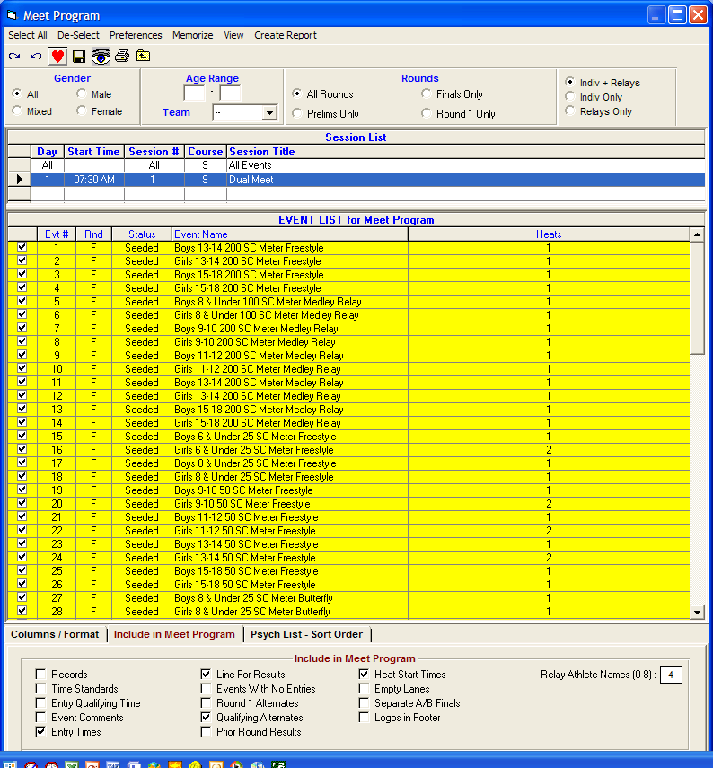

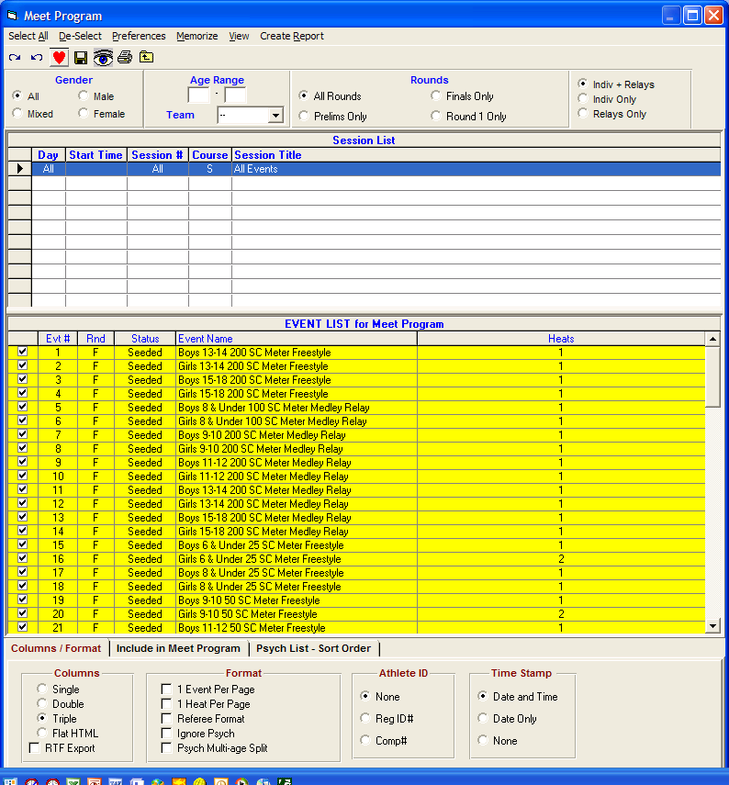

Optionally, you may select these features:

Check “Records” to display the records for each event.

Check “Standards” to display the All Star qualifying times.

Check “Heat Start Times” to display the anticipated event start times

After selecting the appropriate options, click **Create Report.** The report will appear on the screen.

Click on the printer icon to print



* + 1. Entry Lists

Check the following-

“By Team”

“Event Description and Time”

“Athletes Only”

“Sort-Alphabetical”

“Team-Blank”

“Sex-Both”

Age Range-Blank”.

*This is to post on a wall so athletes can see their events.*

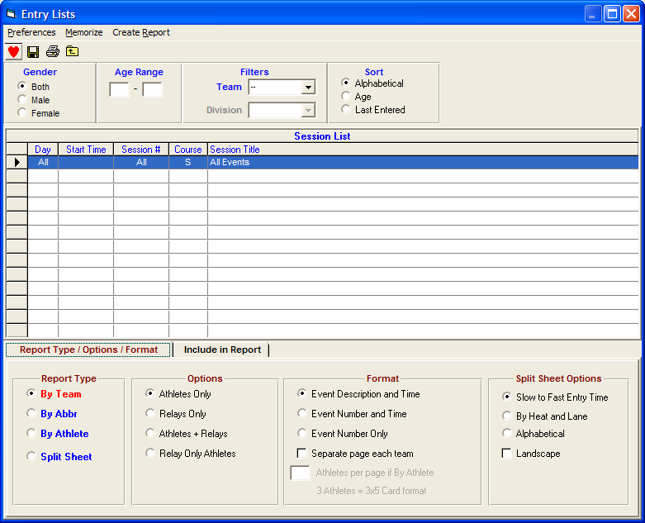

After selecting the appropriate options, click **Create Report.** The report will appear on the screen.

Click on the printer icon to print

* + 1. Entry Lists *(for Swimmers)*

Optionally you can provide the coaches an entry report for handing out the events for individual swimmers.

Check the following-

Gender “Both”

Age Range: 5 – 6

“Select Team”

Sort “Alphabetical”

Report Type “By Athletes”

Format “Event Description and Time” & Athletes per Page “3”

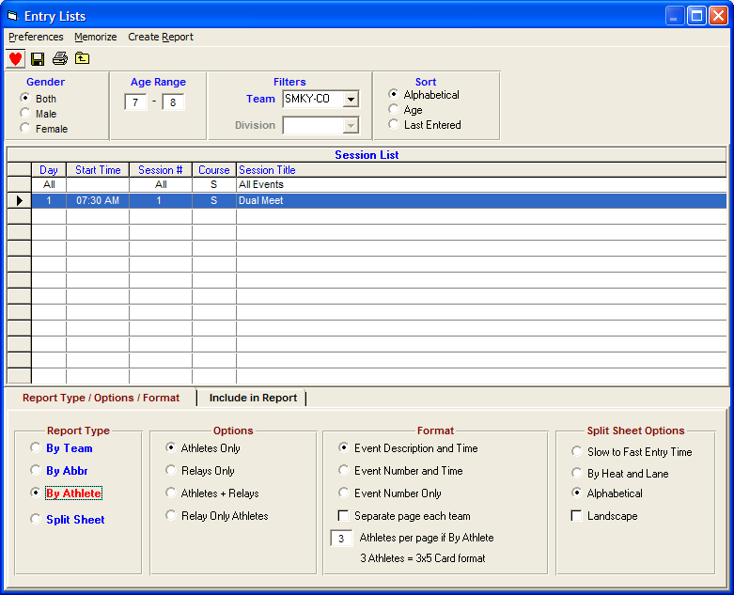

After selecting the appropriate options, click **Create Report**. It will ask for an optional coach message (enter coaches message), click OK then the report will appear on the screen.

Click on the printer icon to print

Repeat for age ranges

7 – 8

9 – 10

11 – 12

13 – 14

15 – 18

Coaches can cut up the report and hand out to each swimmer after warm-ups.

* 1. Timeline

To create a separate timeline report, click on **Events** and then **Sessions**. Select **Session 1** that has all the events included. Select **Print**. Select the session for the timeline. Check the **Include Event Start Times** and **Include Heat and Entry Count** boxes. Click on **Create Report** and print the report shown on screen.

* 1. Create Backup and e-mail

It is strongly suggested you make a backup of your meet after the set-up and before your meet. To backup the data, from *Meet Manager*’s main menu, select **File / Backup**. This will create a window prompting you for the drive and folder to store the backup. The backup can be stored on the hard drive, CD, or a floppy. It is also suggested that you e-mail the backup to the other team’s MM contact.

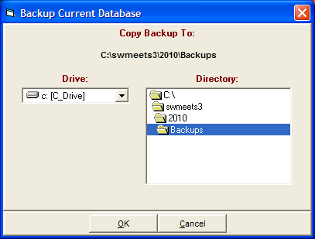

After creating the back-up, it is strongly suggested you rename the backup as “pre-meet”. This allows you to go back to the starting point prior to the day of the meet.

1. RUNNING THE MEET

* Make sure you have the copy of the back-up prior the starting the meet.
* Also it is strongly suggested you take back-ups through-out the meet.
* P&P 14.15.3: The scoring table should post and/or announce the score at the meet after every 10 events.
  1. Deck Changes

There are various ways to perform deck changes thanks to the drag and drop features of *Meet Manager*. We suggest you try to make as many of the deck changes prior to the start of the meet as you can. Deck changes are to be given to you by set time from the home team, for example 20 minutes prior to the start of the meet. Most of the deck changes can be performed under the **Athlete** option on the main menu bar. The following functions can be performed.

1. Add a swimmer to an event, assigning a heat and lane.

2. Scratch a swimmer or swimmers from an event or more.

3. Delete a swimmer from the meet.

4. Change a swimmer’s event.

5. Declare an athlete as an exhibition athlete.

6. Adjust or Declare swimmers in a Relay.

If changes need to be made during the meet, the Athletes Menu can also be reached from the Run Meet menu by clicking on **Athlete.**

* + 1. Add Swimmers

If a swimmer was not included in the *Meet Manager compatible software* entries when they were imported, you will have to add him/her on meet day. To add a swimmer, you must know:

First name

Middle initial

Last name

Sex

Date of birth (MM/DD/YYYY)

Entries cannot be accepted without this information. Parent Delegates are required to carry their team’s insurance information to all meets. This information should include the swimmers registration and can be obtained from them.

Select the **Athlete** option on the menu bar. This will display a list of the athletes that are currently in the database. Select **Add Athletes** button on the left side of the screen. This will display the “Add New Athlete” window requesting the above information. Fill in the boxes with the appropriate information. After the date of birth is entered, *Meet Manager* will automatically calculate the age of the swimmer and then display the eligible events for that swimmer.

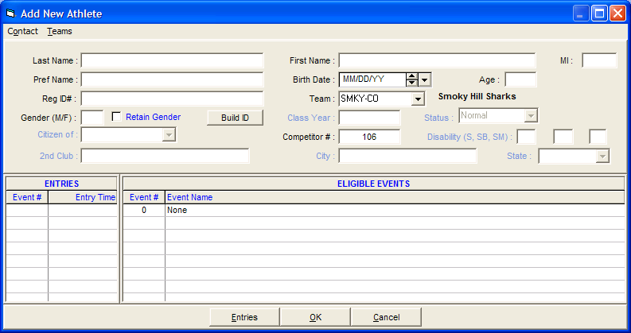

Click **Entries**. Enter the swimmer into their events by clicking on the events to highlight. At this point, you can deck enter the swimmer into a heat and lane. Check your meet program (heat sheets) and locate an open lane. Enter the heat number and lane number into the **Heat/Lane** box.

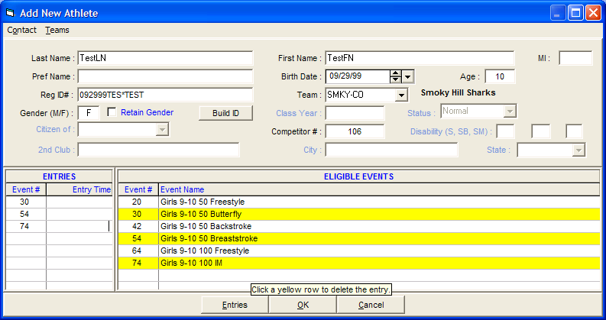

After you have entered all of the information, click **Close.** You may now enter another swimmer or exit this screen by clicking **Close.**

**The Clerk of Course will need deck cards for the added swimmers. Hand write deck cards for the added swimmers including their name, event number, event name and heat/lane assignments.**

* + 1. Scratch or Delete a Swimmer

The **Athlete** option is used when scratching a swimmer from a meet. Click on the swimmer’s name and click on **Scratch All.** This will remove the swimmer from all the events they are entered, while still keeping the swimmer information in the database.

If you need to scratch a swimmer from one event, click on the highlighted event and *Meet Manager* will verify whether you want to scratch the swimmer from that event.

You can also scratch them by clicking on the **SCR** box. Selecting **Delete Athlete** will remove the swimmer and all the entries completely from the database. If you select this option, *Meet Manager* will verify whether you want to delete the swimmer and all their entries. Also you can select Edit Athlete then select the event to scratch.

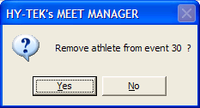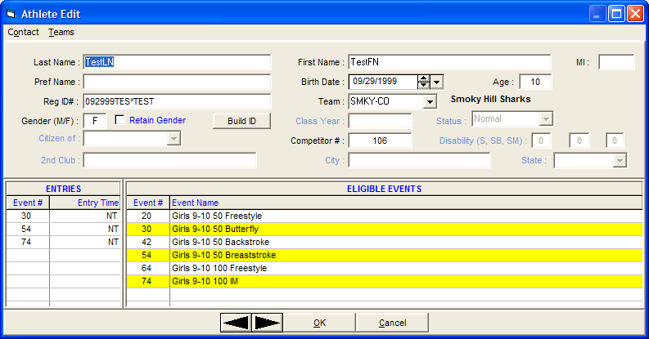

* + 1. Change a Swimmer’s Events

A swimmer can be added to an event simply by clicking on the event to highlight. Remember a swimmer may only be entered into 3 individual events. If they already are in 3 events, scratch them from one event by unselecting the event, before entering them into another.

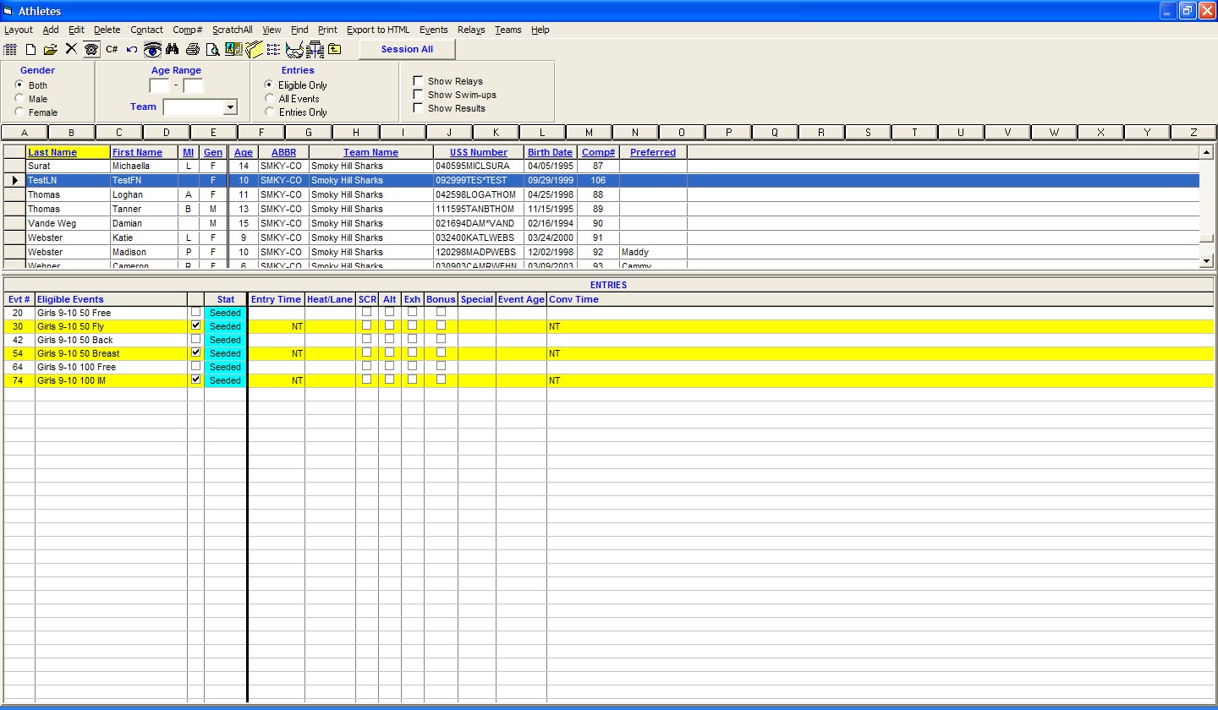

* + 1. Declare an Athlete as an Exhibition Athlete

To declare an athlete as an exhibition athlete in an event, click on their name. Then click on the **Exh** box.

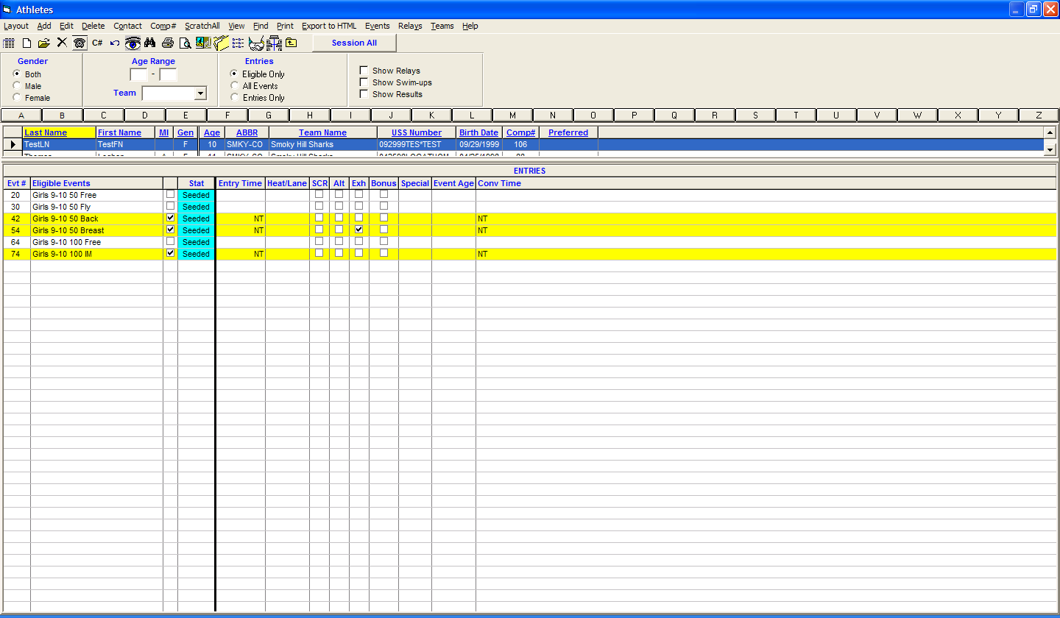

* + 1. Adjust or Declare Swimmers in a Relay

If a team did not include the swimmer names for their relays on their imported entries, those names will need to be specified on meet day. Before the meet begins, this can be done from the **Relays** option on the main menu bar or by selecting **Relays** or **Athletes/ Relays**. Select the event from the “Relay Events” window and then select the relay team in the “Relay Team Entries” window. Then click on athletes from the “Eligible Athletes” window and drag them to the **Finals column** in the “Relay Order” window. Select the **Close** button when all modifications are done. This task can also be performed during the meet from the “Run the Meet” screen by clicking on the **Relay Names** button.

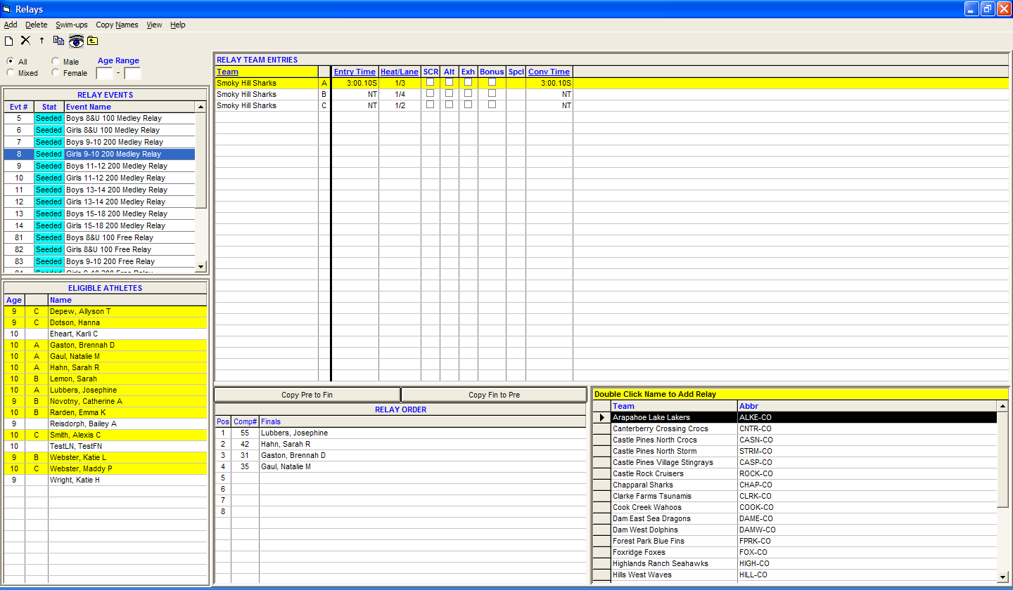

Double click the swimmer to remove. Then double click on the swimmer to add.

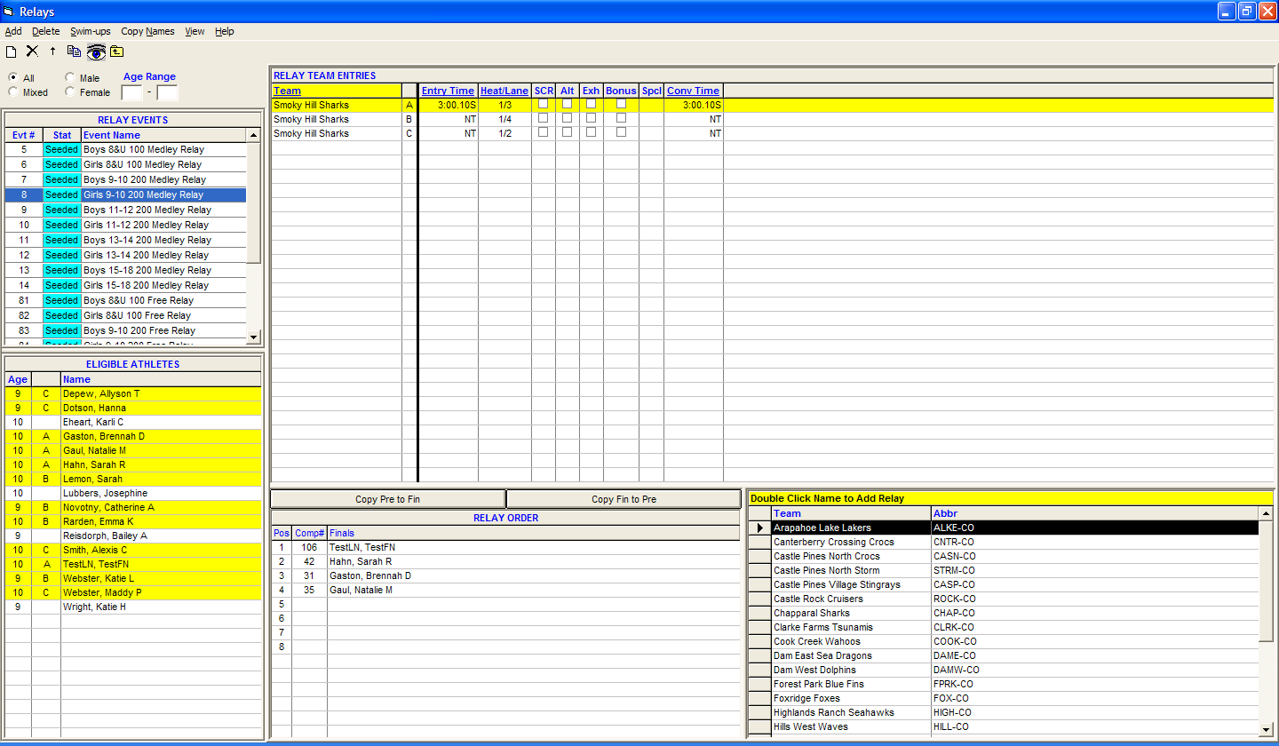

The previous swimmer is now un-highlighted, the new swimmer is highlighted and in Relay Order.

* + 1. Change a Heat/Lane Assignment

The following changes can also be performed under the **Seeding** option:

1. Change heat and lane assignments,

2. Add a swimmer to an event, assigning a heat and lane,

Select **Seeding** from the main menu. Click on the Event you wish you make a change in. Click on **Preview/Adjust.** This will bring up the “Preview” screen. Click on the athlete you wish to change and drag him to the correct lane. To swap swimmers, drag either of the swimmers over the name of the other and *Meet Manager* will swap the names. Click **Accept.**

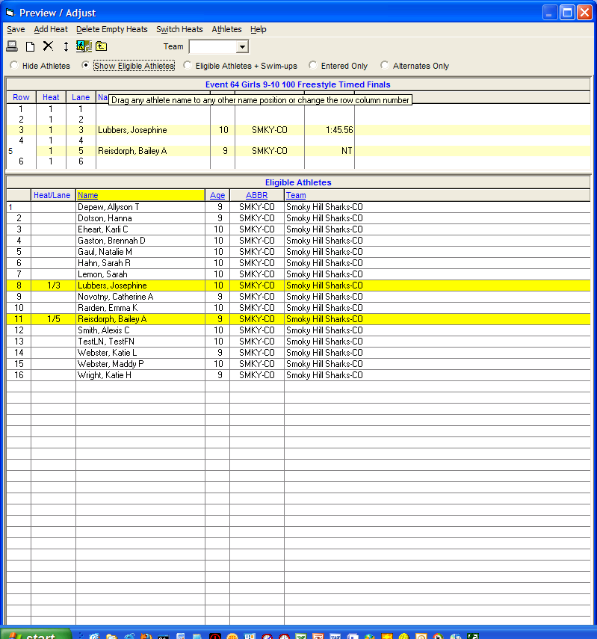

* + 1. **Add a Swimmer to an Event, Assigning a Heat and Lane**

Select **Seeding** from the main menu bar. Select the event by clicking on it to highlight. Select the **Preview /Adjust** option on the left side of the screen. This brings up the “Preview” screen listing the swimmers in the event and their heat/lane assignments. Click on **Show Eligible Athletes** to display the eligible athletes for this event. Simply drag the swimmer you want to enter into this event to an available lane. Click **Accept.**

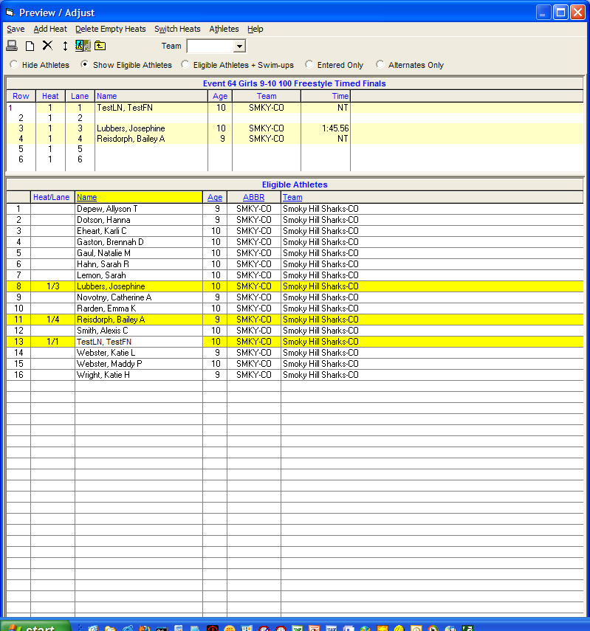

* 1. Enter Event Results
     1. Enter Event Times

Entering meet results is accomplished by selecting **Run** from the menu bar. When **Run** is selected, the screen is divided into three sections; the list of events in the upper left, the record for the event in the upper right, and the athlete entries for that event below. The times for the events are entered into the **Finals Time** column. When entering the time, colons and decimals do not need to be entered. *Meet Manager* will automatically insert the colons and decimals in the correct locations. When a time of 10405 is entered, *Meet Manager* will display the time as 1:04.05 after the ENTER or RETURN is hit.

**DQs**– entry

Next to the Final Times column are DQ check boxes. Simply click on the check box for any swimmer that was DQ’ed. Even on a DQ, enter a time this provides for the easy correction of time enter/scoring if the event a DQ is overturned. Additionally, the swimmer will be able to see how they are improving in that swim.

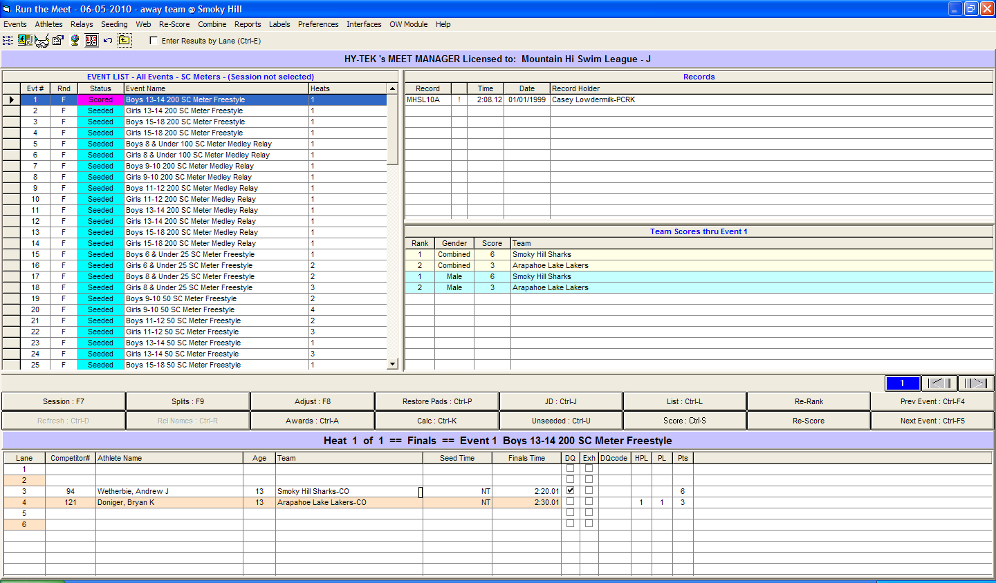

**Multiple Heats**

The Heat Buttons are located in the middle of the screen on the right side. The heat that is currently opened highlighted. Below this is a row of menu items that perform these functions:

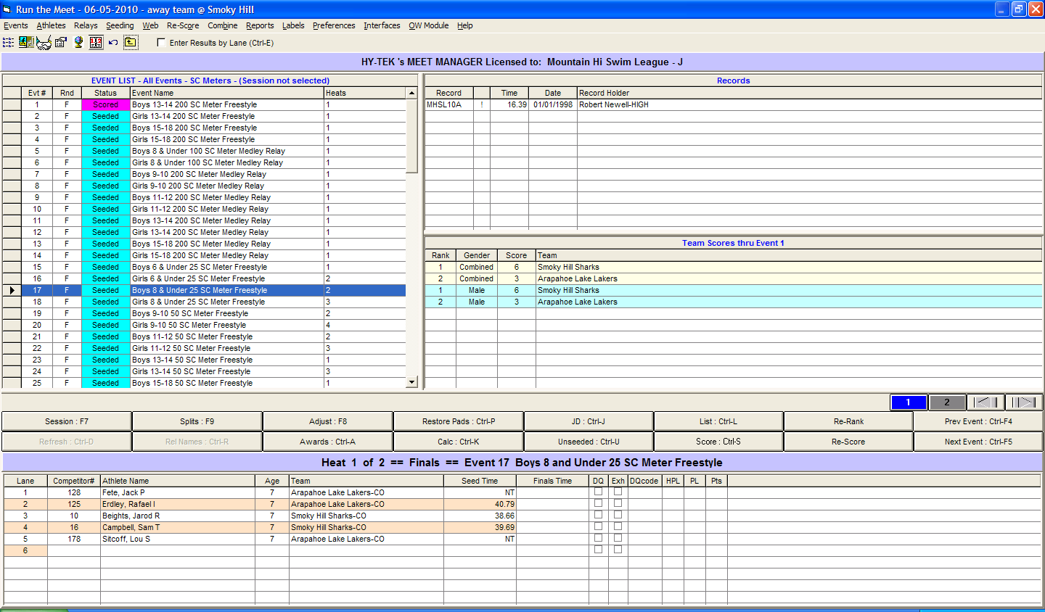

**Session** – ignore.

**Adjust -** This allows you to adjust swimmers between heats or add a swimmer to this event. A list of all the heats and the seeded swimmers along with a list of eligible swimmers will appear. Swimmers can be dragged up from the eligible swimmer list into the correct lane, or swimmers can be moved into the correct lane. After all changes are made, the **Accept** button on the left side must

be selected prior to the **Close** button for the changes to take effect.

**Splits** – generally ignore (see “Entering Lead-Off Times”)

**Awards –** If you print labels after you have entered times for all the heats, it will combine all the heats and print labels based on the overall placement of the event - not the placement within the heat. In order to save labels, click **Preferences** from “Run the Meet” screen. Click **Awards Labels.** Under the Print Method, click **Print directly to Printer**. Click **Print only when Page is Full**. *Meet Manager* will hold the labels until a page is full and then print them. To print labels for all heats see the directions below in the section titled Print Ribbon Labels.

**JD (judge’s decision) –** See “Entering Place-Picker Results”

**Show Backups –** ignore

**Relay Names** - This will bring up the three screens that will allow you to modify who is swimming relays. Names of swimmers can be dragged and dropped to and from the appropriate locations to remove and add.

**List** – Generates a list of the event results

**Previous Event and Next Event** – Allows you to move between events.

**Score Event** - Click on this to evaluate the results for this event and place and score each swimmer. A Results Report will be displayed and optionally printed. Clicking on **Ctrl-S** allows place and score assignments to be made but no report will be generated. This is a nice feature to use when you want to score each event, but then print the Results Report after every 10 events.

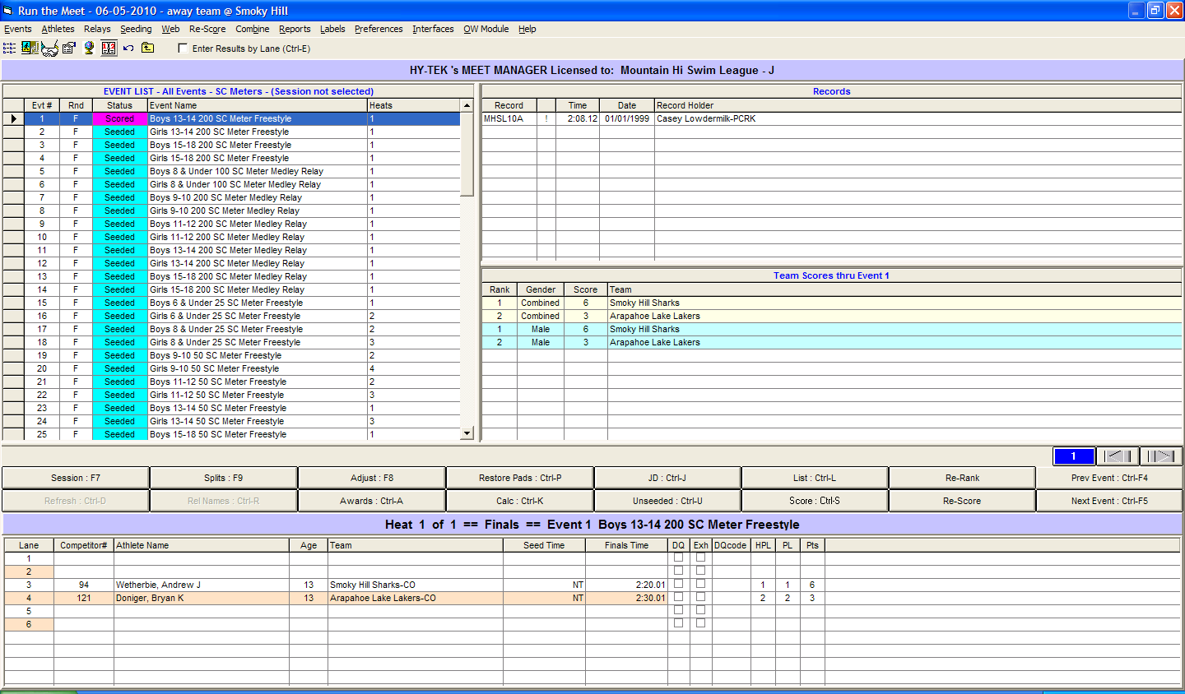

**Results Report: Partial** – When running a Results Report, you can highlight the specific events you want in the report, for example for the last printed result and thru event that is “scored”.

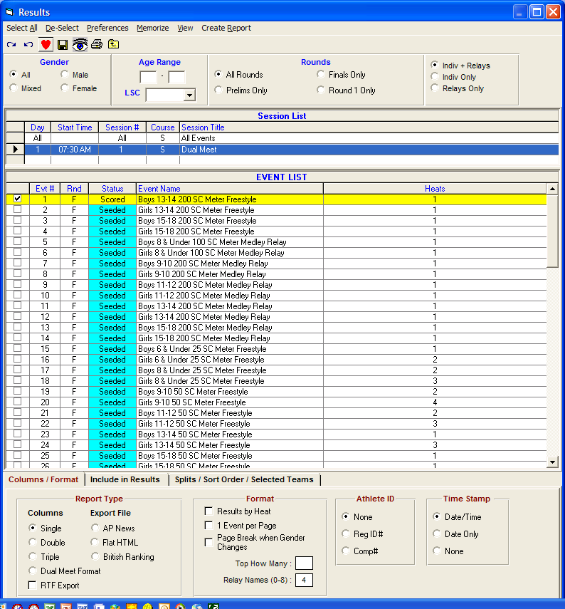

If you leave the “Run the Meet” window, it will return you to the same event you were at when you exited.

* + 1. Verify Results

It is good practice to have the printed results verified against the original cards before posting the results. This check process often finds errors that can slip past the entry team.

* + 1. Modify an Entry Time

Modify a swimmer’s entry time by clicking on it and typing in correct time. If the time change aqffect the scoring select the Re-score button, once an event is scored you must use Re-score not Score..

* + 1. Create Periodic Backups

It is strongly suggested you make periodic backups of your work during the meet (every ten events at a minimum). These can be used to restore the data if your computer crashes or you lose power during the meet. A computer crash may not destroy the data, but if it does, the backup will contain all of the current entries made up to the time that the backup was made. This eliminates the need to re-enter swim times from the first event to the current event.

To backup the data, you must exit from the “Run the Meet” screen. From *Meet Manager’s* main menu, select **File**. In the File menu, select **Backup**. This will create a window prompting you for the drive and folder to store the backup. The backup can be stored on the hard drive or a floppy. To restore a backup, click on **File** from the main menu and then select **Restore**. This will create a browser window requesting you to supply the location of the backup file. I suggest backing up every time you give a score, just to ingrain a good habit.

* 1. During the Meet
     1. Score the Meet

The score of the meet should be announced periodically. It is suggested that after a group of events have been swum (i.e. after all freestyles, all backstrokes, etc.) give the current score of the meet to the starter to be announced. To see the team scores, select the **Reports** from the “Run the Meet” main menu. Then select the **Scores** option. This will display the **Scores** window. Click on the **Select All** button and then the **Create Report** button. This will bring up the report containing the scores of each team. You can close out of the report without printing or print the report if desired.

* + 1. Print Event Results

Event results can be printed from the “Run the Meet” window. Click on **Reports** and then **Results**. This will bring up the “Results” window where you may select what event(s) you would like to print. Select which options you would like to display on the printout and select the **Create Report** button. Preview the printout on the screen, then print. Since you are allowed to print several reports at a time, you may want to print results every 5-10 events. Caution should be exercised when generating printouts during the meet. Slow printers can cause delays in the operator’s ability to enter event results while the printer is operating. Printouts should be generated only if a printer with sufficient speed is available.

After results are verified have the result report posted and the score announced.

**TIP:** If you select labels for just the away team with a range of a single place level (e.g., “Individual Places of 2-2 only) at the end of the meet, the program will tell you how many (in this case 2nd place) ribbons to give to the away team.

* + 1. Records Set

If a record is set for the event, the record in the upper right will turn blue. If this happens and the time is verified, you should ask the announcer to announce the new record.

* 1. Special Situations
     1. Entering Lead-Off Times

Swimmers may wish to enter the lead-off leg time as a relay lead-off split in order to qualify for All-Stars. The relay event must be completed with no DQ for this lead-off time to be considered valid. That is, if the lead-off swimmer completes their leg, but the remainder of the team fails to finish or if the team is DQ’d, then the lead-off time is invalid and cannot be considered for All-Stars. The process for recording the official time is described in the P&P Manual, Section 10.14.

Similar to normal entries, you should use the median time as with all time cards to establish the official time. In the *Meet Manager* Run page:

* Select the relay event
* Select Splits.
* Enter the lead-off leg time in the first segment of the splits list (make sure you put it on the right relay.

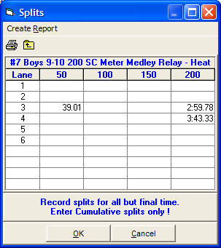

After the meet results have been imported into *Team Manager*:

* Select Meets
* Select the appropriate meet.
* Select Results> Results by Event
* Select the relay event.
* Underneath the names is a box labeled: Lead-off leg
* Enter the time into this box.

When a Top Times report is run in *Team Manager*, it will show this time with an “L” next to it. If the All-Star standards are selected, and the time qualifies, it will display the all-star label.

* + 1. Entering Intermediate Distance Times

Swimmers may wish to enter the “lead-off” leg time of a longer individual event in order to qualify for All-Stars. An official individual event time may be recorded for an intermediate distance for a swimmer during that event. The swimmer must complete the event legally for the time to count. That is, if the swimmer completes the initial intermediate distance, but fails to finish or is DQ’d, then their intermediate (“lead-off”) time is invalid and cannot be considered for All-Stars. The process for recording the official time is described in the P&P Manual, Section 10.14.

Create a separate event number by adding 100 to the appropriate distance event number. For example, if a 9 year old boy is swimming in Event #63 100 Free and wants an intermediate distance time for the 50 Free, then the event number would be #119 since the event number for 9-10 Boys 50 Free is #19. Manually place the swimmer in that new event and enter the athlete’s intermediate distance time.

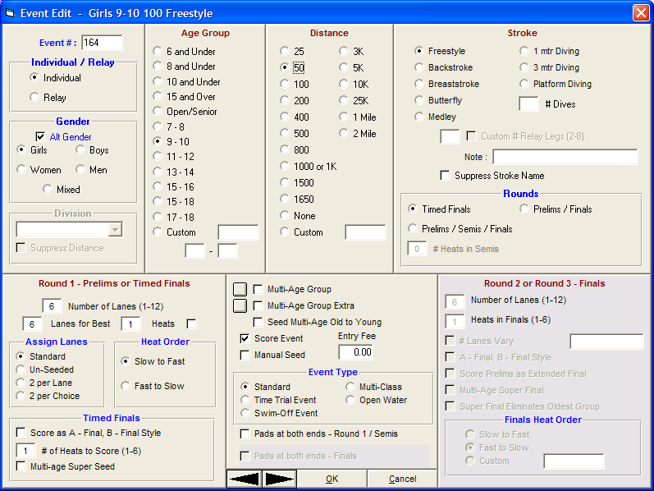

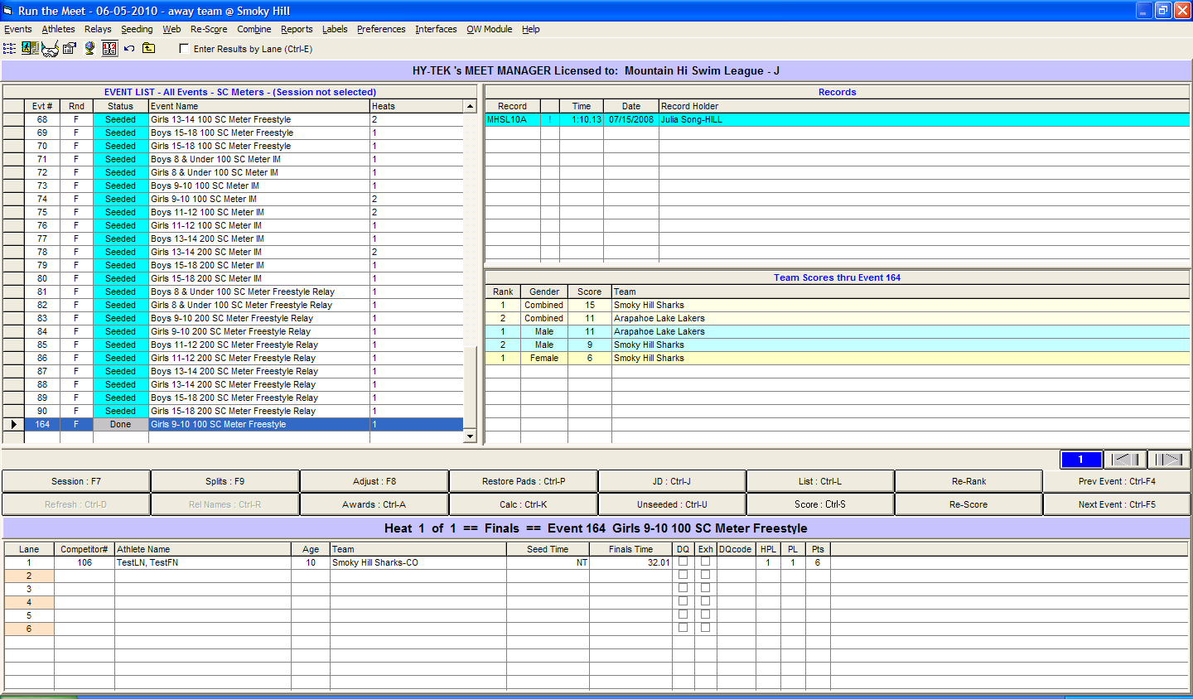

* + 1. Swim-Offs (during Prelims)

In Prelims, only the first 8 swimmers (in an 8-lane Championship pool) or the first 6 swimmers (in a 6-lane Championship pool) move on to the Finals. If during Prelims there is a tie for any of these spots, then a Swim-Off is required. The software should indicate that a swim-off is required in the results printout.

The winner of the Swim-Off retains the last spot, the loser is moved (using Judges Decision) to the next position. The times from the swim-off need to be recorded in a separate swim-off event.

To input Swim-Off times into the MM database file:

* From *Meet Manager* database File, Click “Run", "Events", then Highlight Event that required Swim-off – (for this demo, assume it was Event 20)
* Click "Add".
* In the New Window:
  + Name new event "120" (add 100 to original event)
  + "Rounds" - Click Timed Finals
  + "Assign Lanes" - Click Unseeded
  + Unclick Score Event
  + "Event Type" - choose Swim-off
  + Close Window;
* From "Run" menu, "adjust athletes" to add swimmers, input times from Swim-Off in the new event (Event 120).
* Use "Judges Decision" to place swimmers in the original event (Event 20).

1. TIMING AUTOMATED SYSTEMS
   1. Standard practices for dealing with timing discrepancies

* Terminology: Often referred to as a pickle, the semi-automatic timing device on a long cord that is plugged into the timing harness and has a plunger button on the top is called a button
* A timing discrepancy is defined as two different types of timing systems (started at approximately the same time and stopped when any part of the swimmer’s body touches the wall at the end of the race) have a difference greater than 30 one-hundredths of a second between each of the different timing devices for the final time on that lane for that race
* If timing adjustments on a heat change the finish order from the original data received, always check with the Starter for Order of Finish for that heat. If there is any concern that the data being used may need substantiating, use OOF as one of those resources
* Any time Calc is used for a timing adjustment on a heat:
* Make sure **all** lanes with data are checked “yes”
* Print out the calc report first, then click the “accept” button
* Document all decision making data points on the CTS printout or the calc page, including OOF
* If timing discrepancies continue over several heats on a specific lane or specific lanes:
* Have the head timer check with those lanes to verify proper instructions were understood for using the button
* If the issue is not operator error, check the pad or button for an equipment malfunction
* Always address the problem as quickly as possible
  1. Selecting Timing System

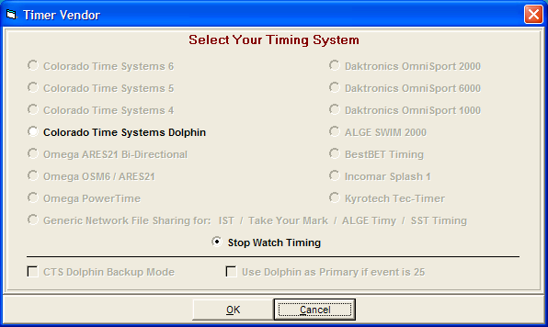

For Dolphins systems, switch your timing system from Stop Watches to Dolphin.

* 1. Dolphin Timing

|  |  |
| --- | --- |
| ***Possible Timing Situations*** | ***MM Response*** |
| Option #1: Pad and button times available for all lanes; no discrepancies between pad and button times. | No action required. Heat processing is finished. Move on to the next heat or finalize the event. |
| Option #2: Pad and button times available for all lanes, with discrepancies between pad and button times on one or several (but not all) lanes for that heat (lane malfunction). Manual watch times available for all lanes. | Check watch times on lanes with discrepancies.   * If pad time is confirmed to be correct, note on System 5/6 printout and enter one watch time in MM in either Backup 2 or Backup 3 column and delete the button time. ***Do not run Calc.*** Move away from the heat and then come back to check that the colored line has been removed. * If the button time is confirmed to be more correct, run calc procedures without entering watch times in MM. * If pad, button, and watch times do not agree, consult with Admin or Meet Ref for guidance. Check in with the coaches to see what times they have for their swimmers. |
| Option #3: Pad and button times available for all lanes, with discrepancies between pad and button times on all lanes (heat malfunction). | Determine, if possible, whether the timers are operating their buttons correctly. If they are, then check the equipment to see if everything is plugged into the correct places on the starting system. Fix any discoveries. To determine what system has the more correct time, compare the watch times with the data available to see if an answer can be found. If no consistent answer can be determined, treat each lane separately and proceed as noted above for the proper adjustment. Consult with the Meet Referee and verify OOF. |
| Option #4: Pad times available for all lanes with no button time for one or several (but not all) lanes. Manual watch times available for all lanes. | Check watch times for lanes without button times to see if they confirm pad time. If so, enter one watch time as Backup 2 or Backup 3 and ***do not run Calc.*** Heat processing is finished. If watch times do not confirm pad time, consult Meet Ref or Admin Ref/Timing Judge for guidance. Check OOF. |
| Option #5: Pad times available for all lanes with no button times for all lanes. Manual watch times available for all lanes. | Check watch times for lanes without button times to see if they confirm pad time. If so, enter one watch time as Backup 2 or Backup 3; ***do not run Calc.*** If watch times do not confirm pad time, consult Meet Ref/Admin Ref for guidance. Check OOF. |
| Option #6: Pad and button times available for all lanes with discrepancies between pad and button times on one or several (but not all) lanes. No manual watch times available for the lanes with discrepancies. | Check with coaches for times on their swimmers. See if the data supports one or the other timing systems. Consult Meet Ref and/or Admin Ref for guidance. Check OOF for supportive information. |
| Option #7: Pad times not available for one or several (but not all) lanes. Button times and manual watch times available for all lanes. | If the button time is confirmed by the watches, run Calc procedures without entering watch times in MM. If not, consult with Meet Ref and/or Admin Ref for guidance. Check OOF. |
| Option #8: Pad and button times not available for one or several (but not all) lanes. Manual watch times available for all lanes. | Enter the manual watch times in Backup 2 and Backup 3. Run Calc procedures outlined above. Check OOF. Consult with Meet Ref/Admin Ref for any questions. |
| Option #9: Pad and button times not available for all lanes (heat malfunction) in only one heat of an event. Manual watch times available for all lanes. | Enter the watch times in Backup 2 and Backup 3. Calculate the timing differential for the heat before and the heat after the one you are dealing with. Average the differentials and add (or subtract) that number to the calculated times for each lane. Document everything. Check OOF. Consult with Meet Ref/Admin Ref. |
| Automatic timing system not being used. Manual watch times available for all lanes. | Enter watch times as Backup 1, Backup 2, and Backup 3 (if three watches are being used). Run calc, print out calc screen before accepting results, and then accept calc. |

1. CLOSING OUT THE MEET

Send 1-Back-up and 2-Results files to the Team Manager / Meet Manager contact for all teams in the meet. The results file is used to import the meet into each team’s TM.

* 1. Create a Result File for Team Manager

Each team will need a file of results from the meet to import into *Team Manager*.

Select **File** from main menu bar. Then select **Export**. Under **Export** is **Results for *Team Manager***.

This will open up the “Export Results” window. It will give you several options to select. You will have the option of exporting both teams or just one of the teams. When you have selected the options, click **OK.** *Meet Manager* will notify you that the export has been completed and ask where it should put the file.

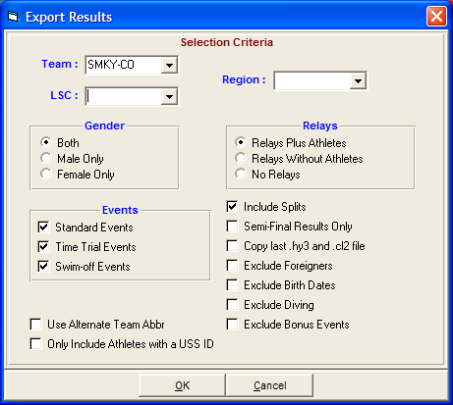

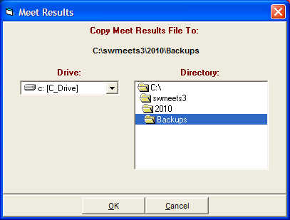

See the Team Manager guidelines for importing meet results into the team’s TM database.

* 1. Create a Backup for Away Team

Select **File** from main menu bar then **Backup**. Select the location.



* 1. Send Results to Division VP and Webmaster

Create Score report. Click on **Reports** from the “Run the Meet” menu bar. Click on **Score**. When finished selecting criteria, click **Create Report.** Save Report as PDF or copy for emailing.

Select the criteria for the report

**Age Range** – leave blank

**Report Type** – by Team

**Report Gender Choices** – Male / Female / Combine

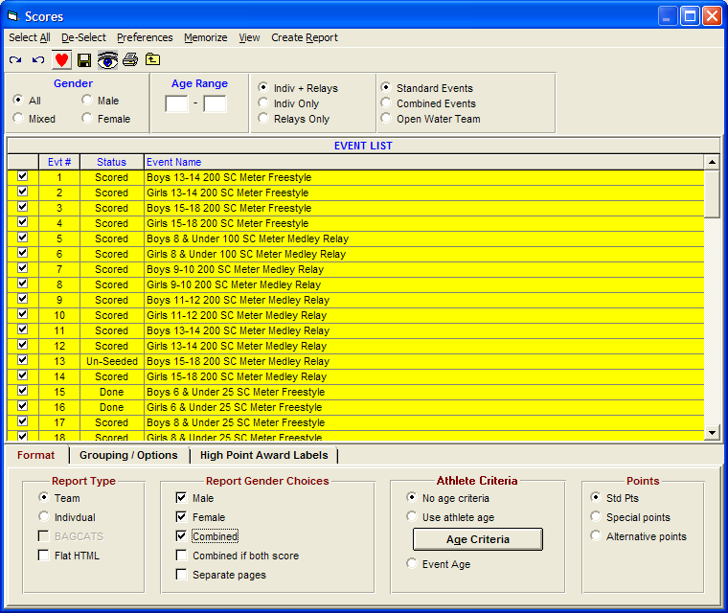

Send PDR or screen print to Division VP and Webmaster for posting by Sunday evening.

* 1. Print Ribbon Labels

Ribbon labels are printed on the Avery 1-inch labels. The labels can be printed while running the meet or later through *Team Manager*. Click on **Labels** from the “Run the Meet” menu bar. Click on **Award Labels**. When finished selecting criteria, click **Create Labels.** Preview the labels on the screen, *the preview will identify how many label sheets to insert into the printer*. Send to the printer by clicking on the printer icon.

Select the criteria for the labels you want printed

Select “Team” or leave blank for all in the meet

Select Range of Events for Labels

**Indiv + Relays**

Indiv Places – note default is 6, use ‘99’ for all swimmers

Relays Places – note default is 6, use ‘99’ for all swimmers

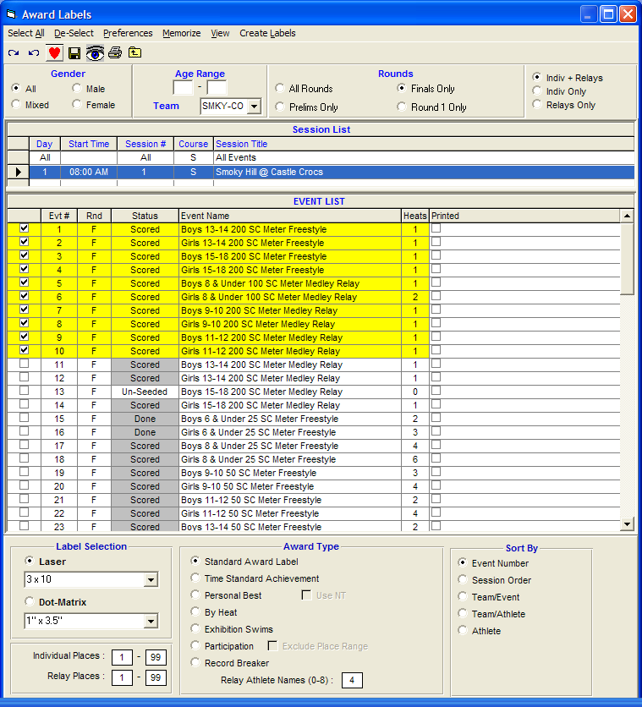

* 1. New League Record Submission

*Meet Manager* will flag potential new league records. To check for any new records, use the **Reports** – **Records / POP** form. “Select All” and select “MHSL10A” in the record field. This form should be included with the cards for establishing the records.

New league records must be submitted using the “League Record Submission” form to the MHSL Scoring Committee Chairperson no later than the Tuesday night of the week following the meet where the potential new record was swum.

Manual Timing

* Supportive hard copy documentation (deck cards and report) must accompany this form for the submitted information to be considered.
* Please complete the form in its entirety using a separate form for each record broken.
* Relays must include the names of all four (4) swimmers.

Electronic Timing

* Please complete the form in its entirety using a separate form for each record broken.
* Relays must include the names of all four (4) swimmers.
* Printout of electronic scoring results
* Have Signed by Meet Reference

Email a copy of this form with a backup copy of the *Meet Manager* database by the Tuesday after the meet to:

kcornelison@hrcaonline.org

The hard copy information (deck cards & this form) must be delivered, faxed or scanned and e-mailed as an attachment as quickly as possible to:

Kimsey Cornelison

8801 S. Broadway

Highlands Ranch, CO 80126

Fax: 303-791-0657

Mobile: 303-471-8942

*All of these hints originate from the “Run (the Meet)” screen*

**To Move kids in lanes or between heats:**

* Highlight Event
* Click on “Adjust”
* Move, Add or Delete heats from this screen

**To Scratch a swimmer out of an event:**

* Double-click on Swimmer

**To Score an event:**

* To score an event without printing a verification sheet for each individual race, click on “Ctrl S” on the middle menu bar after all times have been entered for each heat.
* To score an event or correct an event time and print a verification sheet to show the correction for that individual race, highlight the race, click on “score event” on the middle menu bar, then “print”.

**To add an athlete to an event:**

* Click on the “Adjust” (F8)  menu to middle menu bar
* Click  from the side menu bar – show eligible athletes
* Highlight Athlete name and drag to heat/lane

**If athlete is not on the roster (Add Athlete):**

* Verify Insurance form.
* Click on “Add Athlete”
* Type in registration info as asked for on screen – if no middle initial – use “*” for the middle initial place. The Registration ID will generate the Registration ID using formal name: Birthday, 1st 3 letters of 1st name, middle initial, 1st 4 letters of last name

Ex. Sally J Goodwin, born on 6/26/87 = 062687SALJGOOD

Ex. Paige Andrzejczak, born on 5/24/95 = 052495PAI*ANDR

* Make sure you’ve highlighted the correct team from the left hand team menu.
* Remember to click on “OK”

**To adjust swimmers in a relay:**

* Highlight race
* Click on “Relay Names” on middle menu
* Highlight team.
* Drag names with mouse.
* To add a young swimmer click on “Swim-Ups”

**Watch for Swim-Offs during Prelims!**

* If there is a tie for 8th place – (in an 8 lane pool, or for 6th in a 6 lane pool) – then the Score table needs to alert the Head Referee that a swim-off is needed.

**To add a team to a relay:**

* Click on Athlete
* Click on Relay
* Assign team letter (A, B, C, etc)
* Add athletes to the new relay team by double clicking on their names from the athlete menu.
* Assign Heat/Lane

**To change lanes in a heat:**

* Drag name to lane on main screen

*All of these hints originate from the Award Label Menu*

**To provide Award Labels for Heats, Age Group:**

* Click on Team
* Click on Age Range, if age group sensitive, for example all 10 & unders, input “0” (not 1) then 10 or 12
* Click Heat – if only “1” heat – deselect heat to avoid duplicate ribbons
* Click on Athlete to print alphabetically
* To not duplicate heat ribbons and overall ribbons – only select the heats that have multiple heats for heat awards.

**To count the number of ribbons for Overall Ribbons:**

* New Meet Manager Software has report to show the number of places, so ribbons may be provided to the away team.

**Suggestion for Running the Meet**

* Scoring Chairperson – the person in charge of the scoring table
* Timing Judges (2 volunteers) – process the deck cards by heat; determine the correct time for each swimmer; pull the times for the Dolphin watches and verify times against watch data
  + Organize by Heat / Lane Order
  + Circle the **median** finish time of the three times listed
  + If only two times are available, **average** the times without rounding up
  + If only one time is available, that is the official time
  + If times **in the same heat** are within 0.30 seconds (30 one hundredths) of each other, Order of Finish must be obtained
* Computer input (1-2 volunteers) – enter the times from the cards or pull the times from the Dolphin watches or buttons, depending upon the type of timing system
  + After approximately 10 events print out results (2 copies) for verification
* Score verifiers and ribbon label processors (1-2 volunteers)
  + Separate Cards by team
  + If all time check-out Post results
  + If there is a correction return to Computer input for correction

**Medley Swim Order**

* Relay – Backstroke, Breaststroke, Butterfly, Freestyle.
* Individual - Butterfly, Backstroke, Breaststroke, Freestyle

**Meter/Yard - To convert times:**

* Yards Time (in seconds) x 1.11 = Meters Time (in seconds)
* Meters Time (in seconds) /÷ 1.11 = Yards Time (in seconds)