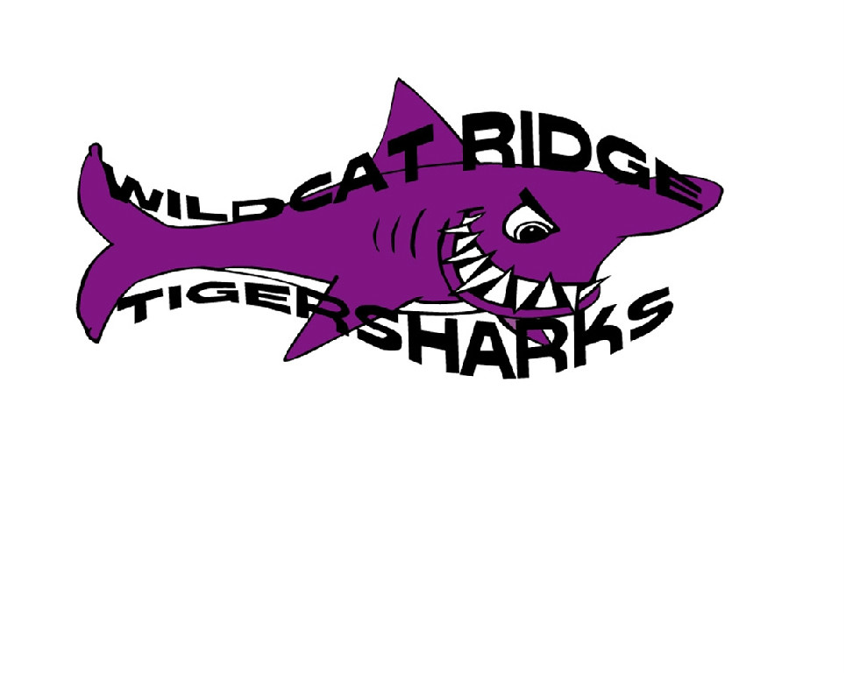
Wildcat Ridge Athletic Association
Tigersharks Swim Team Donation Form
Please complete the following information and submit a copy with your donation.

DONOR CONTACT INFORMATION (please print)
Name of Donor:

Individual or business

Contact Name:

Representing business

Address: | Address | City State | ZIP Code

Phone: |  | FAX:

Email

DONATION INFORMATION (please print)
Detailed Description of Donation:
Restrictions:
Estimated Fair Market value $:

DONATION DETAILS (Check all that apply)
Delivery: | I will deliver (please email questions via the “Contact Us” button at www.gotigersharks.org)
 | Please contact me to arrange pick up
Certificate: | I will provide gift certificate
 | Please create a gift certificate
Miscellaneous:
Thank you for your support. The Wildcat Ridge Athletic Association, Inc. (“WRAA”) is a Section 501(c)(3) nonprofit organization, Federal Tax ID No: 84-1470661. Your donation may qualify as a charitable deduction for federal income tax purposes; please consult your tax advisor. The WRAA Tigersharks summer swim club is run by parent volunteers and competes in the Mountain Hi Swim League.

