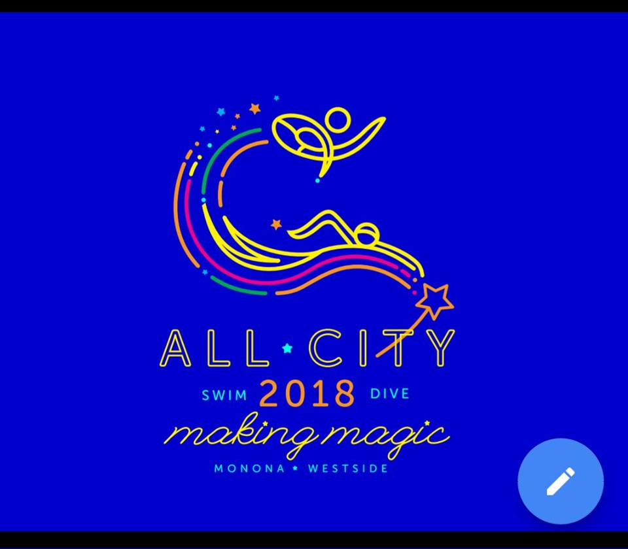

MO 2018 registration for returning families opens today!!
Don’t miss out on the opportunity to be part of this magical season. Practice groups will fill up. Upon registering, you will notice a volunteer commitment section. In order to complete registration, you will be required to acknowledge that you agree to volunteer at the All-City swim meet.
Each family will be required to volunteer for at least 3 shifts during the three-day event, July 26-28th. Additionally, it will be expected that each family assists with set-up the week before the event and take-down after the event.
Feel free to email Rhonda Holler-Steenhagen (rhollersteenhagen@gmail.com) or Anne Saloma (saloma06@gmail.com) if you have any questions or concerns. We are looking forward to seeing you on deck in just a few months!

