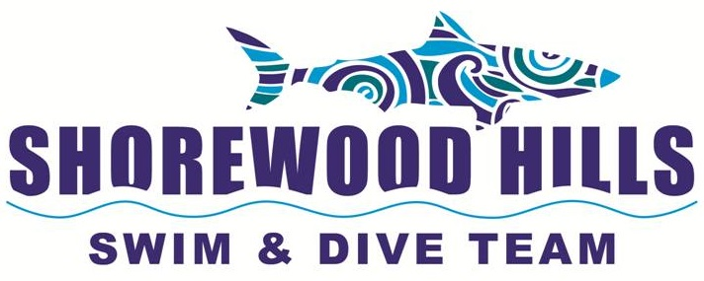

DIVE TEAM 101:
A Guide to Meets and the Sport of Diving

Goal of the Shorewood Dive Team:
To offer an opportunity for learning, advancing, and competing in the sport of diving in manner
that is both safe and fun!

What to Bring to a Meet:
- At least two towels and/or a Sammy to dry-off and keep warm
- Extra Clothing: If it is cool outside, it is nice to have a fleece blanket, sweats.
- Entertainment: cards are nice, but typically the kids socialize together.
- Water: Stay hydrated during the event!
- Snacks/Treats: Sharing with the team is a tradition-please make it peanut and nut-free.
Some kids make brownies/Rice Krispie treats, others bring lolly pops, fruit, etc.
- Concessions: The Shorewood Pool concessions stand is open during dive meets should you need a snack or drink for your diver.

What Time do Pre-Meet Warm Ups Begin?
Home dive meet warm ups begin at 3 pm. There is a 1 hour break while the away team warms up. The meet begins at 5 pm. Away meet warm ups begin at 4 pm at the meet location.

What is the Order of Events?
The 10 & Unders are the first to dive in a meet. The girls dive prior to the boys. Then the 11-12 year old divers compete, followed by the 13-14 year old divers. Last to dive are the 15 & older divers. Sometimes the last two age groups are combined in order to move the meet along more quickly.

What is a Required Dive?
The required dive is the first dive of the competion, and it is selected by the host pool coaches
prior to the meet. For example, the required dive for the first meet may be a forward dive. This
means that a diver must select from that dive group. So, an acceptable required dive could be a forward dive in pike position, a forward dive with 1 somersault, and so on. You can read more about dives below (Guide to Diving).

What are Optional Dives?
The remaining dives for a diver after the required dive are optional dives. The sum of dives
performed by a diver must come from at least 4 different groups of dives, and no more than 2 can come from any one dive group.

How Many Dives Does My Child Perform?
That depends on the age of your child as of June 1st of this year.
If your child is 10 and younger: 5 dives (but only needs to know 4 dives to join the team).
If your child is 11 and older: 6 dive (but only needs to know 5 dives to join the team).

How Does My Child Sign Up for a Dive Meet?
Have your child talk to the coaches early in the week. They will teach you child how to fill in an Individual Diver Score Sheet and help select dives for that diver.

If you would like to see a diver's score sheet, here is a link. It gives values for dives that are used to calculate scores. Again, the parent does not need to fill in this form.
http://allcityswimdive.org/_uploads/forms/p32tv-2012-13_Score_Sheet.pdf

How Long is a Dive Meet?
That depends on how many divers are competing. When Shorewood competes against a small team like Maple Bluff or Nakoma, a meet can be finished by 7 pm. When Shorewood competes against a larger team like Park Crest or Ridgewood, the meet may last until 8:30 pm or later.

Can't Volunteer for the Duration of the Meet?
Please consider volunteering during 1 or 2 age events (ie, 10 & under and/or 11-12). We can use your help to keep the meet running safely, effectively, and in a timely manner. Thanks!

Can My Child be on Swim Team too?
Yes, Shorewood has a number of Dual Athletes! Some kids practice their starts with the Swim
Team between 4 pm and 5 pm during home meets, but not during the actual meet.

Does My Child Need a Team Suit?
No, but if you want to purchase one, you may do so at Shorewood's swim suit vendor. The current vendor is listed on the team website, www.shorewoodswimanddive.com.

How Can I Get More Information about All City Dive?
Go to www.allcityswimdive.org and click on the All-City Dive link. Also, the coaches will send out loads of information about All City Dive as it approaches, and the swim and dive team website, www.shorewoodswimanddive.com has a link under Events for information about All City Week, and it is very informative.

Divers need to register early for this event, where divers from 12 pools compete over the two days. High school seniors receive recognition and gifts, and an amazing diving display by coaches and older divers usually cap off the event. It is truly a memorable event!

Who Do I Contact with Concerns and Questions?
You may contact the coaches at divecoach@shorewoodpool.com.
You may contact the Dive Parent/ Dive Meet Director at: diveparent@shorewoodpool.com.

How Do I Get Team Emails?
First you must be a member of the Shorewood pool. Once your pool fees have been paid, you may register for dive team at the Shorewood Swim & Dive Team website, www.shorewoodswimanddive.com. This registration, without fees, gets you on the roster to get emails about dive team. That's it.

GUIDE TO DIVING

TYPES OF DIVES
There are five different groups of dives that you may see on our springboards at Shorewood. The first four types involve rotating in different directions relative to the board and the starting
position, while the fifth group includes any dive with a twist and a sixth group involves an arm
stand starting position on the platform (but the dive team does not compete in this last dive
group).

1. Forward Group:
The diver faces the front of the board and rotates toward the water. Dives in this group vary from the simple front dive to the difficult forward four and one-half somersaults.

2. Backward Group:
All the dives in the backward group begin with the diver on the end of the board with his back to the water. The direction of rotation is away from the board.

3. Reverse Group:
These dives begin with the diver facing the front of the board (using a forward approach) and
rotating toward the board.

4. Inward Group:
The diver stands on the end of the board with his back to the water and rotates toward the board or opposite of the backward group's movement.

5. Twisting Group:
Any dive with a twist is included in this group. There are four types of twisting dives: forward,
backward, reverse, and inward. Because of the many possible combinations, this group includes more dives than any other.

BODY POSITIONS
When each type of dive is performed, the diver utilizes one or more of the four different types of body positions:

Tuck:
The body is bent at the waist and knees, the thighs are drawn to the chest while the heels are kept close to the buttocks.

Pike:
The legs are straight with the body bent at the waist. The arm position is dictated by the
particular dive being done or by the choice of the diver.

Straight:
This position requires that there be no bend at the waist or knees. However, there may be an arch in the back, depending on the dive. As in the pike position the arm placement is either the diver's choice or defined by the dive done.

Free:
This is not an actual body position but a term used to describe the diver's option to use any of the other three positions or combinations thereof when performing a dive which includes
somersaults and twists.

PERFORMANCE & JUDGING:
As you watch more and more diving, especially by talented performers, you will observe that
although several divers may do exactly the same dive, it never looks quite the same. This is
because each individual has different mannerisms, characteristics of movement, strengths and sense of timing-which all add up to an abstract but observable phenomenon called "style".

Style is difficult to assess by any standard, except whether or not you like it. This is why it is
hard to judge diving. Even though there are criteria of execution all divers must meet, evaluation remains a subjective process. No matter how well a dive is performed, artistic likes and dislikes of the judges play a large part in the outcome of any contest, and for this reason there are usually differences of opinion among coaches, competitors, judges and spectators about the accuracy of results.

A dive is scored between zero and 10 points in either full or ½ -point increments by each judge. At higher levels of diving, you can better and explain and classify the scores, but at the All-City level you will notice the younger kids – who are learning how to dive – get lower scores, and that the older kids tend to earn higher scores. As divers get older and get more experienced and improve their dives, their scores will increase.

You’ll see at meets there are 3 judges, and the judges are actually the coaches from both teams!

ELEMENTS OF A DIVE
In classifying a dive into one of the judging categories, certain parts of each dive must be
analyzed and evaluated, and an overall award obtained. The 5 parts of a dive are:

1. Approach:
Should be smooth but forceful, showing good form.

2. Takeoff:
Must show control and balance plus the proper angle of landing and leaving for the particular
dive being attempted.

3. Elevation:
The amount of spring or lift a diver receives from the takeoff greatly affects the appearance of
the dive. Since more height means more time, a higher dive generally affords greater accuracy and smoothness of movement.

4. Execution:
This is most important, for this is the dive. A judge watches for proper mechanical performance, technique, form and grace.

5. Entry:
The entry into the water is very significant because it is the last thing the judge sees and the part probably remembered best. The two criteria to be evaluated are the angle of entry, which should be near vertical, and the amount of splash, which should be as little as possible.

Individual Score Sheets for Divers:
If you would like to see a dive score sheet, here is a link. It gives values for dives that are used to calculate scores.
http://allcityswimdive.org/_uploads/forms/p32tv-2012-13_Score_Sheet.pdf

MORE INFORMATION:
If you are interested in more information about diving, you may find the National Federation of
State High School Association's Rules Book informative, as are websites such as
www.usadiving.org. These are the rules Shorewood follows as does the rest of the All-City
League. Additional All City League rules can be found on their website:
www.allcityswimdive.org
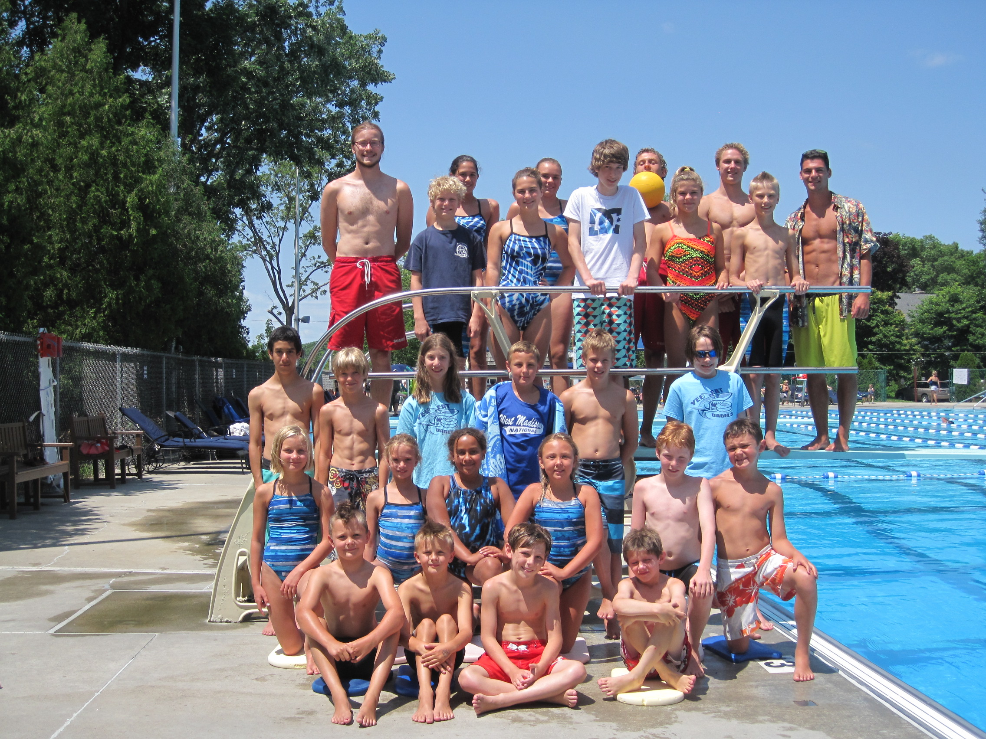
Summer 2014 Shorewood Hills Dive Team

