Briefing to MSL Board & Teams on 2014 MSL Championships

Welcome to the MSL CHAMPS meet for 2014. Swimarin is proud to be the meet host for 2014 and is looking forward to another exciting day of swimming. Thank you for attending this meet and encouraging our young stars. This information package has been designed to provide you with the necessary information to help you maximize your understanding and enjoyment of the CHAMPS meet.

- Parking:
  - LOT 1 (near the front of the campus) will be reserved for College of Marin students and NO event parking is allowed. No Parking on INDIAN HILLS ROAD as it is a narrow road and causes a fire hazard.
  - Any car parked in an illegal area (non-marked spot, red zone, motorcycle zone or handicapped parking) are subject to be ticketed and/or towed.
  - Parking will be first come first serve.
  - A “Drop Off Zone” will be available for the morning meet only to help families with the younger swimmers. There will be two lanes for drop off. Drivers may not get out of vehicle, so please have swimmers and belonging ready as you approach the Drop Off Zone.
  - Chaperones will be available to help bring swimmers and their belongings to their team tent while the driver leaves to park vehicle. PLEASE ENCOURAGE CARPOOLING and/or the use of a bicycle. Drop off, park, walk or bike in. At the end of each meet, please remember you may NOT cross the bridge(s) in a car or other motorized vehicle to pick up your swimmers or belongings.
  - Fire Road above Pool: There is no “camping” on the Fire Road.
**No tents, coolers, or chairs will be permitted. Standing room only to insure quick and easy removal should a Emergency Vehicle need to use the road.

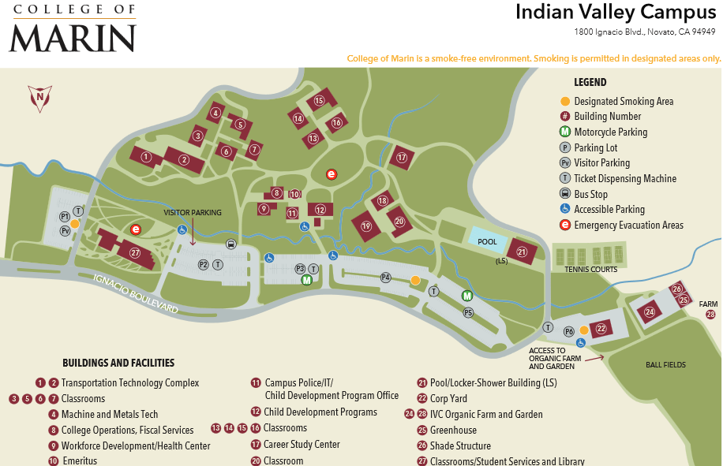
From Hwy 101

From Hwy 101

Drop Off Zone

- NO POSTING of team signs and spirit messages
  - ***Under no circumstances are we allowed to post signs outside the pool area, especially along Ignacio Boulevard and 101 by order of the Novato Police Department. We can post signs on the concrete wall within the pool area, NOT on the glass windows and NO chalk spirit writings are allowed at IVC.
- SPECTATORS:
  - Standing spectators will NOT be allowed on the deck area in front of the bleachers - for the AM meet only. There will be an isle for walking along the deck in front of the bleacher. This is for spectators to access the bleachers and to move between the deep and shallow ends of the pool. The remaining deck space will be roped off for the 8 & Under swimmers – to insure adequate space for fair starts, and to minimize confusion and anxiety for the swimmers.
- PREPARATION FOR SWIMMING
  - All timers, waiting swimmers, and coaches will be required to be behind the blocks (behind the red line) at the start of each race, on the blocks side of the pool, so that the area between the blocks is clear. This is to minimize confusion (among swimmers and Starters) and to provide the fairest possible start environment.
  - Fly-over starts will not be used for either the AM or PM meets. While they can be effective in some meet circumstances, the alternating deep/shallow starts at Champs provide adequate time for swimmers to exit the pool.
  - 8 & under disqualifications. S&T Officials will be instructed to write up all 8&Under DQs (since it they cannot accurately predict who will be among the 16 scoring swimmers). The respective Head Referee and Meet Desk will apply the DQs only to the scoring swimmers, according to MSL dual meet rules.
  - Swimwear: Meet Officials will enforce standing rules on legal swimwear (according to MSL rules, which follow established USA Swimming and FINA standards). Meet Officials will not be imposing restrictions on logos and insignia. There are no documented MSL rules on this, and USA Swimming rules (102.8) on this are rather permissive. Any protests will be handled via the existing MSL procedures. MSL follows USA Swimming rules on swimwear allowed for competition. In brief:-All swimsuits shall be made from textile materials (i.e. woven materials, water permeable)-For boys, the swimsuit shall not extend above the navel nor below the knees-For girls, the swimsuit shall not cover the neck or extend past the shoulders or below the knee-Swimsuits must comply with FINA swimsuit specifications.

- MEDICAL RESPONSE PLAN
  - On-call medically trained professionals will be available by cell phone and walkies throughout the entire meet. Contact information will be posted. The first response to any significant emergency will be to call 911.
- NATURE, PESTS, AND OUR TENTS
- Rattlesnakes and poison oak reported in the creek area at IVC – STAY OUT
  - Yellow jackets have been known to be pests at IVC-Be Cautious
  - No team tent set-up on the lawn Thurs. night. Tent set-up on Fri. or very early Sat.

- TEAM EQUIOPMENT :
  - Equipment check-in: Each team will be required to bring equipment to help run this meet. A separate email was already mailed to each team with team equipment assignments. Drop off of equipment will be Thursday eve, July 10th from 4 pm – 9 pm. Please very clearly mark every piece of equipment to be sure your team will get back what belongs to you. At the end of the meet every team has a break down crew to assist with the overall take down, this is your responsibility to have people assigned to this who know your stuff and can be sure they get back what you brought. After the meet, equipment will be returned to each team's area on the grass.
- LOST & FOUND
  - Lost & Found will be located at the Apparel/Information tent on the lawn. Contact information, pick-up instructions, and a deadline will be emailed to the teams following Champs. Items not picked up by the deadline are to be donated, or tossed out.

- TEAM PACKETS
  - Each team representative should come to the meet Saturday morning with a check for the entrance fees. A separate invoice will be emailed to each team representative during the bye week before champs. We will give the team packet which will contain meet info, heat sheets for the coaches, coaches food passes, & volunteer name badges. Please be sure that whoever is going to pick up the packet they have your check. We will be collecting checks and handing out team packets at the Gear Sales Concessions stand.

- OUR SEASON SWIMMERS
  - 10 Year Swimmers and Graduating Seniors
Each year, all 10 teams submit a list of their 10-year swimmers and also graduating swimmers for that season. The 10-year swimmer list is simply a list of those who have swum for 10 years with their MSL team. The graduating swimmers list includes a short paragraph for each of the swimmers who will be graduating out of the MSL, either because they are 18 or because they are leaving for college after the MSL season is over. It’s a nice tradition to acknowledge the swimmers who stayed with their MSL teams throughout their swimming career. Please make sure you get someone on board from your team to make this happen. Submissions can be sent to Peter Gebbie (gebbie59@comcast.net) with a header in the email: 10YR SWIMMERS and GRADUATING SENIORS<TEAM NAME>

Please create an email to send to your families which contains the important info above about parking and any other important info you think they will need from this doc: Below is helpful info you may want to send out also:

GENERAL CHAMPS INFO:

The Championship Swim Meet, where all the swimmers from all 10 Marin Swim League Swim Teams come to IVC Pool to compete. This is scheduled for Saturday, July 12th. 2014. It is essentially two meets run in one day. Scores compiled from both meets = final results at the end of the day with an awards ceremony.

The Heats will progress from slowest swimmers to fastest swimmers. Hence the fast heat is the last heat in that age group. The same format will be followed as in dual meets:
1.Medley Relays
2. Freestyle
3. Backstroke
4. Breaststroke
5. Butterfly
6. Individual Medley
7. Free Relays
ATTENTION: No one but swimmers and timers will be permitted behind the starting blocks. NO EXCEPTIONS

MEET PROGRAM

- The Morning Program (10 & Unders) - 8 & U Boys and 9 -10 Girls will swim in the Deep end of the pool. 8 & U Girls and 9 -10 Boys will swim in the Shallow end of the pool. All Relays will be swum in the deep end.

  - 8 & Under and 9-10 Warm-Ups
All 8 & Unders & 9-10 need to be at your Team Tent no later than 6:15 am. Warm-Ups start promptly at 6:30- 7:15 am. Meet begins at 7:30. All Medley Relay Team Members need to be ready, by their lane(s) by 7:15 am.

- The Afternoon Program (11 & Older) - 11 -12 Boys & Girls will swim in the Shallow end. The 13 & Older Boys & Girls will swim in the Deep end. All Relays will be swum in the deep end.

  - 11 & Olders Warm-Ups
All 11 & Olders need to be at your Team Tent no later than 12:45 pm. Warm-Ups start promptly at 1:00 - 1:45 pm. Meet begins at 2:00. All Medley Relay Team Members need to be ready, by their lane(s) by 1:45 pm.

- Awards:
- 12:00 noon, the high point awards will be given out to the 10 & under boy and girl winners of each age group.
- 6:00pm, awards will be given to high point swimmers in each age group, and top five championship teams.

- A Perspective for the Uninitiated
It helps to know a little about championships if you’ve never attended this meet before.
It can be confusing.
It will be crowded. (2000 swimmers, 600 volunteers and lots of spectators)
It’s always fun.

- TEAM LOCATION:
  - Each team will have a tent in the IVC field. Please keep the area outside your tent area clean.
- BLEACHERS:
  - Bleacher Area: There is no “camping” in the bleachers:
**No reserved seating (unused blankets, towels etc. will be removed). Signs will be placed on the wall above the bleacher area indicating that this is standing room only. Please advise all team members that we want to maximize everyone’s enjoyment and viewing pleasure.
**No folding chairs
**No tents, coolers etc.
This is important to insure that there is space for spectators in the bleacher area, since pool deck space will be limited, and roped off, during 8 & under events.

- 8& UNDERS- A NEW EXPERIENCE FOR SWIMMERS AND PARENTS
  - Especially for 8 & Under Parents: 8 & Under boys will swim in the deep end. The staging (lineup) area for 8 & under boys is the ramp at the deep end of the pool. 8 & under Girls will swim in the shallow end of the pool. The staging (lineup) area for 8 & under Girls is the road above the pool near the locker room. Please have your child at their line-up area no later than 7:15 am.
  - IT IS YOUR RESPONSIBILITY TO GET YOUR CHILD TO THE LINE UP SPOT. EXPLAIN THE IMPORTANCE TO THEM OF LISTENING TO THE LANE MARSHALS SO THEY WILL MAKE THEIR RACE!
  - MARSHALS AT THE STAGING AREAS WILL BE LINING UP CHILDREN FROM ALL 10 TEAMS AND WILL NOT KNOW YOUR CHILD!
  - Please help out by writing your child’s name in bold black letters on his or her swim cap. ALSO -WRITE YOUR CHILD'S RACE, LANE AND HEAT NUMBERS ON HIS/HER HAND. "L" for Lane and "H" for heat
Fr L4 H12 B L7 H15 Br L2 H4 FL L3 H5 IM L2 H6
  - If this is your first Championships, you will see that an event this size cannot take place without the cooperation of every parent and swimmer from each of the ten teams in the Marin Swim League.
  - We want to thank all our fabulous parents... at this time for their help and support.... See you at Championships.
Please remember that every swimmer and parent will be representing the Marin Swim League. Good sportsmanship is more important than a win any day!

Warm up lane assignments
 | Sleepy Hollow | Sleepy Hollow | Marinwood | Marinwood | Rolling Hills | Rolling Hills | Strawberry | Strawberry | Swim Marin | Swim Marin | XXXXXXXXXXXXX | Lucas Valley | Lucas Valley | Novato | Novato | Orcas | Orcas | Scott Valley | Scott Valley | Tidalwaves | Tidalwaves
Deep End | Gutter Lane | 9 | 8 | 7 | 6 | 5 | 4 | 3 | 2 | 1 | 10 XXXXXXXXXX | 9 | 8 | 7 | 6 | 5 | 4 | 3 | 2 | 1 | Gutter Lane | Shallow End

Facilities Outside Contact List
CONTACT | ROLE | PHONE | SCHEDULE
TOM EVERS | Pool Manager | 902-0064 (cell) | On and off AM/PM
TRACY THOMAS | Pool Supervisor | 747-0605 (cell) | All day
CAMPUS POLICE DISPATCH | Dispatch | 485-9696 | 24 hours and emergencies
MARCO MINOIA | Campus Police | 747-0663 (cell)  485-9455 (desk) | All day
TODD KIDDER | Campus Police Sergeant | 747-0651 (cell) | emergency contact only
MELINDA MALLOY | COM Business Office | 883-2211 x8101
HILLARY SHEPHARD | Novato Sanitary | 707-588-3684
JENNI | Conservation Corp | 415-827-2342
JOHN SINGER | METRO MOBILE COMMUNICATIONS | 650-367-1992
Novato  SNACK BAR | Catherine Falvey |  | falveyCF@aetna.com
Novato  SNACK BAR | Claudia Hernandez |  | Red41468@sbcglobal.net

SWIMARIN Contact List

Meet Host (Swimarin) Contact Information
 |  | 415 (unless otherwise stated)
Contact Role |  | CELL ONLY | E-Mail
Peter Gebbie | Champs Director | 342-9930 | Gebbie59@comcast.net
Andrew McCullough | Pool Meet Director | 613-0770 | Andrew_McCullough@150Pelican.com
Tanya Burdick | Awards | 250-2188 | tanya@theburdicks.com
Kris Kelson | Champs Gear | 350-6590 | kris_kelson@yahoo.com
Chas Thorpe | Equipment/facilities | 299-9017 | chas.thorp@gmail.com
Tom McCallister | Drop Off Zone | 819-8957 | thomas.mccallister@comcast.net
Monika Farrar | Meet Volunteer Coordinator | 250-2929 | ptmonika@yahoo.com
Rachelle Larson | Treasurer | 608-9908 | rachellelarson@comcast.net
Andrew Marrinson | Computer Desk |  | amarrinson@yahoo.com
Toby & Lotte Smith | Colorado | 596-5867 | tobys573@hotmail.com
 | Lead Line-up Marshall
 | Medical Response Team

College of Marin IVC POOL: Site Layout & Set Up

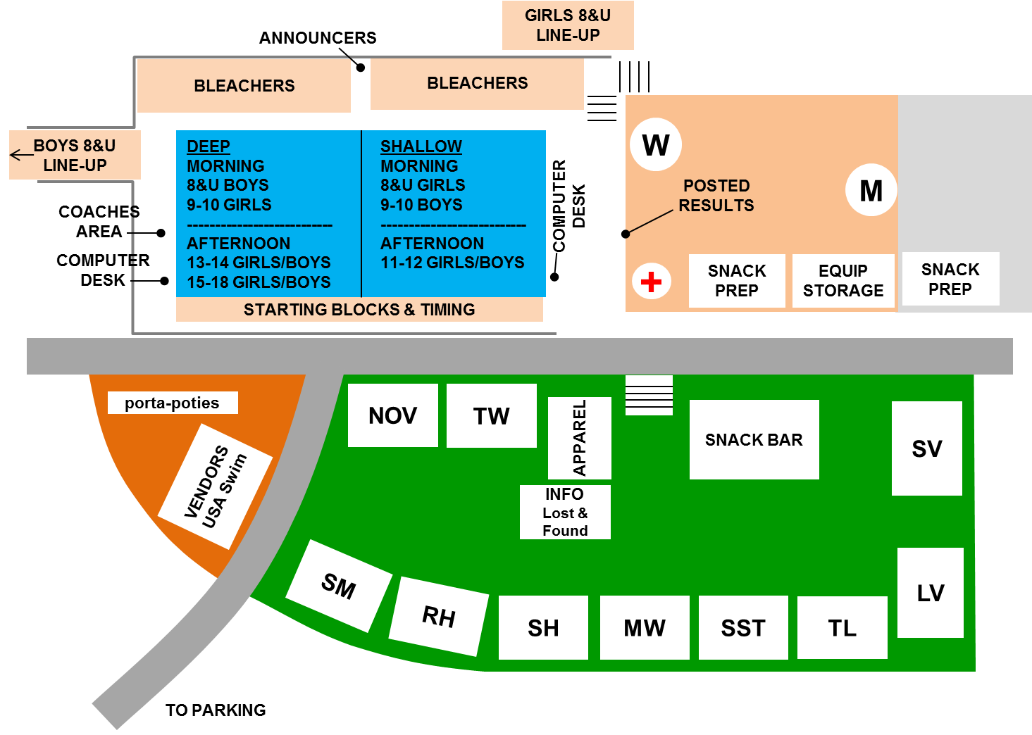

SM

RH

NOV

SST

TL

SH

MW

TW

SV

LV

Volunteers
Deadline to get all volunteer info entered into spread sheet is Tuesday, July 1st, after our last meet. The volunteer list has already been sent out to all team presidents and MSL team reps.A separate email to each team was already mailed assigning volunteers to each team. Below is a description of the key jobs and their responsibilities.

Head Referees

With the Meet Director(s), the Referee(s) presides over the meet with Assistant Referees, Stroke & Turn Judges, Announcers, Starters and all Head Coaches. Officiates the meet and arbitrates disputes. Experience required.

The Assistant Referee organizes all S&T Judges, Relay Exchange Judges, and Runners, attends Referee’s Meeting and reviews all deck assignments. Experience required.

Head Referee and Assistant Referee focus on officiating. Meet Directors will coordinate the operation of the meet, communicating directly with the Announcer, Starter, and officials on the other side of the pool to insure smooth transitions between the deep and shallow ends of the pool.

- Starters
The Starters attend the Referee meeting. Starters begin each race and call false starts. One starter system will be set up on each end on the bleacher side, positioned 10 yards down so that swimmers and timers in the farthest lanes can see clearly. A second starter system is set up on the blocks side, positioned 10 yards down to keep the starter blast away from the desk volunteers. The extra system on deck provides backup if necessary.

Sequence | Example | Comments
Announce Next Heat | “Next up, Heat #4” | Announce as soon as previous heat touches
Call Heat to Blocks  (into pool for backstroke) | “Heat #4 swimmers please step up on the blocks”  “Heat #4 swimmers in the water” | Call heat to the blocks (or in the water) as soon as possible – even as previous heat is getting out of the pool  This keeps the meet moving, focuses the attention of the swimmers, and gives them sufficient time on the blocks. Many adjust goggles, caps etc. only after they are on the blocks.  Look for indicator light on scoreboard, or sign from Desk that Colorado is set.
Repeat call  to swimmers and judges | “Heat #4 (50 yd. freestyle)”  “Timers and Judges Ready” | Raised hand indicates that you are starting
Start | “Swimmers take your marks”

- Develop your own pattern or style, but try to be consistent over the course of the meet. Swimmers quickly learn what to expect, and will anticipate the same instruction sequence for the next event
- Keep commands sharp and even-toned. Leave a break after the “marks” command to allow swimmers time to come down and hold. Don’t let the “marks” command blur into the actual start signal.
- Don’t let one swimmer control the start by being too slow to come down and hold. If necessary, stand the swimmers up (e.g. “swimmers please stand up”). Give explicit instructions to the swimmer at issue (e.g. “lane #4, please come down on my command” or “lane 5, can you hear me?”)
- How long to hold? Just long enough to insure that all swimmers are still.
- Soft focus, or focus at a distance to see all the lanes at once using peripheral vision. Don’t focus on individual lanes, or try to scan the lanes.
- False starts. This should be quick, otherwise the swimmers may not hear the false start signal. This will become instinctive to the point that you will be able to react even before the swimmers enter the water.
- First false start is called on an individual swimmer, and must be announced (e.g. “one false start on lane #7”) and verified with the referee. Second false start results in D.Q.
- Backstroke. Feet must be below the top of the gutter on the start. You may need to give explicit instructions to the swimmer at issue.

Stroke & Turn
Four judges at each end of the pool (two per side per end) ensure that the rules for each stroke, turn and finish are observed. Signed DQ slips are sent by way of the Runners to the desk. Relay Exchange Judges are positioned next to lanes 1 & 4 and 8 & 5 on the diving block side of the deep end. For eight and under races, Relay Judges are also positioned next to lanes 1 &4 and 8 & 5 on the bleacher side. Two signed dual confirmation forms are necessary for a relay DQ.

Head Line-up Marshall
THE JOB:
The job of the Head Line up Coordinator and crew is to get the under-8 swimmers lined up in the two waiting areas before their events—typically girls on the shallow side and boys on the deep side.
The Head Coordinator and crew then clear the walkways of parental traffic so the lane marshals can walk the swimmers down to their lanes in groups, sending down more groups as necessary.
THE CREW:
The Head Line up Coordinator typically has a crew of 6 assistants from the host team, as well as a group of lane marshals that come from all the teams. There are 3 lane marshals per lane for a total of 27 on the shallow side and 27 on the deep side, or 54 total.
ONE WEEK BEFORE THE MEET:
Send an email out to your crew letting them know what to expect, including a brief job description, and tell them to expect a 6 am orientation meeting. One on the girls side and one on the boys side.
Work with the meet directors to communicate to the parents that the bleachers are Standing Room Only.
Work with meet directors to get announcements onto announcer sheet. I think they needed a schedule to know what they need to announce: kids lining up for each event and that the marshalls need to be there as well. They also need to remember to repeat the announcement. Talk to last year’s crew to get schedule of announcements and review it for your team.
Work with the set up crew to make sure you have your gear:
- lane sheets—one set of sheets for each lane marshall. so 27 sets for girls, 27 sets for boys, a set for the 6 assistants and a set for the Head line up coordinator The lane marshalls don’t need more than just names of the girls in their lanes for each event. But the Head line up coordinator and the assistants should have the full set of data.
- 61 vests
- lane number signs on sticks, 2 signs per lane per side. So the girls side will have 18 signs, and the boys should have 18 signs.
- rope for parental traffic control. About 25 ft. long.
- Signs directing boys to deep end, and girls to area on the road behind the pool.
- Walkie talkies were nice
- Garbage can up at the girl’s area.

- FRIDAY SET-UP:
On Friday, mark out the waiting areas. One easy way to do this is to use green duct tape. Ask your set up crew to pick some up for you.
The girls are on the road behind the shallow side, and the boys are on the walkway just outside the deep end of the pool. See the diagram for how to arrange the lines.
Work with set-up crew to prep the swim area for traffic control.

- FRIDAY: PREPPING THE POOL SPACE
During Friday set-up, supervise your team’s set-up crew as they prep the bleacher side of the pool to get ready for the 8 under swimmers. The crew should set up two roped areas that run the length of the pool: one rope runs right next to the pool and has enough room for the waiting swimmer. No one else should be in that space. Once that swimmer has entered the water, the next swimmer should enter the space and wait for the signal to start the race. The lane marshall should be on the other side of the rope, but be prepared to physcially restrain the swimmer, so they don’t jump in when the other side starts.
The other roped area also runs the length of the pool, and has enough room for 4 or 5 swimmers as well as one lane marshall parent per lane. That second rope should leave about 5 feet of walkway before the bleachers begin.
:
- SATURDAY
Put enough vests and sticks for each lane there ahead of time.
Get one of the assistants to put up the signs directing the boys to the deep end of the pool and girls up the stairs. About 3-4 signs per side.
Hold an orientation meeting at each end, that is, one on the girl’s side and one on the boy’s side, to make sure all your lane marshalls are there, and know what to expect. Make sure they all have their gear and their name tags. You should have someone designated to run the meeting on the other side of the pool from where you are.

Line up Marshalls
LINING UP THE SWIMMERS
Once the announcers call for the 8 unders to line up the fun begins. Relay swimmers will head to the pool for their relay, then will join the line up. The line is arranged from slowest heat to fastest, (unlike the regular season in which heats are scheduled from fastest to slowest) so when the relay swimmers arrive, they head to the back of the line.
Shallow side:
The girls typically line up on the shallow side of the pool, up the stairs on the road behind the pool. There is enough room for five lines of girls on one side, and 4 lines of girls on the other side. See diagram.
The girls line up behind a lane marshall (LM) who is holding a number sign for their lane. All girls should be lined up before the event begins, except the relay swimmers as noted above. Each lane has 3 LMs for a total of 27 parent volunteers per side. LM #1 will stay at the road waiting area holding a lane number. LM#2 will walk the first group of girls down to the pool and stay down there to assist the swimmers getting ready to swim. LM #3 will walk small groups of girls down to the pool, and then return up to base camp for more girls as necessary. LM #3 will also hold a number sign. All LMs should have a list of girls who are in their lanes.
Deep end:
The boys line up on the deep end of the pool. Their line-up positions can be seen in the diagram. The deep end runs the same way as the shallow end, but does not have to fight parental traffic to get to the pool.

GETTING THE FIRST ROUND OF KIDS DOWN TO THE POOL:
When the time comes to get the swimmers to the pool, each lane sends a group of 4-5 swimmers down at a time. Begin with lane 9, as they have the farthest walk to get to their lane. LM#2 holding the number 9 lane sign will walk toward the pool with the swimmers behind her. Once they have passed, the LM#2 with the number 8 sign will follow with 4-5 swimmers, then 7 etc.
The boys should begin with lane 9, then 8, then 7 … as well.
The lane marshalls on the girls side must also get the parent traffic out of the way, so that kids can pass.

GETTING THE PARENT TRAFFIC OUT OF THE WAY
As the kids start coming down the stairs, designate a team to block off parent traffic.
Almost everyone was happy to wait while the girls were passing through.

GETTING THE NEXT FEW ROUNDS OF KIDS DOWN TO THE POOL
After the girls were lined up and the heats went on, when we were down to 4 heats we would send another batch down. It would vary depending on how fast or slow the heats were going. We usually sent down 4-5 heats at a time. The assistant by the pool should communicate with the Head line-up coordinator via walkie talkie and hand signals to decide when to send down another group. The HLC communicates with her assistant at the top of the hill to send down another batch.

DEALING WITH THE IM SWIMMERS.
Since IM swimmers need to start on the blocks side of the pool, the girls will need help getting through the crowd to the block side of the pool.
You need a group to help break a path so the girls can get through to other end of the pool.
Once the IM is over your job is through!

Head Timers
Responsible for holding timer meeting before each meet, giving instructions to timers and recorders and get timers in their places to insure a timely start of the meet.

Timers should also be instructed to help coordinate swimmers behind the blocks by calling out heats and swimmers names when the next heat is up.

- Announcer(s) & Event Coordinator

Experience required.

Morning shift Announcers are on hand at 6:30 am at the deep end of the pool. Afternoon Announcers are in position by 12:45 pm to direct arriving parents and children to volunteer meetings and warm-up lanes and to remind parents that information is posted at the field entrance and in programs. Announcers identify each event as requested by Meet Directors.

The announcers will be positioned mid-pool on the BLEACHER SIDE of the pool so they can have the best view of what’s happening in the pool. Announcers will announce swimmers in each heat after the start of the heat.

Swimmer announcements must be sharp, and brief, to avoid delaying the meet:
“lane 4, John Doe”
“lane 5, Mike Smith”

Do not squeeze in team names and other extraneous information.

- An Event Coordinator or Meet Director:
- Meet Directors will be positioned in front of the announcer’s desk to indicate using flags when each end’s starter is free to start the next heat.
- Reminder: the Meet Directors, in coordination with the Starters and Referees will run the meet, and the Announcers must follow, and fill in where there are gaps. Do not hold up the meet to announce. If necessary, pause and let the race start, then complete the announcement.
- An Event Coordinator will be positioned in front of the announcer’s desk to indicate using flags when each end’s starter is free to start the next heat. The Event Coordinator will relay instructions from the Meet Directors to the Announcers.

