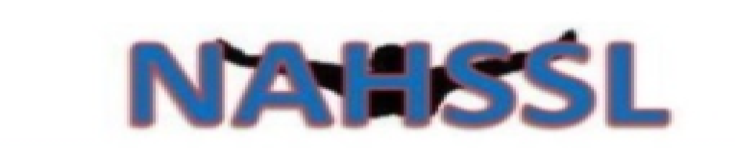
North Alabama High School Swim League
Scholarship Application – School Year 2022-23
Completely answer the following:
(Please type or print legibly)

Swimmer’s Name: _________________________________________________________________________________

Address: ___________________________________________________________________________________________

Phone: ____________________________________ Email: ________________________________________________

High School Name: ________________________________________________________________________________

High School Address: _____________________________________________________________________________

Senior Counselor’s Name: ________________________________________________________________________

Senior Counselor’s Office Phone Number: ______________________________________________________

High School Swim Team: _________________________________________________________________________

Swim Coach: _______________________________________________________________________________________

Phone #: _______________________________________ Email: __________________________________________

College Attending: ________________________________________________________________________________

College Swim Team Coach: _______________________________________________________________________

Phone #: _______________________________________ Email: __________________________________________

_________________________________________________________________________________________________________

North Alabama High School Swim League
Scholarship Application – School Year 2022-23

Parent(s)/Guardian(s) Name(s): ____________________________________________________________________

List parents(s)’/guardian(s)’ contribution (volunteer service) to the swim community:

__________________________________________________________________________________________________________
__________________________________________________________________________________________________________
__________________________________________________________________________________________________________
__________________________________________________________________________________________________________
__________________________________________________________________________________________________________
Phone #: _______________________________________ Email: __________________________________________

_________________________________________________________________________________________________________

Please list your personal accomplishments in swimming. Be sure to include sectional and state qualifying and finals accomplishments. Please list accomplishments on a separate sheet of paper.

_________________________________________________________________________________________________________

To be completed by Senior Guidance Counselor:
Student’s overall GPA: _________________________________________________________________________
Student’s academic program (AP, IB, Dual enrollment, etc): ________________________________
Is student on track to graduate on schedule with graduating class: _______________________
Signature: _____________________________________________ Date: _________________________________
*Guidance Counselor may choose to attach unofficial transcript
North Alabama High School Swim League
Scholarship Application – School Year 2021-22

____________________________________________________________

Provide two letters of recommendation:
- One letter of recommendation from your high school swim coach
- One letter of recommendation from someone outside the swim community. Someone who knows you outside of swimming.
____________________________________________________________

On separate paper, please complete the following:

Write a narrative about yourself and your future plans. Provide the committee with information about you. Please include:
- How membership in NAHSSL/participating in high school swimming has benefited you
- Why you should be considered for this award/scholarship

