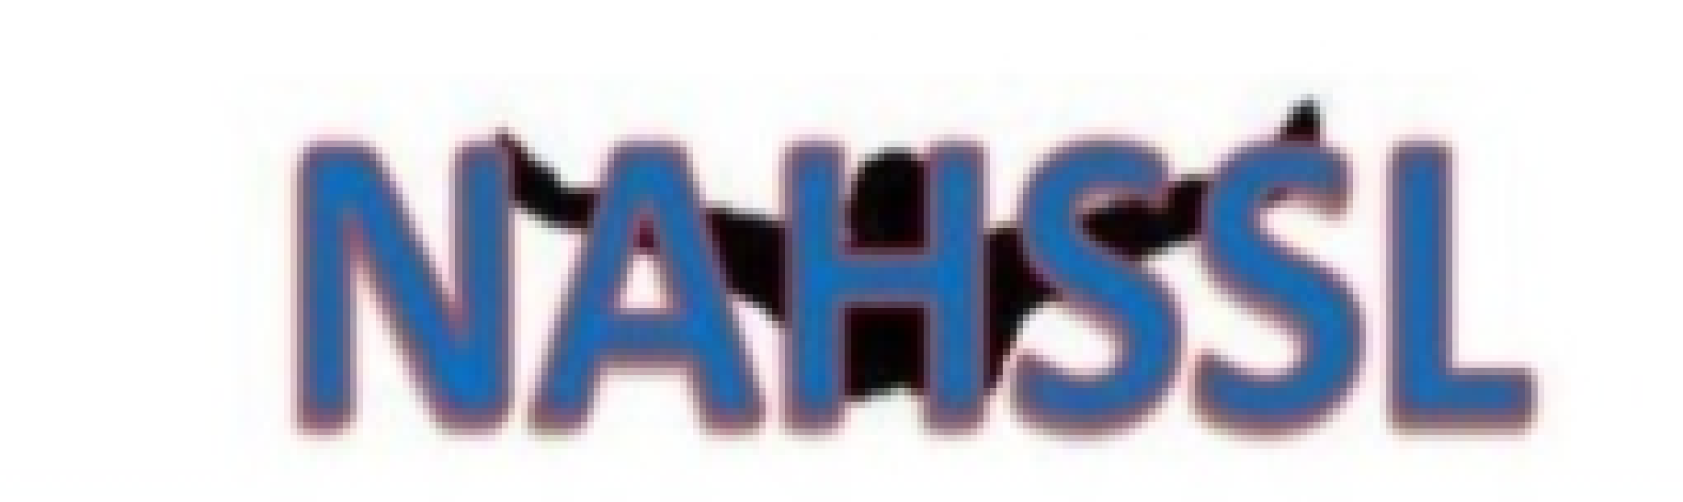
North Alabama High School Swim League
2022-23 Scholarship Application

- Complete the application packet. An incomplete packet will not be reviewed by the scholarship committee.

- Submit completed packet with all documentation by the scholarship deadline, to be received by April 1, 2023. Please do NOT staple scholarship packet.

- Send completed packet in large envelope, received by April 1, 2023, to:

NAHSSL
PO Box 18401
Huntsville, AL 35804

CHECKLIST

Completed application Swimming resume’ (accomplishments)
Unofficial transcript (optional)
Collegiate Coach letter with signed document – acceptance on team
Letter of recommendation – high school swim coach
Letter of recommendation – non-swim
Personal narrative

