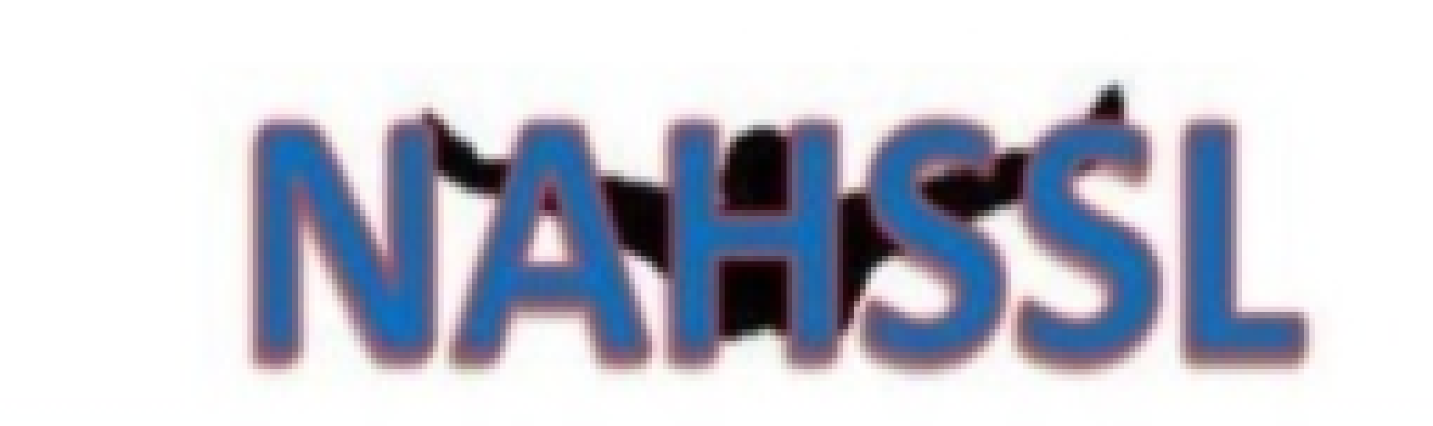
North Alabama High School Swim League
2022-23 Scholarship Eligibility

- Candidate must be a graduating senior in the class of 2023 from an accredited high school program; AND

- Candidate must be a member in good standing of a high school swim team with membership and good standing in the North Alabama High School Swim League; AND

- Candidate must have signed with a collegiate swim team prior to receiving scholarship award

