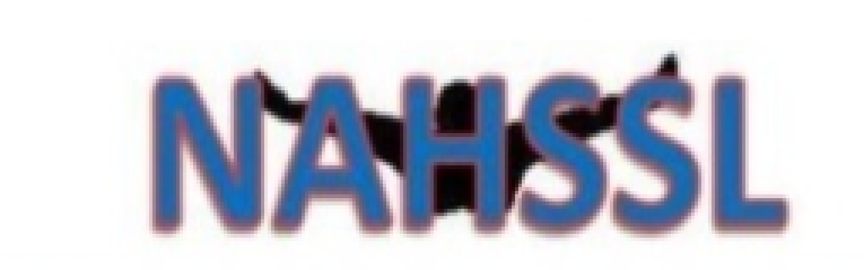
North Alabama High School Swim League

Jan. 1, 2023
To: NAHSSL League Members
Fm: NAHSSL Board
Re: NAHSSL Scholarship info

The North Alabama High School Swim League will award two $750.00 scholarships in the Spring of 2023. The scholarships will be awarded to one female swimmer and one male swimmer participating in high school swimming.
Eligibility requirements:
- Participated in high school swimming as a member of a NAHSSL team (high school team must be in good standing with the league).
- Committed to swim or dive on a university/college swim team as a scholarship or walk-on swimmer (must provide verification from college swim coach) for the 2021-22 season.
- Complete scholarship application packet
- Meet required deadline
All applications will be reviewed by a scholarship committee pre-appointed by the NAHSSL Board. The NAHSSL Board will follow all decisions and award scholarships as provided by the NAHSSL Scholarship Committee.
The NAHSSL Board will start accepting applications on January 1, 2023, and ALL completed applications should be received at the PO Box listed on the application on or before April 1, 2021.
The two NAHSSL Scholarship winners will be announced at the NAHSSL Coaches meeting in May.
If you have any questions, please do not hesitate to call Glenn Carr at 256-534-1604.

