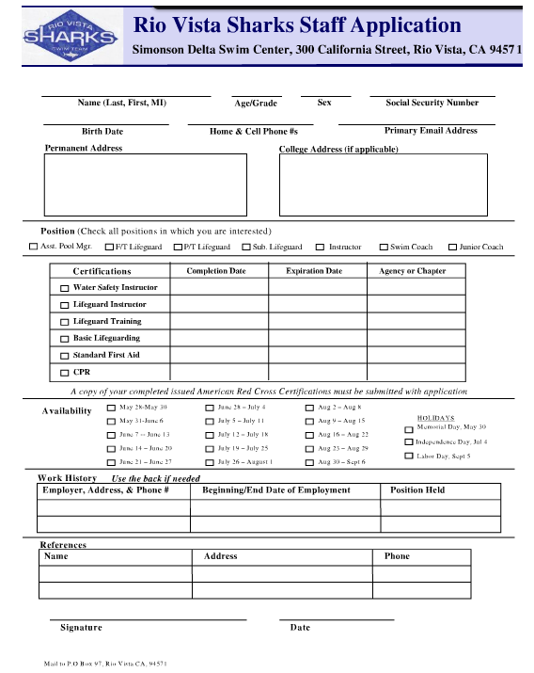

Open publication - Click the application and print it - More application

