Rio Rapids Annual T-Shirt Sponsorship

Please help support the 2016 Rio Del Oro Rapids Swim Team. Your advertisement helps purchase swim equipment and keeps this healthy activity affordable. We generally have about 250 swimmers who can help promote your business all year.

1 Spot $500
1 Spot $500

6 Spots
$400

$300
9 Spots

spots to fill fast!

Please count me in. I would like to advertise on the Rio Rapids T-­Shirt
-­‐-­‐-­‐-­‐-­‐-­‐-­‐-­‐-­‐-­‐-­‐-­‐-­‐-­‐-­‐-­‐-­‐-­‐-­‐-­‐-­‐-­‐-­‐-­‐-­‐-­‐-­‐-­‐-­‐-­‐-­‐-­‐-­‐-­‐-­‐-­‐-­‐-­‐-­‐-­‐-­‐-­‐-­‐-­‐-­‐-­‐-­‐-­‐-­‐-­‐-­‐-­‐-­‐-­‐-­‐-­‐-­‐-­‐-­‐-­‐-­‐-­‐-­‐-­‐-­‐-­‐-­‐-­‐-­‐-­‐-­‐-­‐-­‐-­‐-­‐-­‐-­‐-­‐-­‐-­‐-­‐-­‐-­‐-­‐-­‐-­‐-­‐-­‐-­‐-­‐-­‐-­‐-­‐-­‐-­‐-­‐-­‐-­‐-­‐-­‐-­‐-­‐-­‐-­‐-­‐-­‐-­‐-­‐ Please complete the information below and mail or deliver to the Rio Del Oro Racquet Club (119 Scripps Drive Sacramento CA 95825) along with your check made payable
to the Rio Del Oro.
Name

$500 Logo Spot

$400 Logo Spot

$300 Logo Spot
Business Name

Address

Phone Number

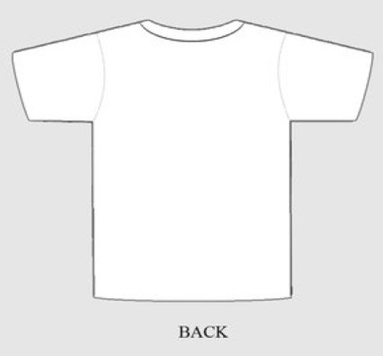
Come Swim with us. Clinics Start in March and Swim Team Starts April 4th. Register at www.riorapids.com
Come Swim with us. Clinics Start in March and Swim Team Starts April 4th. Register at www.riorapids.com
Email Address

Please email CLWheelerDC@cs.com for more information or call 916-213-1247.
We will contact you for copy of your logo. Acceptable logo formats JPEG, TIFF or PDF.

