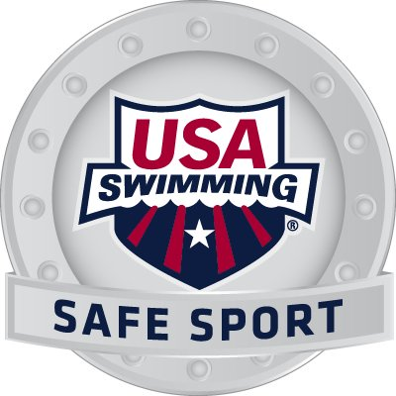 | SAFE SPORT  Contacts and Responsiblities | 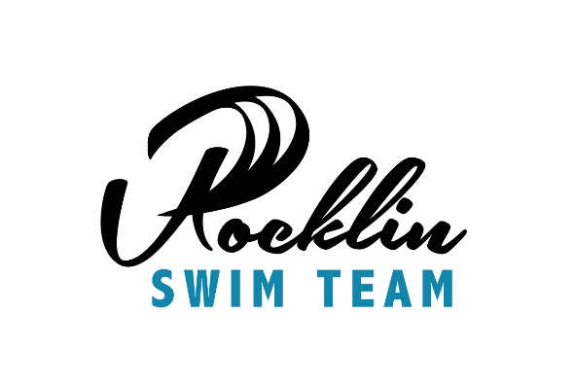

Who do I contact if I have a Safe Sport question or concern?
- Rocklin Swim Team Director Contact:
Chris Stehula, cell 805-704-4484, RSTdirector@rocklinswimteam.org
- Safe Sport Coordinator:
Patricia Hill, cell 916-768-4739, secretary@ rocklinswimteam.org
- USA Swimming 719-866-4578 and US Center for Safe Sport 833-587-7233
- Additional reporting at http://www.uscenterforsafesport.org/
What is the team athlete/family responsibility?
- See something, say something.
- Photography, Instagram, Snapchat, privacy for all.
- All communication with peers, coaches, officials, should be as a rule of thumb, open and observable.
- Support your team culture and know your team’s safe sport policies.

