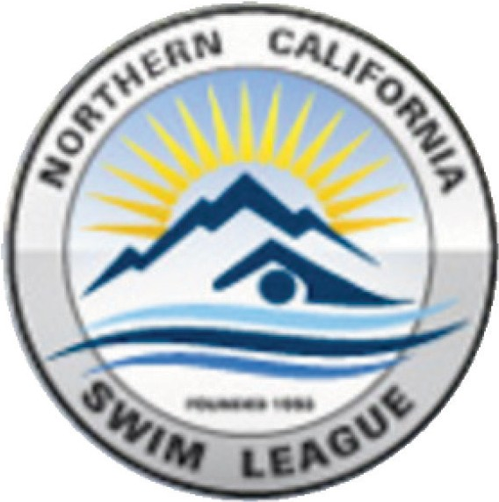
2021 January Meeting
Northern California Swim League:
Board of Directors Meeting
January 27 7:00 pm

Attention NorCal Swim League clubs:

NCSL Board has reviewed and voted on two separate By-law proposals, 11.01 & 12.05 and 12.03.

By-law, 12.03, was presented in December board meeting and 11.03 was presented on the January 14th special meeting.

The first by-law proposal was 12.03, the 19-year-old exemption for the 2021 recreation season. This proposal allowed the 18-year-olds that have turned 19 to compete in 2021 due to the canceled 2020 COVID season. This 2021 exemption was voted on and passed on January 27th meeting. See attached by-law.

The second vote was on the 11.03 and 12.05 proposal to allow swimmers to swim until recreation registration deadline/practice was set by NCSL. Meaning, if swimmers swam or practiced during the months of February and March or even April, there will be no penalties or restrictions that will prevent them from registering and participating in the 2021 recreation season. This proposal/exemption to by-law 11.03-12.06, allows those swimmers who swam during the months before the 2021 season to be able to register with the NCSL league and swim the NCSL recreation 2021 season.

The By-law 11.03-12.05 exemption was passed on January 27th board meeting. Please see attached document.

If you have any questions of comments, please contact your club representative.

Cory Stowell
President
Nor Cal Swim League

p.p. Steve Sahs
NCSL Secretary

1/30/2021

