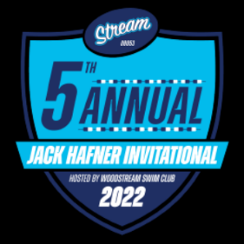
Family Advertisements

Special Pricing for Family Advertisements
We have created special pricing for friends and relatives of participating Jack Hafner swimmers who wish to show their support.

All ads printed in black and white and grayscale. Ads should be submitted to size in PDF, tif or jpeg formats; resolution 300 dpi or higher. Please submit by Tuesday July 15th.

Submit Family Ads and tweets to: Hafnermeet2022@gmail.com
Contact: _________________________________________________________
Email: _________________________________________________________
Address: _________________________________________________________
Phone #: _________________________________________________________
Swim Club: _________________________________________________________
Please select desired ad size from selections below:

 |  | Ad Type | Cost | Size
 |  | Full Page Ad | $80.00 | 10" H x 7.5 W
 |  | Half Page | $50.00 | 5" H x 7.5" W
 |  | Quarter Page | $35.00 | 5" H X 3.75 W
 |  | Business Card | $25.00 | 2" H x 3" W
 |  | Shout Outs | $15.00 | Two Lines, 7.5" Wide
 |  | * up to 178, 12 Point Characters including spaces

Enclosed Amount $____________________________

Please make checks payable to Woodstream Swim Club
Mail to Don Antonelli: 39 Charter Oak Ln Marlton NJ 08053
Phone contact: 609-678-6939

