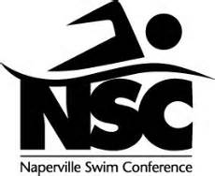

First Annual Fundraiser

Please come and support the Naperville Swim Conference by dining at Red Robin Wednesday June 10, 2015. 10% of all food sales will be donated back to the NSC. You must print this flyer and present it to your server for us to get credit from the sale.

Red Robin Cantera
28260 Diehl Road
Warrenville, IL. 60555
(630) 836-8870

Brookdale, Cress Creek Country Club, Cress Creek Commons, Hobson West, Huntington, Naperville Tennis Club Swim Team, Saybrook, YMCA

All monies raised will be used to offset the fees from our end of the season championship meets. Your support is greatly appreciated.

