Warrior Swim Team
2014 Swim Suits & Caps
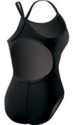
TYR Solid Durafast™ Diamondfit (20-40)
$55 – Price includes Logo and shipping

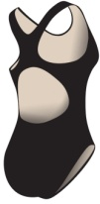
TYR Solid Durafast™ Maxfit (20-40)
$55 – Price includes Logo and shipping

*Logo on front chest

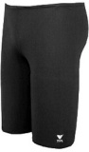
TYR Solid Durafast(TM) Jammer (22-40)
$40 – Price includes Logo and shipping

*Logo on front lower right leg

A Latex cap is included in swim fees. Additional latex caps and/or silicone caps are available for purchase. Caps will be white with team logo.
Latex caps $3
Silicone caps $7
Set of 2 silicone caps with personalization $20
If ordering personalized silicone caps please print personalization below:

________________________
________________________
________________________
Family Name: ___________________

Size(s) ordered: ________________
Subtotal (# of suits x $55) _________________

Size(s) ordered: ________________
Subtotal (# of suits x $55) _________________

Size(s) ordered: ________________
Subtotal (# of suits x $40) _________________

Additional latex caps: _______
Subtotal (# of latex caps x $3) _________
Silicone caps: _______
Subtotal (# of silicone caps x $7) _________
Personalized Silicone caps: _______
Subtotal (# of personalized caps x $20) _________

Total Purchase Amount: ________
Check # ___________
All sales tax and shipping is included. Payable by check to:
White Eagle Swim Team

