Warrior Swim Team
2015 Swim Suits & Caps
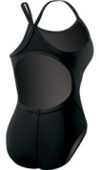
TYR Solid Durafast™ Diamondfit (22-40)
$52 – Price includes Logo, tax, and shipping

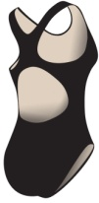
TYR Solid Durafast™ Maxfit (22-40)
$52 – Price includes Logo, tax, and shipping

*Logo on front chest

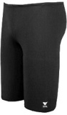
TYR Solid Durafast(TM) Jammer (22-38)
$38 – Price includes Logo, tax, and shipping

*Logo on front lower right leg

A Latex cap is included in swim fees. Additional latex caps and/or silicone caps are available for purchase. Caps will be silver with team logo. Caps can only be purchased with team order.
Latex caps $4
Silicone caps $11
Set of 2 silicone caps with single name personalization $28
If ordering personalized silicone caps please print personalization below:
________________________
________________________
________________________
Family Name: ___________________

Size(s) ordered: ________________
Subtotal (# of suits x $52) _________________

Size(s) ordered: ________________
Subtotal (# of suits x $52) _________________

Size(s) ordered: ________________
Subtotal (# of suits x $38) _________________

Additional latex caps: _______
Subtotal (# of latex caps x $4) _________
Silicone caps: _______
Subtotal (# of silicone caps x $11) _________
Personalized Silicone caps: _______
Subtotal (# of personalized caps x $28) _________

Total Purchase Amount: ________
Check # ___________
All sales tax and shipping is included. Payable by check to:
White Eagle Swim Team

