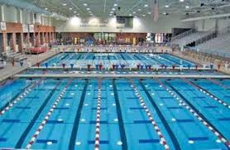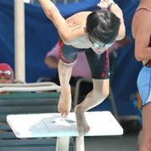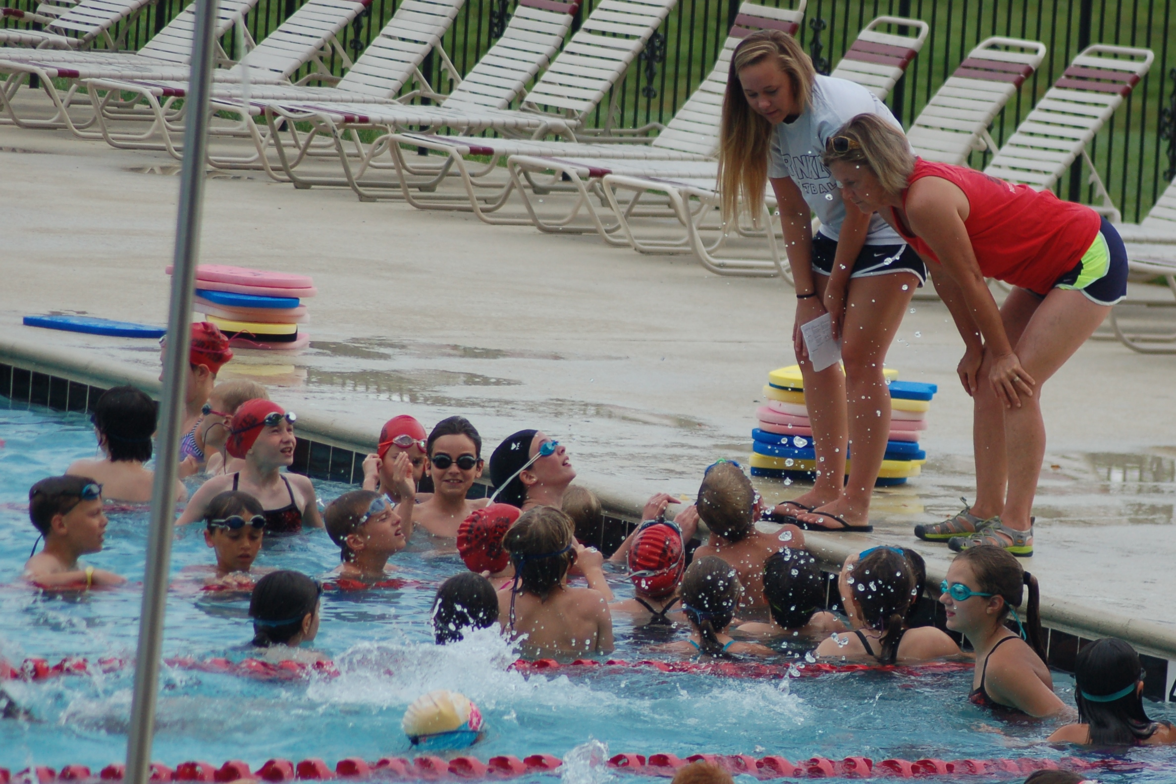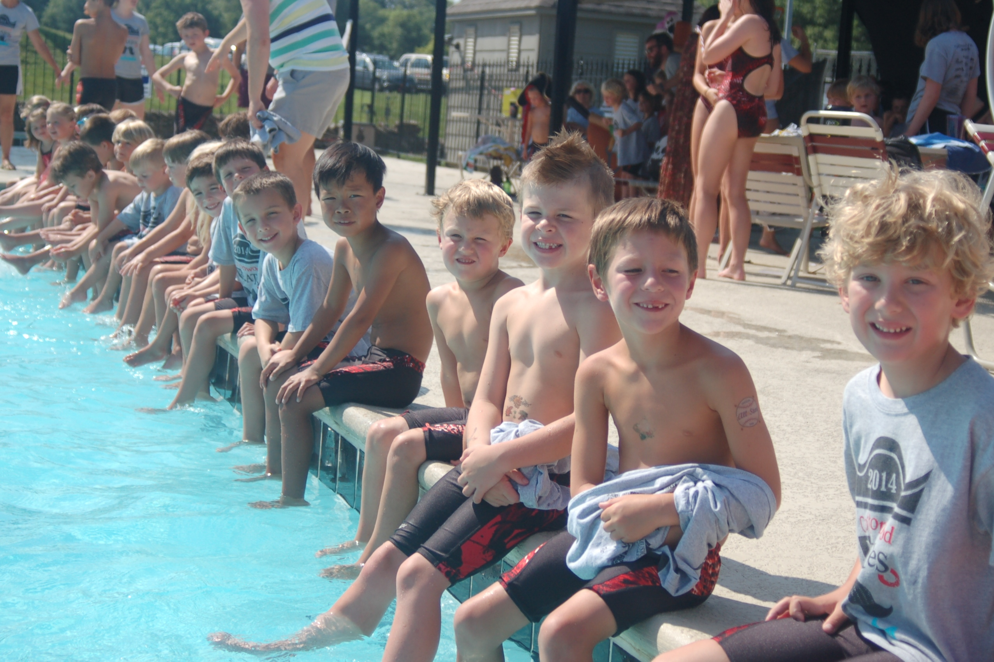

# Making memories for a lifetime

The Nashville Swim League City Meet will be held at the Sportsplex in midtown Nashville **July 8-10**. The meet, which features teams competing within their divisions, is divided into age groups. With all of our help, it will be an exciting and memorable event for each of the swimmers.

Mark your calendars for the annual 4th of July barbeque benefitting the Cottonwood Pirates,which will be held on **July 4th** this year!

**Mark your calendars for the annual 4th of July barbeque benefitting the Cottonwood Pirates, which will be held on July 4th this year!**

##### The Cottonwood neighborhood is special for a variety of reasons but there’s no reason greater than the little and big Pirates that make up the swim team. The team’s season launches Monday, May 23, with practice every weekday (weather permitting). The swim season will conclude with the Nashville Swim League City Meet July 8th – 10th.

##### The Pirates will gather to celebrate their successful season on July 12th.

Team registration signups can only be completed online at cottonwoodpirates.com. Registration and payments are to be made by May 1.   
 Team and practice swimsuits and other swim gear are available through All-American Swim Shop in Brentwood. You don’t have to buy a new suit every year.   
 Keep up-to-date on swim team news by visiting cottonwoodpirates.com. The website is your Pirate portal for meet sign-ups, registration, and volunteer opportunities.  
 It’s a short season but we’ll do our best to keep you connected with emails and through social media. There will be file folder at the pool for every swim family. Check it often for info. Stay in touch!

**the ye olde Pirate gazette**

## **Swim practice: What to expect**

Participating in swim practice, which begins Monday, May 23, is expected and is critically important for swimmers. Each day is important as swimmers learn new strokes and skills and take part in conditioning drills.

Help your swimmer have a positive experience at practice by insuring they have their towel, goggles, and water bottle. And don’t forget the sunscreen!

If you have a young swimmer, please stay for their practice. But know that, for your child’s sake, parents aren’t allowed on the pool deck during practice. For the first week, it’s helpful to the coaches if you write your young swimmer’s first and last name on their shoulder.

Swimmers practice Monday through Friday (Tuesdays are meet days) from 8:00 am to 11:30 am. Practice times are posted elsewhere. There is no practice Memorial Day, Monday, May 30.

If there is dangerous weather in the area (thunder heard or lightning seen), swimmers will be moved from the pool deck to a safe area for a minimum of 30 minutes.

The Red & Black Practice Meet will be held at the CW pool on the morning of **June 1**. This practice meet allows swimmers, coaches, officials, and parents to get ready for the season.

The first official Pirate event of the season is the ice cream social on Sunday, **May 22**. You’ll have a a chance to fellowship with swim families and meet your coaches.

Don’t let your little Pirates miss the boat. Deadline for registration and payments is **May 1**. Late registration with a penalty is May 7. The late fee is $25.00.

Visit cottonwoodpirates.com!

Summer 2016

### Upcoming events

**Can any Cottonwood (4-18) child join the swim team?**That’s a great question. It’s worth noting that ‘swim lessons’ are not a part of the team experience. It is desirable that a child ‘know’ a stroke and must be able to swim unassisted across the pool by the second meet of the season. We want this to be a good experience, not a frightening memory in the pool. There are opportunities for swim lessons during the summer.

**How much does it cost?**If you have one child, the cost is $135. The fee includes one official Cottonwood Pirate t-shirt. And it includes a silicone cap, ribbons, trophy, practices, all dual and City Meet fees, and a team picture plus lots of fun. Checks for fees go to Emily Butler. Official Pirate shirts in adult sizes can be ordered. It is important to note that a family’s HOA dues must be current in order for their swimmers to participate. That’s a neighborhood rule.

**What will my child need?**Swimmers need a competition swimsuit and a practice suit. They will need a towel, goggles, water bottle, sunscreen, and, hopefully, a cheerful disposition for each practice.

**Do you need any volunteers?**  
Well, thanks for asking! The Pirates are your neighborhood team. Volunteers are the backbone of the operation. Actually each family is expected to fulfill a minimal volunteer obligation. The bottom line: It’s all about the swimmers! And it really is FUN to serve with your friends and neighbors.

**What happens after swim meets?**

Pirates love to celebrate their accomplishments. So on Tuesday nights during the season we gather at the food court at the Cool Springs Galleria for fun and merriment. Chick-fil-A offers a Spirit Night for the team.

## You might have some questions...

## **How to prepare for a swim meet: Permanent markers, a good night’s sleep, and more**

The Red and Black practice meet (June 1) may be the most important meet of the season. It gives coaches an idea of ‘where’ the swimmers are and it allows you to practice getting your swimmer ready before the first ‘real’ meet the following week.  
 The team will participate in four dual meets and the City Meet. While parents are responsible for signing their swimmers up for each meet online, the coaching staff will make the final decision on what events each swimmer will swim.

Swimmers need to arrive on-time at the pool ready to swim. The pool deck can be a hectic place at times, so it’s best to be as prepared as possible. A good night’s sleep for your swimmer (and you) helps!

Information on the events (including heats and lanes) your swimmer will be swimming will be posted online the night before a meet and, at home meets, on the pool house wall (near the slide) the morning of the meet. Make sure your confirm your child’s event info when you get to the pool, sometimes the information changes after it is posted online.

If you have a younger swimmer, you’ll want to check out the **“First Time at a Swim Meet”** information sheet to learn why (and how) you’ll be using a permanent marker on your swimmer before every meet.

While it might not be clear to those watching, swimmers are placed in events to best complement the team and for their individual performance. It’s a bit of science and a bit of artistry at times!

The coaching staff has your child’s best interests in mind. It’s usually not helpful to contact the coach or a board member to complain about the events your child is (or is not) swimming, particularly at a meet. If you have an interest in the coach’s decision, she’ll be glad to hear your concerns and to explain the strategy behind the decision at the right time.  
 Please, don’t let your swimmer leave a meet early without checking with the head coach. There may be a need for them in a relay later.

* 1. AM meets – Lisa Lowery
  2. PM meets – Melissa Ericson

successes.

* 1. a meet, update your status on line.
  2. It is really best to leave non-swimming siblings at home with a sitter. It’s just too hard to keep the little ones out of the baby pools and for you to give your swimmer the attention they need at the meets.
  3. Please check with a coach before leaving a meet, you might not be finished!

**There is a proud tradition among Pirates–we’re a team that supports and encourages one another. Whether a champion or a novice, each swimmer is valuable and deserving of everyone’s respect.   
No Pirate walks   
the plank alone!**

There’s no denying the fact that swimming can be hard work. The Pirate coaching staff recognizes that most of the swimmers don’t do a lot of swimming the other 46 weeks of the year, so they gradually and intentionally increase the workouts for the swimmers during the season.

But Coach Marla knows there’s a time for work and there’s time for fun! It’s her hope that each swimmer will gain a love for the sport that endures throughout their life.

In addition to working on their strokes, swimmers will get to hone their cheering skills and have plenty of opportunity to laugh at every practice. Meets are even fun for the swimmers (and for us parents with good attitudes.) And there’s plenty of fun for the families too. (Thanks to volunteers!) Here’s a sampling of Pirate fun:

* Thrilling Thursday
* Hunt Brothers Pizza Night
* Meeting at the Cool Springs Galleria food court at 6:00 after every dual meet
* Age group socials
* Getting hooked (If you don’t know, you’ll need to ask.)
* Kids Swimming for Kids
* Smiling faces at every practice
* And the bittersweet Pirate End of Season Awards Banquet!

We will make sure you have the training you need. We hope you will find somewhere new and exciting to serve. There are plenty of needs! For some of the positions, specifically stroke and turn judge. There will be “live” and online training.  
 We know you come to a swim meet primarily to see your swimmers swim, so unless you have a prized front row ‘seat’ as an official or timer, you’ll want to arrange for a swim buddy to take your place so you can watch your child swim. Otherwise, it is important you remain in your volunteer position for the entire session. There will be people serving as floaters who will ensure you get a break.  
 There are many other important roles, such as hospitality or social activities, that need to be manned during the swim season, in addition to during a meet, that need to be covered.   
 We are a team­—swimmers and parents alike!

**We’re a fun bunch of Pirates!**

Re a

# **Parents don’t get to swim in the meets but they get to volunteer!**

You can’t get in the pool during a swim meet but by volunteering you can (and will) get wet—especially as a stroke and turn official or a timer!   
 It’s important to remember this is a volunteer organization. And while that might strike terror in your heart, it is really what makes the Cottonwood swim team so very special: Neighbors working with neighbors to help make the swim season a special time for the swimmers.   
 Don’t be overwhelmed when you review the list of volunteer opportunities. It’s our hope that every person will find a place to help that fits his or her gifts and talents. And by serving, you’ll have plenty of opportunities to grow to be an expert.   
 Sign up at cottonwoodpirates.com for volunteer assignments. Each family is required to help by volunteering for a minimum of three “jobs” at a meet. If you have a swimmer in both the a.m. and the p.m., you will volunteer for four opportunities in both meet sessions (on different days of course.)  
 If you are unable to fill the position you committed to for a meet, please make every effort to find someone to fill your place. If necessary, text Lisa Lowery (morning meet session) or Melissa Ericson (afternoon meet session). The Nashville Swim League requires each team to provide a specified number of volunteers for each meet. Just because the team is at an ‘away’ meet does not mean there is not a need for volunteers.   
 While the roles sound odd to a new swim parent–clerk of course, stroke and turn officials, runners, timers, starters, and the scorer’s table–little experience is needed.