Logging in the first time

Each returning member should have received a logon instruction email. This email is sent to the first email listed in the system. If you have not received it, check your spam folders and inboxes of all your email accounts. If you have changed your email account since last year, cannot remember what email you used for swim team last year, or just can’t find the logon instruction email, let Kim Coke know. Send Kim an email at kfcoke@gmail.com with your current email address and she will set it up in the system and send out logon instructions again.

It is important to use your existing account if you are a returning member as your swimmers are linked to this account. We do not want you to set up a new account unless you are truly a new family to the Cottonwood Swim Team!

Registration
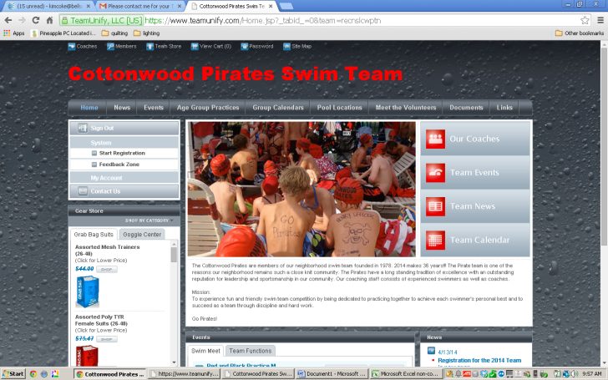 | 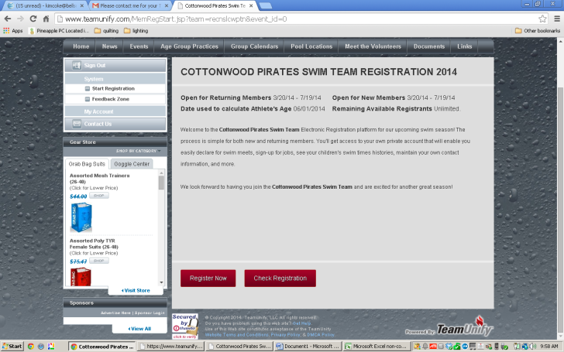
1. From the home page, select Start Registration from the left side of the screen under system. | 2. Select Register Now.
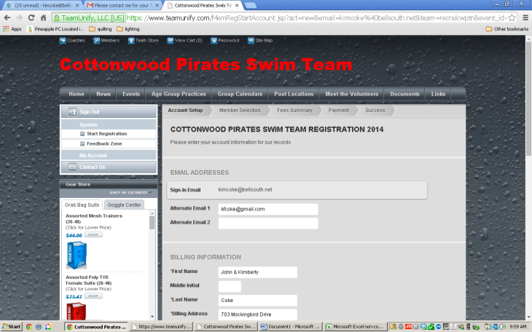 | 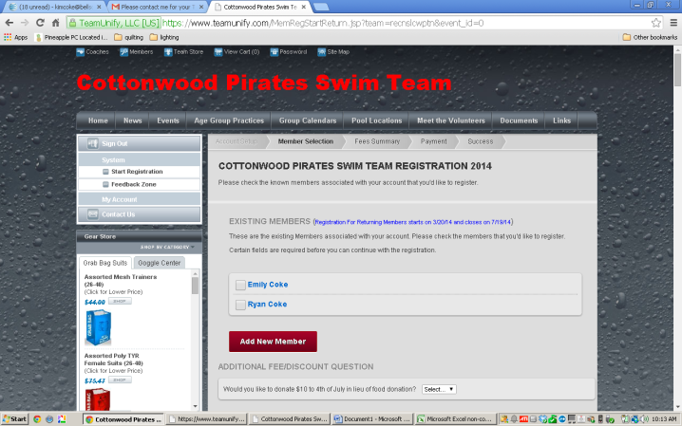
3. Verify all information is accurate and select continue. | 4. The next screen allows you to select existing members to register or add new members.
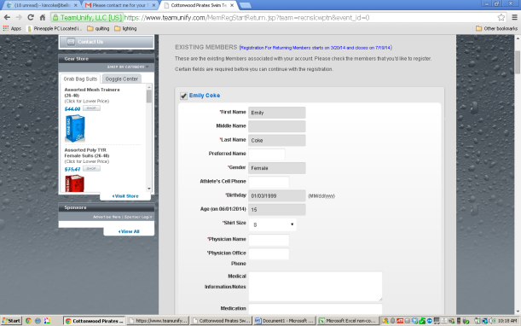 | 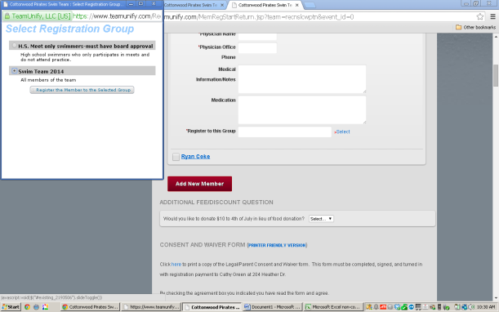
5. Select your member or enter new member. Verify all fields are accurate. Select Shirt Size. Register to this group. Pick Select (small in blue to right of field), then check Swim Team 2014 and Register the member to the selected group.
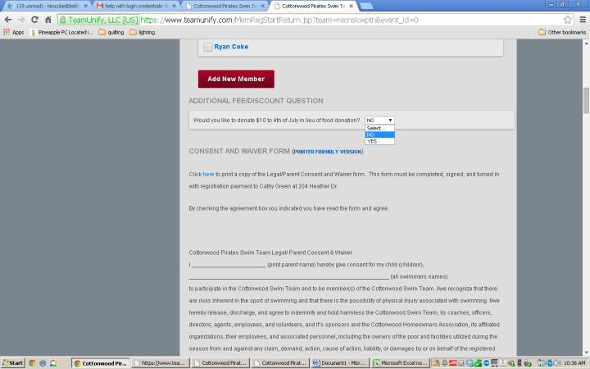
6. Next…If you are going to pay the $10 donation in lieu of donating food for the Fourth of July BBQ Fundraiser select yes. Remember if you select NO, you will need to volunteer to bring food to the BBQ. | 7. Read and print the Liability Waiver and Concussion Forms. Both forms must be signed and turned in with payment to Cathy Green at 204 Heather Dr. There is a box on her front porch or you may mail it in.  You must agree with both of these before proceeding with registration. Select continue after agreeing, printing and signing the forms.
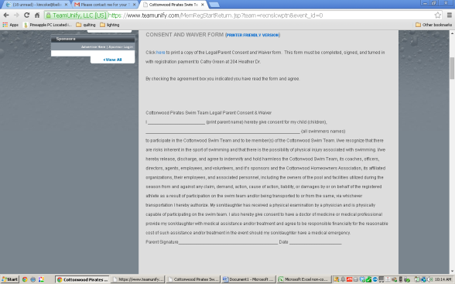 | 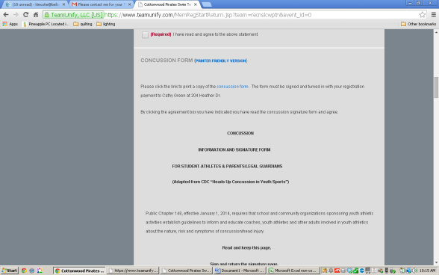
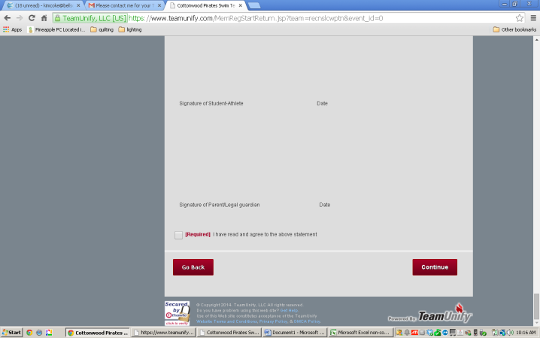 | 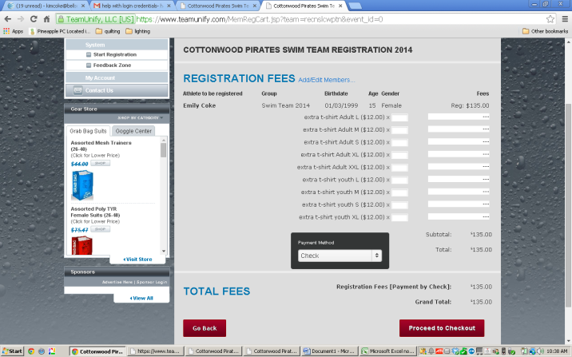
7. (continued) | 8. Order extra t-shirts and proceed to checkout.
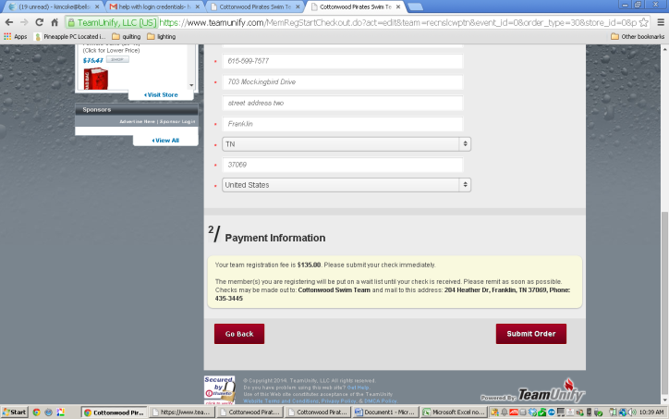

9. Final screen. Verify information is correct and submit order. After payment, liability and concussion forms have been received and your HOA Dues have been determined to be current your swimmer will be made active. You can sign up for your job requirements and other volunteer opportunities before your swimmer is made active.

Job signups
- Each family with swimmers in only the AM or only the PM sessions are required to work 3 meets during the dual meet season. Families with swimmers in both the AM and PM sessions are required to work 2 AM session meet jobs and 2 PM session meet jobs for a minimum of 4 meet jobs.
- In addition to meet jobs there are many other volunteer opportunities under the events tab. These volunteer opportunities include, 4th of July, Thrilling Thursday Treats, Age Group Social Coordinator, Ice Cream Social, etc.

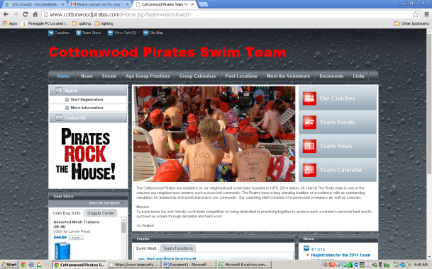 | 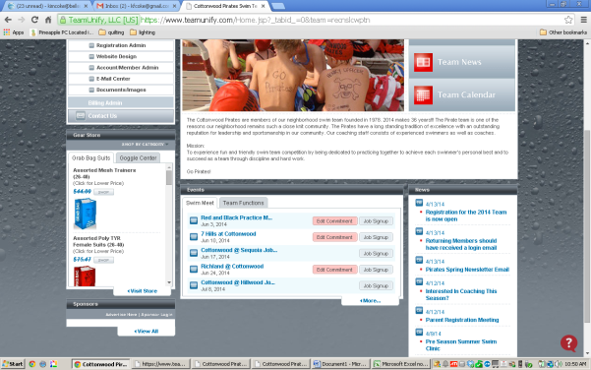
1. From the home page, select the events tab from the top of the page or the meets/team function tabs at the bottom of the home page.
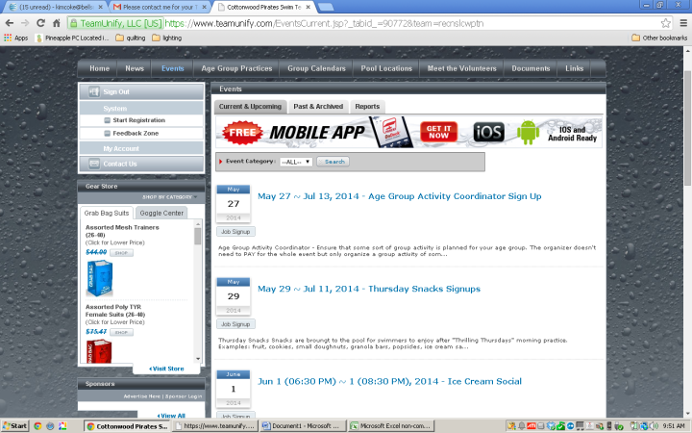 | 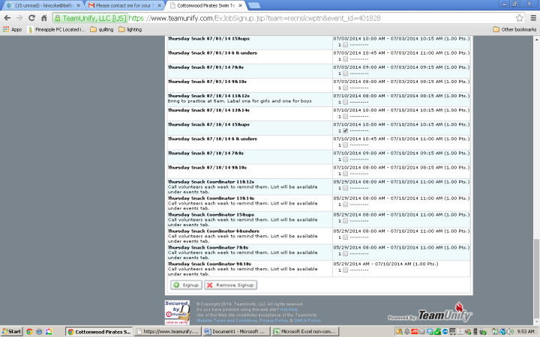
2. Look for the event you wish to sign up for. In this example, we will sign up for Thursday Snacks.  Select job signup. | 3. Find the slot you wish to sign up for and mark the small box next to it. Then select signup from the bottom of the page.
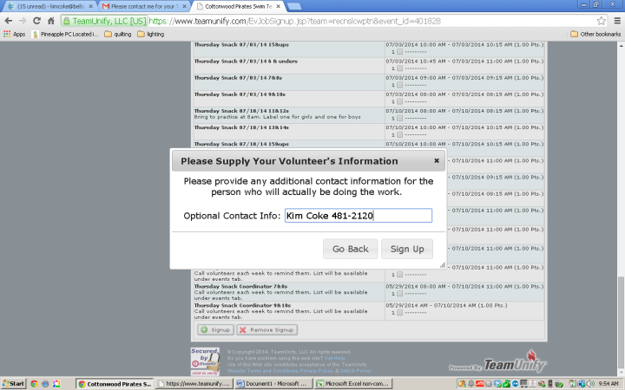 | 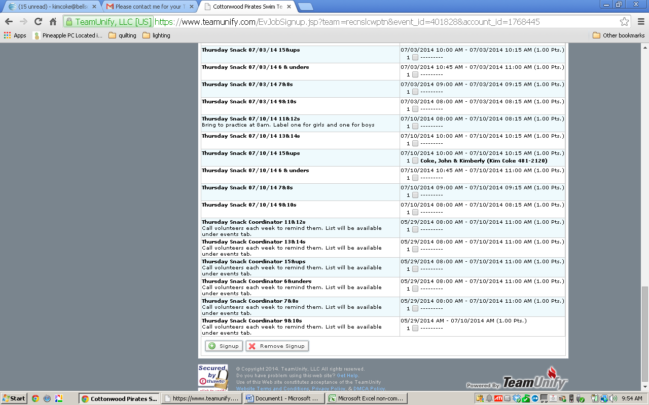
4. Fill out contact information and select sign up.  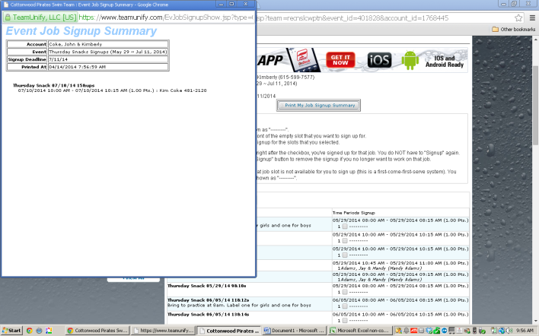 | 5. Your name is in bold in the slot you signed up.
6. At the top of the event job signup page is a job signup summary. You can print this for your records.

Signing Your Swimmer up for Meets
- It is your responsibility to sign your swimmer up for the meets. If you do not sign up your swimmer they may not be entered into the meet.
- Meet signup deadline is noon the Wednesday before the meet.

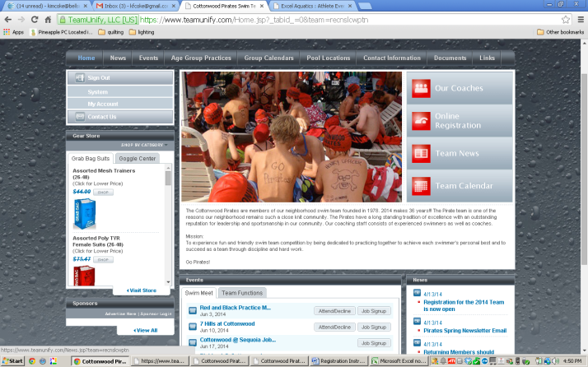 | 1. From the home page, select the events tab from the top of the page or the swim meet tab at the bottom of the home page.  2. Select attend decline and select your member (swimmer). Declare for the event, either Yes, Please sign up (Swimmer) for this meet or No, thanks, (Swimmer) will NOT attend this meet. Remember to select save changes.
3. If you discover your swimmer cannot swim in the meet after the Wednesday noon deadline but before the meet please email Kim Coke at kfcoke@gmail.com and Coach Colin at ackermanct@gmail.com.

If the morning of the meet your swimmer is ill and cannot swim please text Coach Colin and the morning meet director and/or the afternoon meet director. These numbers can be found under the Contact Information tab at the top of the home page.
