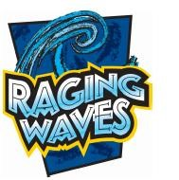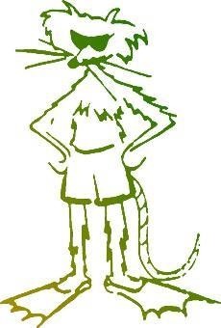**Mudrats Play Day**

# **July 10th, 2018 10am – 6pm**

# Raging Waves Water Park

4000 N Bridge Street Yorkville, IL 60560

1-630-882-6575 [www.ragingwaves.com](http://www.ragingwaves.com/)

Join your team mates, coaches, and family members for a day of fun at Illinois’ largest waterpark!

Park entry tickets are available at a group rate for ***over 40% off the general admission rate***.

Optional meal tickets are available for purchase. Each valid meal ticket can be redeemed at the park for a pizza, hot dog, hamburger, or cheeseburger value meal.

Order tickets **online** or by completing the bottom portion of this form and returning with your cash or check payment in a sealed envelope to your coach.

**Ticket orders are due by July 3rd**

Tickets will be distributed on July 7 (Luau), July 8 (practice) and July 9 (Huntington Estates meet).

NOTE: Tickets are non-date specific and valid for any day of the 2019 season. In the case of inclement weather on July 10th (or if you are not available that day), your tickets can be used on a different day this summer.

Questions? Contact Cortni at Cortnisedgwick@live.com

Raging Waves Ticket Order Form

Family Name:_________________________________

Phone :______________________________________

Email :_______________________________________

|  |  |  |  |
| --- | --- | --- | --- |
|  | Cost Per Ticket | # ordered | Extended Cost |
| Park Entry | $20.23 |  |  |
| Meal Ticket | $8.65 |  |  |

Amount Enclosed:______________________________

Return this complete form along with your cash or check (payable to MUDRATS) payment in a sealed envelope to your coach