HELP!
MY CHILD WANTS TO JOIN THE SWIM TEAM
AND I HAVEN’T A CLUE AS TO WHAT’S GOING ON!

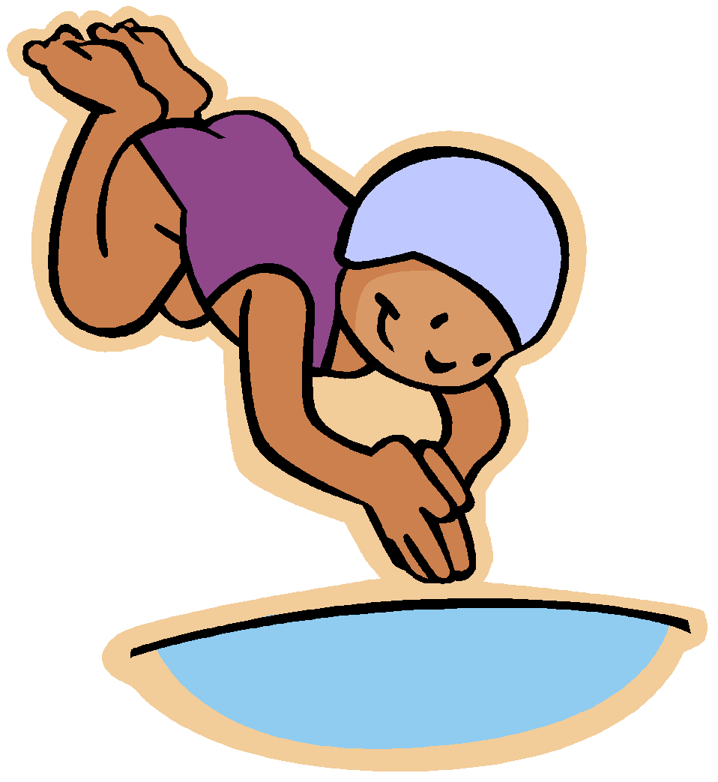

Fair Oaks Sharks Swim Team
Handbook
2019 Edition
INTRODUCTION

Every Fair Oaks Sharks parent has experienced that first day of swim practice or that first swim meet where they may wonder, “Why am I here and what is going on?” We’ve all been there before and will be glad to enlighten you in your quest to understand the world of summer swimming. Inside this Handbook, you will find general information, a description of the swim leagues we participate in, and a description of various meets. There is helpful information on our many non-swimming activities, how we communicate among ourselves and with our fellow summer swimming community. Finally, there is detailed information on the different volunteer positions and their responsibilities, as well as, the organization of the swim team committee.

Your swim team reps, coaches, swim team committee and fellow swim parents all want you to understand and enjoy our summer swim program. Please do not be afraid to ask questions.

Welcome to the Fair Oaks Sharks. We’re glad to have you with us!

Go Sharks! Swim hard! Breathe later!

CHAPTER 1: ABOUT THE SWIM TEAM

Our Philosophy

The philosophy of the Fair Oaks swim team is to have fun while discovering the love of the sport, developing advanced swimming skills, and learning teamwork and good sportsmanship. Personal development is what is most important and for a swimmer that means improving your times. We believe that by establishing a healthy environment that encourages swimmers to do their best, recognizes their contributions and is fun for the entire family – we will have met our goals!

Swimming is unique in that there is a place on the team for anyone eighteen or younger who can swim. How many other sports have kids seven to eighteen years old and their parents on the same team participating in the same competition?

Expectations

Although swimming is considered an individual sport, our summer league is structured with an emphasis on the team. Any team is only as good as its members. In keeping with our philosophy stated above, our expectations are simple:

- Sharks (parents and children) should be supportive of all swimmers, promote leadership and good sportsmanship and assist all athletes in adapting to an individual and team sponsored competitive sport.
- Sharks should demonstrate good sportsmanship as specified in the Shark Code of Conduct and conduct themselves in a respectful manner while at practice, at all swim team events including meets and on social media.
- Sharks must keep their commitments. The team tries to be accommodating, but if you’ve told us that you’re available (to swim, to work the meet, etc.) we are counting on you!
- Shark swimmers should do their best--it’s much more important than being the best.
- Sharks should have fun!

Code of Conduct

One of the main goals of the Fair Oaks swim team is to promote good sportsmanship. The Swim Team Committee and coaches believe that Fair Oaks should be a role model in this endeavor and as a result developed a Code of Conduct containing behaviors considered essential to this goal. Parents are expected to support their swimmers by demonstrating similar behavior throughout the swim season. Though the code is intended to be a positive document, parents and swimmers need to know that a swimmer’s failure to uphold the Sharks Code of Conduct could result in a warning and repeated failures or a particularly egregious incident could result in suspension or disqualification from participation in swim team activities including meets. Every family is responsible for reading and accepting all Code of Conducts (Sharks and Parents) upon registration. These Code of Conducts are located on our website, www.fairoakssharks.com, under “Documents”.

Sharks Code of Conduct
- Fair Oaks Sharks are expected to demonstrate positive and appropriate behavior (e.g., profanity, intimidating or humiliating remarks will not be tolerated) while at practice, at all swim team events including meets and on social media.
- Fair Oaks Sharks are expected to promote team unity and spirit through active participation in practices and spirit events.
- Fair Oaks Sharks are expected to show respect to coaches by listening attentively to coaching instructions during meets and practices, discussing concerns directly with the coaching staff, supporting coaching decisions, and maintaining flexibility as swimmers.
- Fair Oaks Sharks are expected to show respect to officials and other volunteers at all times by supporting decisions, recognizing that all volunteers are doing their best, and by assisting parent volunteers when needed.
- Fair Oaks Sharks are expected to promote team unity by watching and cheering for other teammates during meets and by assisting those younger or newer to the team than themselves. Fair Oaks Sharks are expected to demonstrate good sportsmanship toward other teams by choosing positive cheers, applauding the efforts of other teams/swimmers, and graciously accepting both wins and defeats.
- Fair Oaks Sharks are expected to demonstrate respect for the Fair Oaks community and other host communities by keeping their team areas clean and using equipment and facilities safely and appropriately. All Sharks are to patrol the team area to remove trash before leaving any meet.
- Fair Oaks Sharks shall keep the swim ladder confidential. It will not be shared with anyone outside of our team. Sharing the ladder may provide a competitive advantage to our opponents.

Sharks Parent Code of Conduct
- Fair Oaks Sharks Parent shall not interrupt any practice to try to talk with the coaches or their own swimmer.
- Fair Oaks Sharks Parent shall not make corrections or suggestions to the coaches during practices and/or meets.
- Fair Oaks Sharks Parent shall stay off the deck during all practices and stay in the fenced-in grassy area.
- Fair Oaks Sharks Parent shall maintain an appropriate distance from the competition area by remaining in established viewing areas and shall not encroach the pool deck or interfere with any officials during any meet.
- Fair Oaks Sharks Parent shall not engage in loud, intimidating, disrespectful or negative behavior towards officials, swimmers, other spectators, support personnel or pool staff (including lifeguards).
- Fair Oaks Sharks Parent shall be loyal and supportive to the Fair Oaks Sharks swim team and its coaches. Please do not criticize the coach in the presence of your child. The bond between coach and swimmer is important.
- Fair Oaks Sharks Parent shall speak directly to a Swim Team Committee member if they have any issues with the coaches, procedures or policies.
- Fair Oaks Sharks Parent shall keep the swim ladder confidential. It will not be shared with anyone outside the team. Sharing the ladder may provide a competitive advantage to our opponents.

CHAPTER 2: IMPORTANT BASIC STUFF

Practices

Practice times are posted on the Fair Oaks Sharks website: www.fairoakssharks.com. Swimmers must be punctual for their designated practice times and need to allow time to adjust goggles, put on caps, etc. before the practice begins. We ask that your swimmer adopt the philosophy, “Showing up on time is late. Showing up five minutes early is on time!”
Attendance

Swimmers are encouraged to attend practice every day. 14 and under Sharks swimmers must practice at least two practices with the team each week in order to be eligible to swim in the next NVSL-sponsored event. Each swimmer is allocated one (1) week of vacation without jeopardizing their chance to swim in the following meet. Swimmers having practice schedule conflicts (camp, summer school, etc.) will be able to fulfill their two (2) practices per week minimum requirement by signing up for “Make-up Practices” through Sign Up Genius.

Each team member must confirm their attendance for every meet. This can be done by going to our website and declare whether your swimmer will or will not be attending. If your swimmer is unavailable to swim in an “A” meet, you must notify the Team Rep or Head Coach by noon on the Sunday prior to the “A” meet, so that the absence can be entered into the database. Failure to notify the team could result in your swimmer being scheduled for a meet and preventing another swimmer from swimming which possibly could cost our team points and potentially lose the meet. The team representatives’ email is listed on our website.

Coach Conversations

Coaches report to the Swim Team Committee. Their main responsibility is to assist swimmers to improve their strokes and times and to ensure a fair and fun season. Coaches should not be interrupted during practices, so they can devote their full time and attention to the needs of the team. Please note that during practice, there are no lifeguards on duty. Swimmers are responsible for listening for information passed along from the coaches at their practices. Every Tuesday is “Coaches Corner” where the coaches are available to talk one-on-one with the parents. Questions or problems relating to coaching, team policies or practices should be addressed with the Swim Team Committee only. Contact information is on our website.

Apparel

There are only a few NVSL rules for attire at “A” meets. No school, club, or other organization attire should be worn.

The Swim Team Committee, in conjunction with some of our swimmers, selects a team suit. Generally, competitive suits are available for no more than two seasons from the manufacturer. Every effort is made to find a reasonably priced team suit that is available for two seasons. We urge all swimmers to wear the team suit at all “A” meets. To show team spirit, the team cap is encouraged for swimmers who choose to wear a cap, but it is not mandatory. Please note that team suits and caps are NOT required for Jr. Sharks.

Spirit wear and other items may be available at registration and at the beginning of the season, as well.

Accessories for the Well Dressed Swimmer

Every swimmer needs a towel, goggles, a swim cap (usually for girls or boys with longer hair), sunblock, and a bag to carry everything. A swimmer should have water always available. We encourage all swimmers to wear their team cap to every “A” meet to show team spirit!

Communications

The Sharks offer a number of ways for parents, coaches and swimmers to share information. In order to keep everyone up to date and save on copying expenses, all of our information is available on our Fair Oaks Sharks website at www.fairoakssharks.com. You must enroll on the website in order to receive communication about the team. In addition, a correct email address is essential for all team families. Changes in email addresses should be made on our website. It is best if you check your email daily!

Each family will be assigned a “mailbox” (a file folder) kept in the swim team file drawer at the pool. Flyers, weekly updates, and most importantly RIBBONS are distributed via this system. We ask that you check your “mailbox” daily. The swim ladder will be posted on our website after every meet. You will also receive weekly emails that provide all pertinent meet information.

CHAPTER 3: ORGANIZATIONAL STUFF

Team Reps and Coaches

The people you run into most in your swim team dealings are the Team Reps and the Coaches. The Team Reps are volunteer parents who were new to swimming at one time just like you are today! The Team Reps are part of the Swim Team Committee and are the representatives of the Fair Oaks Swim Team to other swim teams and the NVSL. It’s a job that is impossible to do successfully without help from a great many parents. The coaches are responsible to the Team Reps for the swimming portion of the swim team program. There are two Team Reps:

“A” Team Representative:
The “A” Team Rep serves as Meet Manager for home "A" meets and represents the team at away "A" meets. He/she also represents the swim team at all NVSL meetings and provides requisite information to the NVSL. The “A” Rep coordinates NVSL meet activities with the Swim Team Committee and ensures all meet Officials are NVSL- or USS-certified.

Developmental “B” Meet Representative:
The “B” Meet Rep serves as liaison to the Fairfax Developmental League and Meet Manager for home Developmental meets and represents the team at away Developmental meets. He/she coordinates Developmental meet activities with the Swim Team Committee.

Swim Team Committee

The Swim Team Committee is a standing committee of FORA and is comprised 5 to 7 members. Meetings are held as needed throughout the year. The Committee’s role is to plan for each upcoming year and to serve in an advisory capacity for the summer team.

Responsibilities include:

- Long-range planning
- Developing and approving the annual team budget
- Hiring coaching staff
- Developing and disseminating team policies and procedures
- Assisting in dispute resolution regarding policies and procedures

Junior Sharks

The Jr. Sharks program was established in 1999 for children ages 4 to 8 (or at coach’s discretion) who can swim, but are not yet comfortable swimming the entire length of the pool. Jr. Sharks is an excellent program geared to teach your young swimmers how to be competent and comfortable in the water. The program is designed to provide individualized stroke instruction and improvement. The goal for this group of swimmers is that they are able to compete in the Lollipop Meet in at least one stroke (generally freestyle) and at least one Developmental “B” Meet (must be approved by the Jr. Sharks Head Coach) by the end of the season. The Jr. Sharks are part of the Sharks Swim Team and are encouraged to attend all social activities. Continuation of this program is determined by the coaches year to year and is based on interest and need. The Jr. Sharks program is managed by the Jr. Sharks Coordinator who acts as liaison between parents and coaching staff and coordinates all Jr. Sharks activities including the end-of-season Lollipop Meet and banquet. Our Jr. Sharks Coordinator contact information is listed on our website.

CHAPTER 4: EVERYTHING YOU EVER WANTED TO KNOW ABOUT SWIM MEETS AND MORE

The Fair Oak Sharks participate in two different, but related, swim leagues:

- Northern Virginia Swim League (NVSL): "A" meets

The NVSL
The Northern Virginia Swimming League (NVSL) began in 1956 with six founding pools. Today, it is the largest summer league in the United States. The teams are seeded by overall speed rather than by size or location with the fastest teams in Division 1. The NVSL reseeds teams each year to keep each division as competitive as possible.

- Fairfax Developmental League (FDL): Developmental “B” meets

The FDL
The Fairfax Developmental League (FDL) is comprised of local teams. Its purpose is to provide a similar, but less competitive environment than the NVSL, so that all swimmers have the opportunity to compete and measure their progress. Developmental meets ensure that all swimmers have the opportunity to swim, compete, and improve their times. Finally, this league allows some experienced swimmers to try new strokes, as well as, for our new officials to learn their responsibilities. Generally, all NVSL rules are followed for these “B” meets.

During the season, the Sharks compete in all NVSL and FDL sponsored events. These events include:

NVSL:
5 weekly (Saturday) "A" Meets
Divisional Relay Carnival
All-Star Relay Carnival
Divisional Individual Championships
All-Star Individual Championships

FDL:
4-5 weekly (Monday) Developmental “B” Meets
Individual Medley (IM)/Fly Carnival
Developmental Relay Carnival

Logistical Notes

All meets are held, rain or shine. The only exception is lightning at the host pool, which may result in a delay. For away meets, we normally meet at our pool and caravan to the host pool. Departure time from our pool and directions to the host pool will be announced prior to the meet via our website (www.fairoakssharks.com). If you choose not to caravan with the team, you need to be at the host pool no later than 8:15am for "A" meets and 5:15pm for Developmental meets. If you plan to meet the team at the host pool for “A” meets, please let the coaches know. The coaches assume that all team members will be available for "A" meets unless they have informed the Data Coordinator by email that a swimmer will be absent. If a child becomes ill on the morning of an "A" meet, please call or text the A Team Rep by 7:00am. The phone number is available on our website under the “Contacts” tab.

For any meet, swimmers need to know what events they are swimming and be ready when the event is called. Swimmers should stay in the “team area” during the entire meet in order for the coaches to collect them for their event. For “A” meets only: 1. If a swimmer needs to depart before the meet is over, they MUST tell the Head Coach first; 2. Swimmers are expected to stay for the entire meet to cheer for teammates; and 3. Use of any electronic device by a swimmer in the team area is prohibited.

Time Trials

After approximately three weeks of practice, Time Trials are held at the Fair Oaks pool. The purpose of this “meet” is to provide an opportunity for the swimmers and the parent volunteers to participate in a trial run of a meet. Each swimmer’s goal is to obtain times in all four events. These times will be recorded on the Swim Ladder (see paragraph below).

Time Trials must be conducted prior to the first meet to obtain an official baseline time for each swim team member in each individual event/stroke. These times are then used to select swimmers for the first "A" meet which is held the following Saturday. If a swimmer misses the Time Trials, he/she will need to swim in the following Monday’s “B” meet in order to get times to qualify to swim in the next “A” meet. A swimmer is only allowed to swim two events and an IM in a “B” meet. Your swimmer will not have a time in all four events unless he/she swims in the Time Trials.

What is a Swim Ladder?

A Swim Ladder is a record of each swimmer’s official time listed by gender, age and event. The Swim Ladder is updated after every meet (“A” and “B”) and will be posted on our team website. If a swimmer DQ’s (see definition later in this manual), that time is not considered an official time and is not listed on the Swim Ladder. The coaches seed an “A” meet off the times from the Swim Ladder. Each team member shall keep the ladder confidential. It will not be shared with anyone outside of our team. Sharing the ladder may provide a competitive advantage to our opponents.

NVSL Meets

"A" Meets
"A" meets are held on Saturday mornings from 9am until approximately noon. There are five of these meets and they are conducted only against teams in our Division. Two or three of these “A” meets will be held at Fair Oaks each season.

Each team fields three swimmers per age and gender in the four individual strokes (freestyle, backstroke, breaststroke and butterfly). Relays are swum in each age group plus one with mixed ages at the end of the meet. NVSL rules allow swimmers to swim a maximum of two individual events, participate in one age-group relay team and the mixed-age relay team, if selected. Beginning with the youngest age group, boys swim first then girls follow. NVSL events are swum in the following order: freestyle, backstroke, breaststroke, butterfly.

“A” Meets consist of 40 Individual events and 12 Relays. The events swum for each stroke and age group are shown below:

Age Group | Freestyle | Backstroke | Breaststroke | Butterfly | Freestyle Relay | Medley Relay
8 & Under Boys | 25 M | 25 M | 25 M | 25 M | 100 M
8 & Under Girls | 25 M | 25 M | 25 M | 25 M | 100 M
9-10 Boys | 50 M | 50 M | 50 M | 25 M |  | 100 M
9-10 Girls | 50 M | 50 M | 50 M | 25 M |  | 100 M
11-12 Boys | 50 M | 50 M | 50 M | 50 M |  | 100 M
11-12 Girls | 50 M | 50 M | 50 M | 50 M |  | 100 M
13-14 Boys | 50 M | 50 M | 50 M | 50 M |  | 100 M
13-14 Girls | 50 M | 50 M | 50 M | 50 M |  | 100 M
15-18 Boys | 50 M | 50 M | 50 M | 50 M |  | 100 M
15-18 Girls | 50 M | 50 M | 50 M | 50 M |  | 100 M
Mixed Age Boys |  |  |  |  | 200 M
Mixed Age Girls |  |  |  |  | 200 M

Swimmer Selection
Swimmers are selected for "A" meets by the Head Coach. There are several criteria which are evaluated by the Head Coach. Each week, we swim a new team with different strengths and weaknesses. Since our goal is to win the meet, we need to try and match up our swimmers with those of our new opponent as best we can.

The Head Coach will make "A" meet assignments weekly. The assignment is based on the swimmers' best times (Swim Ladder) and the Head Coach’s decision as to where that swimmer will most likely gain points individually or as a relay team member in the "A" meet. Meet sheets are approved by the “A” Team Rep and are typically emailed out on Thursday evening for the “A” meet. Swimmers are expected to know their assignments. Any issues regarding the meet sheets must be brought to the attention of the Head Coach or the A Team Rep by Thursday evening. Those swimmers not selected for that week's Saturday meet should plan to participate in the “B” meet held on the following Monday evening.

Developing the meet sheet is a complicated process. Our opponent’s previous meet sheets are reviewed and swimmers are placed in strokes where their previous times should score the most points for the team. This may mean that the coach will have a swimmer swim in an older age group event (“swimming up”) or swim a stroke that is not their strongest or favorite. Stroke assignments may change weekly, as we match ourselves up against a new team with different strengths. Parents and swimmers need to understand that coaching decisions are made for the benefit of the team as a whole and are asked to support these decisions.

Seeding
Seeding within age group and strokes will be done based on the fastest official times earned during the current season. These times are taken from "A" meets, “B” meets, and Time Trial times only. Swimmers' best times are maintained in the team database. The top times for each individual in each age group will be posted weekly (Swim Ladder) on our website to provide a benchmark for swimmers.

Swimmers compete in age groups based on their date of birth as of June 1st.

Scoring
"A" meets are scored and the outcome of these meets determines a team’s division standing. Points are based on the swimmer’s performance in each event with the total points scored determining the winning team. Each event is scored: 1st place earns 5 points, 2nd place earns 3 points and 3rd place earns 1 point. Each relay earns 5 points for 1st place and 0 points for 2nd place. The score is generally announced during the meet at the completion of each stroke.

Ribbons are awarded for 1st through 6th place finishes. The swimmer’s time, event and age group are recorded on the back of the ribbon. At the completion of the "A" meet season, the NVSL awards a trophy to the team with the best win-loss record in each division. Also, each NVSL division will award a trophy to the team that best demonstrates good sportsmanship throughout the season.

Divisional Relay Carnival
The Divisional Relay Carnival is held on a Wednesday evening in early July and is a highly spirited and competitive meet. The Sharks may enter one relay team per event to compete against all five other teams from our division. There are medley and freestyle relays for each gender and age group, as well as, boys and girls mixed age relays. The Head Coach selects the swimmers for the relay teams based on fastest times. Swimmers must swim in their own age group. Each event is scored: 1st place earns 14 points; 2nd place 10 points; 3rd place 8 points, 4th place 6 points, 5th place 4 points and 6th place which earns 2 points. A trophy is awarded to the team accumulating the most points at the end of the meet.

All-Star Relay Carnival
The eighteen fastest relay teams in each event from all divisions in the NVSL compete against each other the Wednesday following the Divisional Relay Carnival. The Division Coordinator represents the six teams at the seeding meeting and notifies the “A” Team Rep of any team qualifications. One alternate team is selected for each event. There is one substitution allowed for each relay team only for illness, injury or absence.

Divisional Individual Championship Meet
On the Saturday following the last "A" meet, each division conducts a "Divisional Meet” consisting of the fastest swimmers from all of the teams in the Division. Swimmers may compete in only two events. The individual medley (IM) event is included in this meet. There are no relay events.

The Shark with the fastest times in each event (Swim Ladder) has first right of refusal for that event. If the fastest swimmer does not want to swim that event the opportunity is passed to the Shark with the second fastest time. This process continues until all our allotted slots are filled. Next, a Divisional Seeding Meeting is held and is attended by the “A” Team Rep. Each team’s swimmers’ best times are submitted to the Division Coordinator and the swimmers are seeded according to NVSL criteria. If a team does not have two swimmers for an event, another team may add (“bid-in”) additional swimmers in that event. We often have the opportunity to bid-in additional swimmers. Our goal is to have as many Sharks as possible given the opportunity to compete in this meet. Thus, it is essential for families to notify the Data Coordinator if a swimmer will not be available for this meet. With proper notification, another swimmer may be substituted. If not, we might lose that spot to another team. Alternates can be chosen the morning of the Divisional Meet when the “A” Team Reps identify empty lanes due to absence. Plaques are awarded to the top six finishers in each event.

All-Star Individual Championship Meet
After all of the divisions in the NVSL hold their Divisional Meets, the eighteen fastest swimmers and two alternates in each event are chosen to compete in the All-Star Individual Championship Meet. These selections are based solely on times posted from Divisional Individual Championships. This meet is held on the Saturday following the Divisional Meets. Medals and ribbons are presented in award ceremonies following each event.

FDL Meets

Developmental “B” meets are held on Monday evenings from 6pm to 9pm. Depending on the schedule and calendar, there are four or five of these meets during the season and they are conducted against other teams from the Developmental League. Two or three of these meets are held at Fair Oaks pool.

“B” meets do not affect our NVSL standings or what NVSL division we compete in. However, they are a crucial component of our summer swim program, allowing swimmers opportunities to improve their individual times in events. The format is essentially the same as a Saturday meet except that there are generally multiple heats of each age group event. Whenever possible, swimmers are placed (“seeded”) with other swimmers based on their previous times. Ribbons are awarded to all participants (first through sixth place) in each heat. If a swimmer is disqualified or is swimming unofficially, a participant ribbon is awarded. Ribbons record the swimmer’s time, event, and age group on the back.

Developmental swimmers participating in “B” meets can make their stroke selections for up to two strokes (freestyle, backstroke, breaststroke or butterfly) and an Individual Medley (IM) with approval by the Head Coach. A swimmer shall not compete in breaststroke or butterfly until the coaches have determined that the swimmer has a reasonable chance to swim a legal stroke and not be disqualified. For swimmers who swam in the A meet that week and placed 1st, 2nd or 3rd, they will not be able to swim the stroke they placed in and all other events will be time only. See Swimmer Eligibility Guidelines below. Jr. Sharks may swim in a “B” meet only with the approval of the Jr. Sharks Head Coach at the last home B meet.

Individual Medleys (IM) are swam at the end of most Developmental meets. This requires the swimmer to swim one length of the pool using each stroke in the order of butterfly, backstroke, breaststroke, and freestyle. Swimmers will need to have times in all four strokes on the swim ladder in order to participate in IM. As this event is included in the NVSL Divisionals Meet, swimmers are encouraged to compete in this event as often as possible. All swimmers nine and older are eligible to swim in this event. Sharks swimmers younger than nine may swim an IM only with the Head Coach's approval. Since there is not a separate age group designation, those swimmers 8 and under, who are approved by the Head Coach to swim an IM, must “swim-up” with the 9-10 year olds.

Swimmer Eligibility Guidelines
True “A” meet swimmers (e.g., swimmers who regularly swim two events and generally place in “A” meets) shall not swim in the Developmental Meets unless the coaches need times. In those cases, the swimmer will swim in “Time Only” heats and will not be awarded place ribbons. Those swimmers who periodically swim in an “A” meet and placed first, second or third will also swim in “Time Only” heats and will not be awarded a place ribbon in any event except IM. Those swimmers can swim a total of two events: either two strokes they did not place 1st-3rd in the A-meet or one stroke they did not place 1st-3rd in the A-meet and IM. The Developmental Meet eligibility assessment will be determined on a week-by-week basis and will be at the Head Coach’s discretion. See the Developmental League Rules on our website for details. Jr. Sharks may swim in a “B” meet only with the approval of the Jr. Sharks Head Coach.

Developmental Relay Carnival
This meet is open to any swimmer who did not participate in the Divisional Relay Carnival. There are medley and freestyle relays for each gender and age group, as well as, mixed-age relays, which match up boys and girls of different ages together in one relay.

Developmental Individual Medley (IM)/Fly Carnival
Swimmers may participate in the Developmental IM/Fly Carnival, which is held on a weekday evening during the season.

CHAPTER 5: MY CHILD SAYS HE’S SUPPOSED TO SWIM LIKE A BUTTERFLY

If you are not a former swimmer, the strokes and their rules can be a cause of bewilderment. While the stroke rules are simple enough for a seven year old to understand most people do not have a copy of the USA Swimming Rules, so we'll briefly describe the strokes below. The rules below are the USA Swimming rules as modified for use in the NVSL. Teams in other leagues may have slightly different rules.

Freestyle
The freestyle is defined as any means of swimming across the pool. Any stroke and kick are acceptable. There are, however, a few “don'ts” associated with this stroke, specifically: (1) You cannot walk on the bottom or pull yourself along using the lane lines and (2) In a 50 Meter race (two pool lengths) you must touch the wall at the 25 meter end before touching the wall at the 50 meter end (This may seem obvious, but sometimes swimmers miss the wall at the turning end of the pool).

Backstroke
Like the freestyle, almost anything goes on the backstroke as long as you stay on your back. Backstroke starts are different from all others because the swimmer is in the water feet planted against the wall, and hanging on to either another swimmer's legs or the lip on the pool awaiting the Starter's signal. "Legs" must be grabbed below the knee. Persons serving in an official capacity (such as timers or coaches) may not serve as “legs”. If your swimmer is a Backstroker, he or she will learn the backstroke flip turn before they turn nine. This is the one exception to staying on your back and can be used only as part of a turn (not a finish) at the pool wall.

Breaststroke
The breaststroke has two components, the kick and the arm pull. The pull and its recovery must both be under the breast and cannot extend further back than the waist area. The kick is a "frog" kick and the toes must be pointed outward during the propulsive part of the kick. The arm pull and kick must be in an alternating sequence and the elbows must stay below the water except for tagging the wall at the finish.
Breaststroke turns and finishes require a simultaneous two hand touch.

Butterfly
A well-executed butterfly is the most beautiful exhibition of power you'll ever see in a swimming pool. Quite frankly, the fly is the hardest stroke for most swimmers to perfect and while they are learning it many look like they are drowning. There are two components of the fly; the arm pull and the kick. The arm pull must be an over the water recovery (from wrist to shoulder breaking the water surface) with the arms moving simultaneously. The kick is a dolphin style kick with both legs moving simultaneously. Unlike the Breaststroke, there is no requirement to alternate the kick and pull. Turns and finishes require a simultaneous two hand touch at the wall.

Individual Medley
The individual medley (or “IM”) is when an individual swims each of the four strokes in the sequence: Butterfly, Backstroke, Breaststroke, Freestyle. We swim a 100 meter IM, which means 25 meters, or one pool length, of each stroke is swum. In a 100 meter IM, every turn is a stroke change and stroke finish rules apply. This means no backstroke flip turns.

Relays
There are two kinds of relays, the freestyle relay and the medley relay. Both involve a team of four swimmers, each swimming one quarter of the total distance. In the freestyle relay, each swimmer swims the freestyle. In the medley relay, the sequence is Backstroke, Breaststroke, Butterfly and Freestyle. In all relays, each swimmer must wait until the previous swimmer touches the wall prior to leaving the deck. Running starts or pushes from teammates are not allowed.

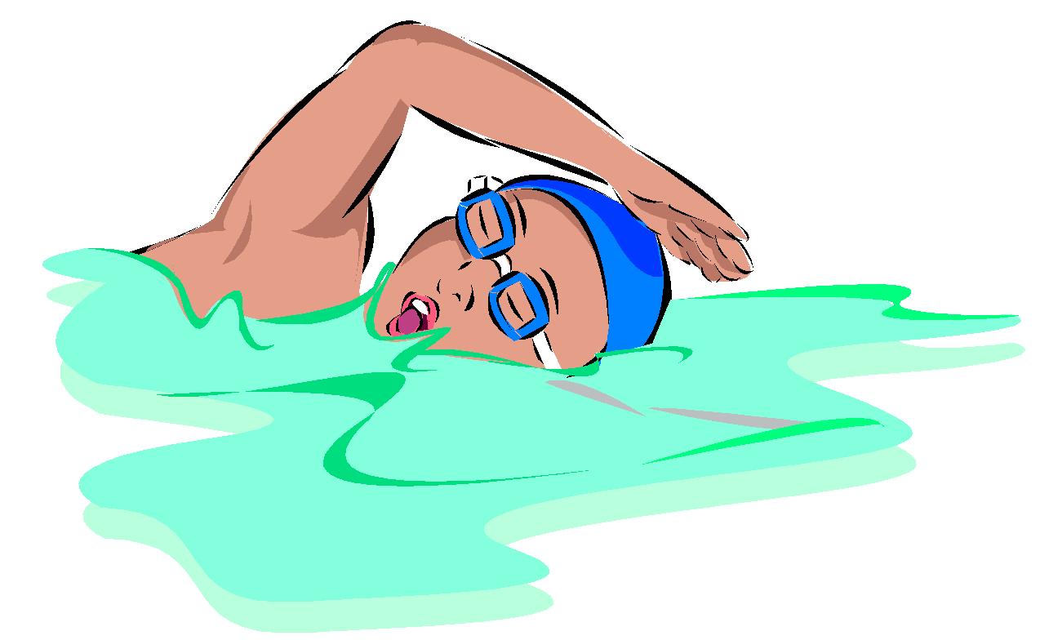

CHAPTER 6: WHO ARE THESE PEOPLE DRESSED IN BLUE AND WHITE AT A MEET?

Your first swim meet can be a confusing experience as you encounter a vast horde of adults dressed in blue and white. NVSL rules require white tops and blue bottoms as the colors to be worn by all Officials and parent volunteers. This is also practical as white is a good color to wear on a hot humid summer morning.

NVSL-Certified Meet Officials (requires NVSL training/certification)
Referee (1 per meet)
The Referee (an NVSL-certified official) is the chief official for each meet. His/her principal function is to ensure that the meet is properly conducted within the NVSL rules and that swimmers have uniformly fair competitive conditions. The Referee serves as the final authority on the interpretation and enforcement of all swimming rules. Prior to the start of each race, the Referee sounds two or three short blasts to advise the participants to get ready. After the event is announced by the Announcer or Starter, the Referee sounds one long blast as a signal for swimmers to get into position for the start or to jump feet first into the water for a backstroke event. For backstroke events, a second long blast is given to bring the swimmers to the wall for the start. When the Referee sees that all the swimmers are ready, he extends his arm pointing towards the Starter.

Starter (1 per meet)
The Starter (an NVSL-certified official) is the only official with direct contact with the swimmers. The Starter makes sure that all swimmers are given a fair and equitable start. The Starter informs the swimmers of the stroke and distance to be swum, and then uses a series of whistles to get swimmers ready for the start. After all swimmers are ready and still, the Starter starts the race using an electronic starting device. The Starter will instruct the swimmers to "Take your mark". After all swimmers are ready and still, the Starter will start the race using a "Colorado System”. This system consists of a public address system, a horn, and a strobe light.

Stroke and Turn Judge (4 per meet)
The Stroke and Turn Judges (NVSL- or USS-certified officials) ensure that swimmers obey all the rules for the stroke that they are swimming including the appropriate turn or finish designated for the event. These people are always at the ends of the pool for starts and finishes. If a Stroke and Turn Judge sees a violation of the rules, he/she raises his/her hand to signify that an infraction has occurred. A Disqualification is recorded on a DQ slip, which the Referee reviews and has final approval. He/she then forwards copies to the Table Workers and the Team Rep.
Additional Meet Officials (Parent Volunteers)
Marshal (2 per meet)
The Marshal is charged with maintaining order at the meet, among swimmers and spectators. She/he monitors the team during warm-ups.

Chief Timer (1 per meet)
The Chief Timer is responsible for delivery of all official times to the Time Recorder, as recorded by one Timer in each lane. The Chief Timer acts as Assistant Chief Timer at away meets. The Chief Timer assigns Timers to their lanes.

Timers (18 per meet)
The Timers are the most important people to every swimmer. They are the people who determine each swimmer's official time for each race. Being a Timer is a good entry level position for new parents to help out. Some parents have been Timers for years and wouldn't want to see a swim meet from any other viewpoint. If you can start and stop a stopwatch, you can be a Timer. We'll even provide the stopwatch! Timers start their watches on the strobe light from the Colorado System and stop their watches when the swimmer touches the wall. There are three Timers per lane and all three times are recorded. The middle time is the Official Time. The Chief Timer collects the time cards from the Timers, reviews them for accuracy and completeness and forwards them on to the Table Workers.

Relay Take-Off Judge (8 per “A” meet)
During relays, you'll see four Relay Take-off Judges at each end of the pool (two per lane). Their job is to insure that each swimmer touches the wall prior to the next swimmer in the relay leaving the deck. Each Judge notes on a slip of paper whether each swimmer in his lane left before or after the swimmer in the water touched the wall. Relay Take-off Judges do not raise their hands when they observe an early take-off because a disqualification occurs only if both Relay Take-off Judges observed an early takeoff.

Clerk of Course (1 per "A" meet; 2 per “B” meet)
The Clerk of Course is the “gatekeeper” for all swimmers, and is responsible for getting the right swimmer to the right place at the right time. Other duties include assembling the swimmers in the order of events, holding the swimmers ready on deck, and interfacing with the Referee and Table Chief/Verifier if there is a problem.

Clerk of Course Runner (2 per home meet)
The Clerk of Course Runner takes swimmers from Clerk of Course to their assigned lanes.

Announcer (1 per home meet)
The Announcer is important for meet management and control. He/she announces the events and the swimmers, as well as, provides the names of the winners and other pertinent information.

Card Runners (2 per home meet)
The Runners are charged with taking completed time cards from the Chief Timer to the time recorder at the table.

DQ Runner (1 per home “B” meet)
The Runner follows the Referee during a DQ and takes the DQ slips from the Referee to the Table Workers who then match the DQ slip with the swimmer’s card. This eliminates extra time taken for each DQ. At a “B” meet, there can be lots of DQs!

Heat Board Attendant (1 per home “B” meet)
The Attendant updates a large Heat Board with each event and heat number, so that the S&T Judges know what event/heat numbers to write on their DQ slips. It also assists the Announcer to announce each event and heat.

Team Area Parent (1 per meet)
The Team Area Parent helps the coaches collect the swimmers for their event. They also patrol the team area. They encourage the swimmers to cheer on their teammates. In “A” meets only, they enforce the rule of no electronic use for any swimmer.

Table Chief/Place Recorder (Table Worker)
The Place Recorder requires previous experience. They determine the placement of order of the finished swimmers, inscribes the place on the time card and records disqualifications as received from the Referee.

Verifier (Table Worker)
Verifiers receive the time cards with the official order of finish of each event from the Place Recorder. They check/verify the times and places of all swimmers against the data entered online, keep the official score of the meet and verify the official automated copy of the meet sheet.

Awards Clerk (Table Worker)
The Awards Clerk receives the time cards from the Verifier after they have been officially checked and verified against the computer data, select the appropriate award, and record the swimmer's name, time and team on the award.

Other folks at the Meets
Data Entry Coordinator
The Data Entry Coordinator inputs the times and places of each race from the time cards. All information needed for NVSL is compiled at the end of the meet.

Team Rep
The Team Rep is the designated recipient of all DQ slips for his/her team and is the only person with any official standing to challenge any decisions made by the Referee. It sounds like an easy job, but remember most of the Team Rep's job is done before the meet starts.

Coaches
During the meet, the Coach’s primary responsibility is to encourage and praise the swimmers and to make sure that they get to the Clerk of Course in time to swim their event. After each event, swimmers should first verify their time with the Timers and then report back to their coaches to get feedback on their performance. Immediate feedback helps the swimmers improve!

CHAPTER 7: WHAT DO YOU MEAN MY CHILD DQ’D?

In swimming, the rules must be followed in total or a disqualification, or DQ, is committed. This can be traumatic the first time a swimmer is DQ'd for just one mistake, but it isn't fair to other swimmers who swim the entire race per the rules to do otherwise.

What is a DQ?
A DQ (short for “disqualification”) is any violation of the rules observed by any appropriate official. Some of the more common reasons for DQ’ing are as follows:

Freestyle: Failure to touch the wall at the turning end of the pool
Walking on the bottom or pulling on the lane lines
Exiting the pool before swimming the specified distance

Backstroke: Past vertical towards the breast at any time except during a flip turn
Leaving the wall after a turn past vertical towards the breast
Improper flip turn (older swimmers)

Breaststroke: Incorrect kick, such as a Scissors kick or Flutter kick
Non-Simultaneous two hand touch or one hand touch at turn or finish
Toes not pointed outward during the propulsive part of the kick
More than one stroke underwater with arms fully extended at start or turn
Arm recovery past waist except on first stroke after start or turn
Head didn't break surface by conclusion of second arm pull underwater after a start or turn

Butterfly: Non-Simultaneous or one handed wall touch at the turn or finish
Non Simultaneous leg movement during kicks
Arms don't break water surface during recovery (judged at the elbows)
Non Simultaneous arm movement during recovery

Relay Races: A swimmer leaves the deck before the previous swimmer touches the wall or deck

False Start: A swimmer starts the race early (more details below)

How will I know a DQ occurred?
Unlike football, we don't blow a whistle and announce to the world that a rules violation occurred. When a Stroke and Turn Judge observes a violation, he raises his hand to signify that he has observed a violation then writes it up on a DQ slip. The judge then takes the slip to the Referee, who verifies that rule has been broken and can question the Stroke and Turn Judge to insure that he was able to see the violation that was cited. The Referee then gives one copy of the DQ slip to the Team Rep and another copy to the Place Recorder (Table Worker). Another clue that a DQ has occurred is spotting a Stroke and Turn Judge writing and a longer than normal pause between events. Disqualifications for early relay takeoffs are done slightly differently. The Referee receives all the take-off slips from all the judges. If both judges on a lane agree that an early takeoff occurred, the Referee will stand over the lane that the team being DQ’d swam in and raise his hand.

False Starts
A false start occurs whenever a swimmer moves towards the pool after having assumed a still position (taking his/her mark) and before the Starter has started the race. When this occurs, a swimmer is usually trying to anticipate the starting signal and beat the other swimmers into the water. If the false start is detected before the starting signal is sounded, the offending swimmer can be removed from the race prior to it starting. If a false start occurs, but the starting signal has sounded, the race will not be stopped. Instead the false starting swimmer(s) will be notified of their false start at the conclusion of the race. The use of a recall signal is now limited to a bad start (i.e. not all swimmers were ready) or for a safety reason. If the starter sounds the recall signal, no swimmer can be removed for a false start.

How do I know if my child DQ'd?
Your child will probably know before you do since the Team Rep tells the Head Coach, who in turn tells the swimmer. You'll probably find out if you saw your swimmer finish with one of the top three times, but he isn't announced later in the top three places. Similarly, someone else DQ’d if your swimmer finished in 4th, 5th or 6th, yet is announced as one of the top three finishers. The Sharks will designate one day each week to review DQ’s. This practice will address those swimmers who DQ’d in the previous swim meet(s). Swimmers who DQ’d will be instructed on why they DQ’d and what they need to improve their stroke, turn, and/or finish. In addition, your child will receive a “Fair Oaks Sharks DQ Notification Form” in his team folder the day after the meet. This form will spell out exactly how your child DQ’d.

Please note that your child will know after Tuesday’s practice why they DQ’d. Please do not approach the coaches during Monday or Tuesday’s practice regarding questions about DQ’s. If, after reviewing your child’s “DQ Notification Form”, you still have questions about your child’s DQ, please contact the Head Coach via email or during “Coaches Corner”.

A Word about Officials and DQ’s
Every Official on the deck will always give the benefit of the doubt to the swimmer. Although the difference between “legal but ugly” versus “illegal” is sometimes close to call, any violation called by an official is an "I saw" not an "I think I saw".

Protesting Disqualifications
The Team Rep is the only person who can officially question a disqualification or any other call by an official. If something happens involving your swimmer which you do not think is right, talk to the Head Coach or the Team Rep. The Team Rep will initiate action in accordance with NVSL rules, if thought to be appropriate.
CHAPTER 8: WE’D RATHER HAVE FUN THAN BE IN DIVISION 1

If you get to know the parents of a Division 1 swim team, some of them will tell you that swimming isn’t always fun. At the pinnacle of the NVSL are the six best teams in Division 1 and they all want to be #1. At Fair Oaks, we like to win, we actually LOVE to win, but it isn’t everything. The Sharks are an active, social group. Throughout the season, we undertake a wide variety of fun activities that help to unify the team. If you are interested in helping with any or all our team’s social events, please sign up on our website.

Pep Rallies
We hold themed Pep Rallies at the pool Friday evenings before every “A” meet. Activities include playing games, eating, swimming, making posters, and learning cheers. Attendance is voluntary, but all team members are encouraged to attend. Besides, you won’t want to miss out on the fun!

After-Meet Outings
After "A" meets, many of our families get together to eat lunch and celebrate the meet. Win or lose, we always find things to celebrate! For home meets, we generally stay at the pool and enjoy our very own concession stand called the “Shark Shack”. For away meets, we often gather at an area restaurant. All are invited, but attendance is strictly voluntary depending upon a family’s schedule and budget.

Picture Day and Team Breakfast
On a Friday morning during the season, the Swim Team Committee sponsors a breakfast following team and individual pictures. There is no practice that morning.

Other Social Activities
Sharks may also organize other activities such as bowling, ice-skating, laser tag and attending movies. The Swim Team Committee also tries to plan some creative events to be held closer to home. Again, attendance is strictly voluntary depending upon a family’s schedule and budget.

End of Season Potluck Banquet and Awards Ceremony
The End of Season Party celebrates the season and what our children have accomplished. It is held at our pool the Saturday of the Divisional Meet in the evening at our pool. We eat, drink and swim. The coaches give out awards and announce our All-Star swimmers.

CHAPTER 9: PARENT PARTICIPATION

Did you know that NVSL is the largest summer swim league in the country? That is largely due to the dedication and commitment of all of the parent volunteers! It takes more than 40 people to smoothly run a swim meet. We can't do it without you! There are officials, timers, ribbon writers, scorers and many other volunteer positions at both meet and non-meet activities. ALL families must help out at meets!
Therefore, if you have a swimmer participating on the Sharks team, it is required that you are willing and able to help. Please note that Jr. Shark families do not have a volunteer quota. Each family must volunteer for a set number of volunteer positions throughout the season. Out of those required positions, at least four (4) must be on the deck at any of the scheduled meets. The required number of volunteer positions changes from year to year, depending on registration.
Sign up for volunteer positions starts in May and you will have until early June to sign up. Please keep in mind that sign up is first come, first serve. If you have not chosen your required positions by early June, volunteer positions will be assigned for you.
We understand that complications arise, so if you need to make any changes, notify the Volunteer Coordinator at the email address listed on our website. The Volunteer Coordinator will contact you directly about finding a replacement, as well as, another volunteer position to replace the one you missed. Please note, if you delete a job online, you will need to find another event in which to volunteer.
If you choose not to show up or find a replacement, we are sorry to say that your child(ren) cannot swim in the immediately following swim meet in which they qualify. Like we said, the swimmers and the team are all counting on you!
Together, we will ensure that it is a great season!

