MAKOS SWIM TEAM
Join us at the

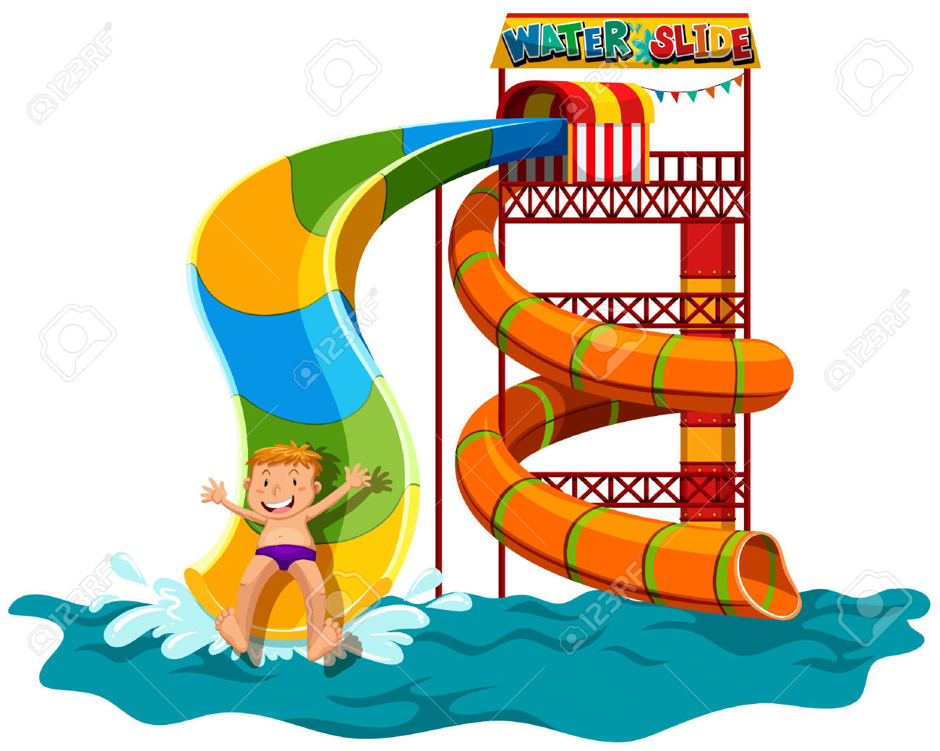
AV Symington Water Park
Friday June 22, 2018
11:30-2:00pm

Pricing
11:30 Town Residents Youth $5.00 Adult $6.00
12:00 Outside Residents Youth $8.00 Adult $9.00

AV Symington Aquatic Center, Leesburg, VA
703-779-5390

Questions- Contact Amy Duellman amduellman@verizon.net

