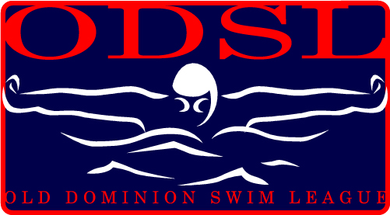
Parental Waiver and Consent 2012 Season
As the parent or legal guardian of the child named below, I hereby give my full consent and approval for my child to participate as a league member in the Old Dominion Swim League.
I understand that there are certain risks of injury inherent in the practice and play of this sport, as well as in traveling and other related activities incidental to my child’s participation, and I am willing to assume these risks on behalf of my child. I hereby certify that my child is fully capable of participating in swimming and that my child is healthy and has no physical or mental disabilities or infirmities that would restrict full participation in these activities, except as listed below.
In addition to giving my full consent for my child’s participation, I do hereby waive, release and hold harmless the organization named below, its officers, the Greenway Gators, coaches, sponsors, supervisors and representatives for any injury that may be suffered by my child in the normal course of participation in swimming and the activities other cause, incidental thereto, whether the result of negligence or any other cause.
Name of Child__________________________________ Date of Birth_____________________
Name of Child__________________________________ Date of Birth_____________________
Name of Child__________________________________ Date of Birth_____________________
Name of Child__________________________________ Date of Birth_____________________
Street Address __________________________________ City____________________ State____
Please list any physical Limitations (allergies, hearing, sight, etc.) __________________________________________________________________________________
__________________________________________________________________________________
Parent’s Signature______________________________________________Date________________
Old Dominion Swim League, Inc.
42820 Forest Spring Drive, Leesburg, VA 20176
www.swimodsl.com

