How to Sign up for Jobs to satisfy Volunteer hours

1 Login to your account, go to http://www.teamunify.com/Home.jsp?team=recodlvetva
2 On the Left there is a sign In link, it takes to screen below

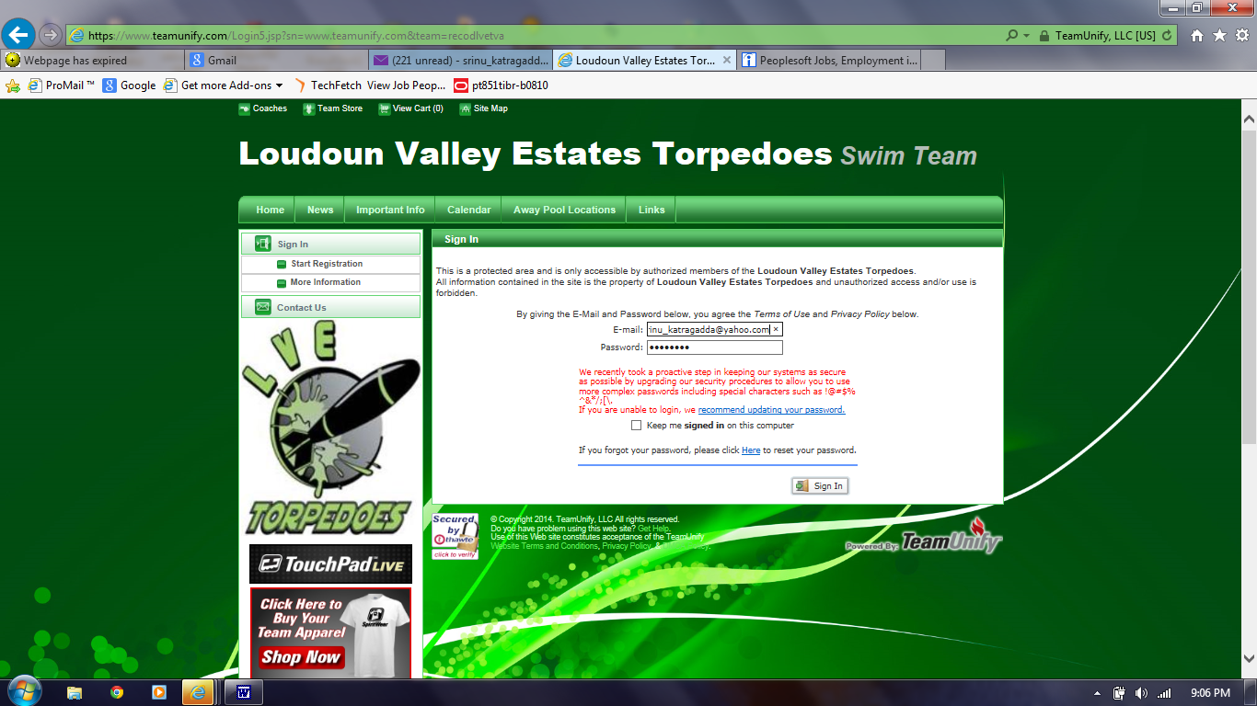

3 One logged in, there is a link for Events, click it. Will show you screen below.
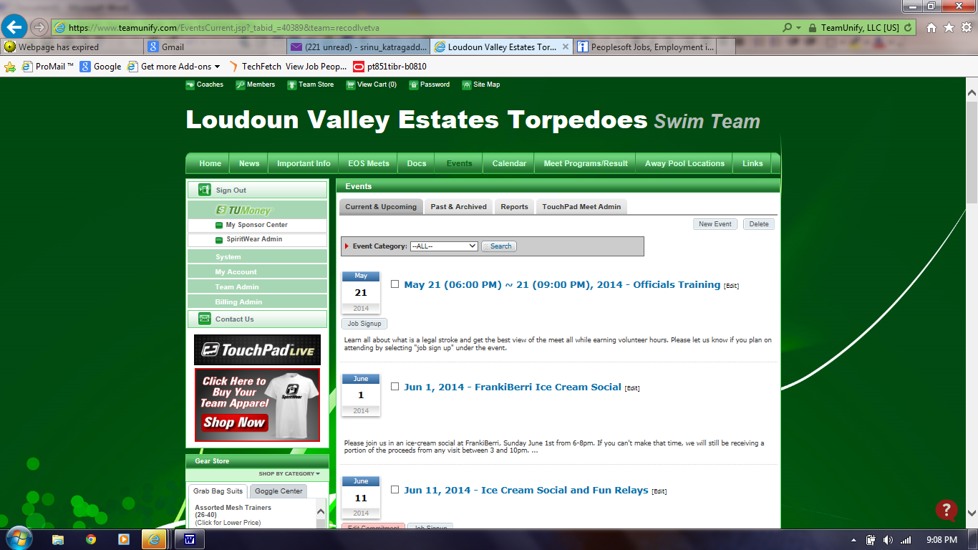
4 Choose the event you want to sign up for, it will take you to below screen shown
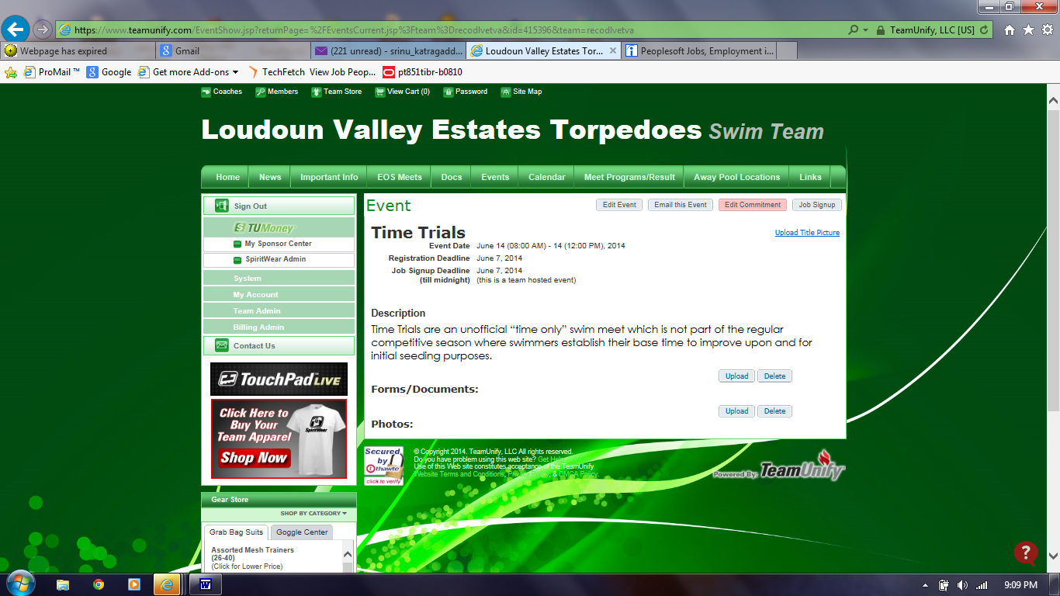

5. Click on the Job sign up link on right corner of event screen. That should show below screen. Job descriptions are found here https://www.teamunify.com/SubTabGeneric.jsp?team=recodlvetva&_stabid_=85394

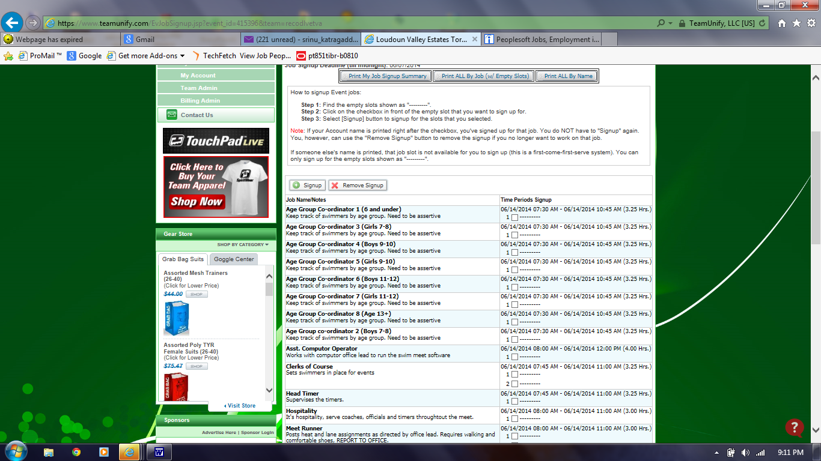

6. Choose the job you want to sign up for. The instructions are on the screen. Once you choose your job, hit sign up button. The refreshed screen will look as shown below. It should show your name next to the job you signed up for.


