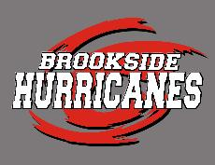
BHST SWIM BUDDY PROGRAM INFORMATION
“Brookside Buddies”
Welcome to the Brookside Hurricanes Swim Team! Spirit and community bonding are crucial parts of a successful team. One of the most contributory programs is being a swim buddy! This program is where older swimmers are matched up with younger swimmers as “Brookside Buddies” to socialize with each other at the pool and cheer each other on at swim meets (especially the big meets!).
WHAT DO I DO FOR MY BUDDY?
Once you find out who your buddy is, introduce yourself. When you receive your buddy’s info sheet, get ready to be a buddy to them. Here are some ideas:
- Notes of encouragement – Draw a picture or make a poster with a creative message for your buddy
- Spirited support – Cheer for them from the side of the pool during their races
- Decorate a cup/water bottle and include a drink for your buddy for swim meets
- Popped popcorn or other favorites for a quick snack
- Baked goods – cookies, cupcakes, brownies (something from your buddy’s favorites list)
- Coloring book items, markers, small games, deck of cards, water toys, beach ball
- Get your buddy a snow cone on a hot day or something from the concession stands
- Decorated plastic containers filled with energy snacks, fruit and/or treats
- A simple congratulation statement such as “Good job!”, “Nice Swim!”, or “Way to go!” is a great way to be a buddy!
GET CREATIVE AND HAVE FUN! EVERYONE LOVES ENCOURAGEMENT BY THEIR FRIENDS AND TEAMMATES!
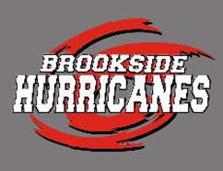
BROOKSIDE BUDDY PERSONAL INFORMATION SHEET
Complete the form below with information about yourself and share it with your buddy at Spirit Night on Wednesday June 14th. The name of your buddy will be in your folders. The buddy pairings will also be posted on the bulletin board inside the clubhouse. **GO HURRICANES**

NAME:_______________________________ BIRTHDAY:___________ GENDER: M / F
AGE GROUP (circle): 8&U 9/10 11/12 13/14 15&O
FAVORITEFOOD/SNACK:_____________________________________________________
FAVORITE BAKED GOOD: ____________________________________________________
FAVORITE CANDY: __________________________________________________________
FAVORITE FRUIT/VEGGIE: __________________________________________________
ANY FOOD ALLERGIES? (circle): YES / NO
IF YES, LIST FOOD ALLERGIES:________________________________________
FAVORITE COLOR: __________________________________________________________
FAVORITE BOOK: ___________________________________________________________
FAVORITE SPORT: ___________________________________________________________
FAVORITE HOBBY: __________________________________________________________
FAVORITE CELEBRITY: _____________________________________________________
WHAT I LIKE TO DO WHEN I’M NOT SWIMMING: _____________________________
______________________________________________________________________________

