Welcome to Meadowbrook Woods
Home of the Makos Swim Team

We are happy to be hosting your swim team this week. We hope the following information will assist you and help the meet run smoothly. Please contact us if you have additional questions.

Directions:
On our website is meadowbrookmakos.com we have a google earth picture of our pool and directions as well.

Using Rt. 234 South (if coming from Manassas area) - follow Rt. 234 South over the Occoquan Creek. After going through the light at Purcell Road, continue for 1 mile and watch for the green sign for Meadowgate Drive in the median. Turn left onto Meadowgate Dr. Take the first right onto Superior Ct. The pool is at the end of the court. The address is 13200 Superior Court.

Using Rt. 234 North (if coming from Ashland/Montcair area) - follow Rt. 234 North past the Woodbine Plaza. Turn right onto Meadowgate Dr. in to the Meadowbrook Woods development.Take the first right onto Superior Ct. The pool is at the end of the court. The address is 13200 Superior Court.

From Hoadly Road (if coming from Woodbridge area) – turn right onto Rt. 234 North. Go approx. 6/10 mile. Watch for the green sign for Meadowgate Drive in the median. Turn right onto Meadowgate Dr. Take the first right onto Superior Ct. The pool is at the end of the court.

Parking: Please observe No Parking signs around the grassy area of the circle. Street parking is fine – please respect owners’ driveways and mailboxes and pull your car with four wheels off the pavement as much as you can without driving/parking on homeowner’s lawns.

Team Area: We encourage visiting teams to set up in the grassy area in the circle in front of the clubhouse and concessions. We will close the parking area and create a walkway of safe passage for families to the circle. There will be a speaker up there and this area provides great shade. We are not allowed on the tennis courts or the deck for any swim team set-up. Please gather all belongings and pick up all trash before leaving.

Warm-ups: Visiting team warm-ups are from 6:30 – 6:50am. The meet will start promptly at 7:00am and we generally finish by 12noon.

Relays: Visiting team relays are in lanes 1, 3, and 5.

Volunteers:
Officials – All officials will meet at 6:30am to go over assignments. Visiting teams should provide a minimum of 3 Stroke and Turn officials plus a Starter and Referee.

Timers/Recorders – we have a six lane pool. This year due to team size we are running two shifts 7-9:30 and 9:30 – 12 or end. These times are approximate and may vary once timeline is published. Your team is welcome to run three shifts—just let our announcer know when you want your shift changes to be and they will announce it.

Visiting teams should provide two (2) timers for lanes 1, 3 and 5 and one (1) timer and one (1) recorder for lanes 2, 4 and 6. There should also be a designated Head Timer. Just FYI – we rotate timers and recorders rather than starts for the 8 & under events. A meeting of timers & recorders will be called at 6:40am.

Other volunteers – we would like 2 Runners to assist during 8 and under events, a Ribbon Writer, at least (2) Clerks of Course throughout the meet to aid in identifying visiting swimmers, and a Heat Ribbon person for the 3rd shift. At least one (1) Scorer and Verifier should be provided throughout the meet.

Equipment: Visiting teams should bring a back-up starter and all stop watches required for their timers.

Viewing: There is roaming/standing only viewing at the back end of the pool, behind the yellow tape. Spectators are welcome to watch through the fence and stand and watch at the shallow end of the pool. We ask that no spectators be present at the start and finish ends of the pool as it gets very crowded and interferes with both the swimmers and the timers/recorders/runners. No tent, chairs/family area set-up is allowed on the deck **See diagram below.

Concessions: Concessions will be available throughout the meet and will be located in front of the clubhouse in the parking lot. Drinks include Iced and hot Starbucks coffee, water, soda, and Gatorade. Donuts, pastries, fruit, the grill should be fired up by 8:00am. Along with hamburgers and hotdogs we will be offering Moe’s burritos or Chik-fil-a. We will be offering meal deals that include chips and drink. Other assorted candies, snacks, and fresh fruit will be on sale. We will also have a roving raffle to win cash and great prizes.

Contacts: Please contact Meet Manager Beth Claessen at (703) 403-3340 or gclaessen4@msn.com for questions regarding volunteers. Head Referee is Craig Kaucher; contact him at craig.kaucher@comcast.net
For more contacts go to our website at: http://www.meadowbrookmakos.com

Meadowbrook Makos Pool Layout
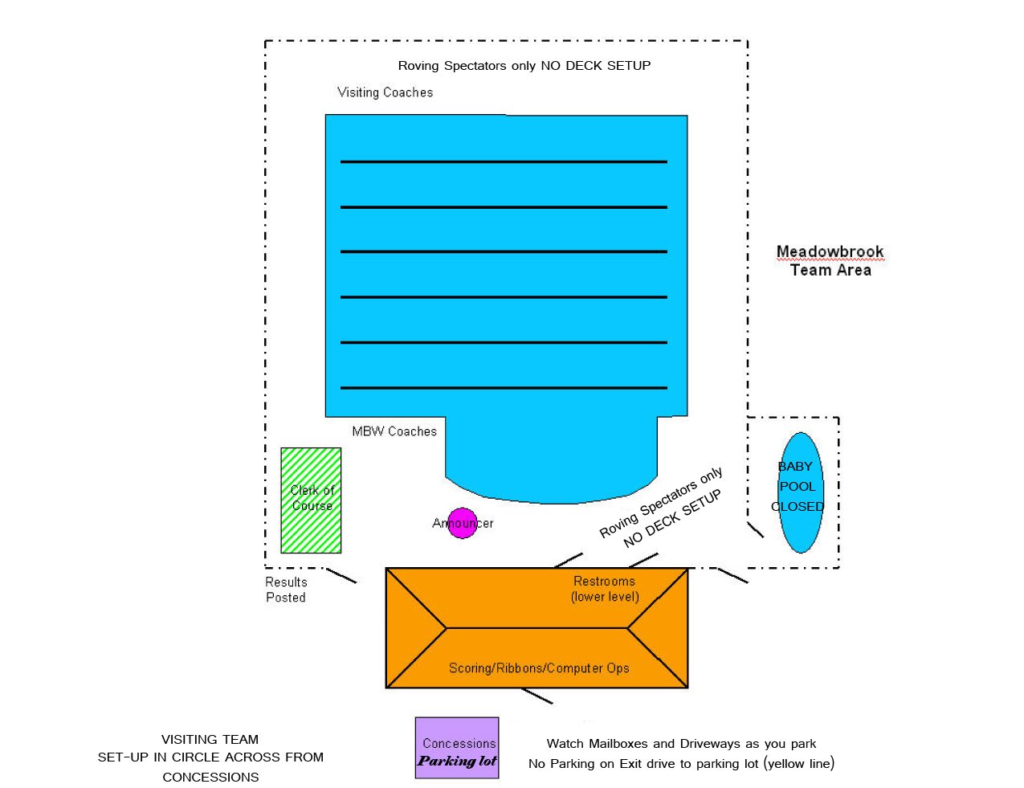

***Note: our shallow end is 3 ½ feet. According to PWSL rules, at that depth swimmers have the option of a water start. This end is only used during relays. This document has been updated June 9, 2013.

