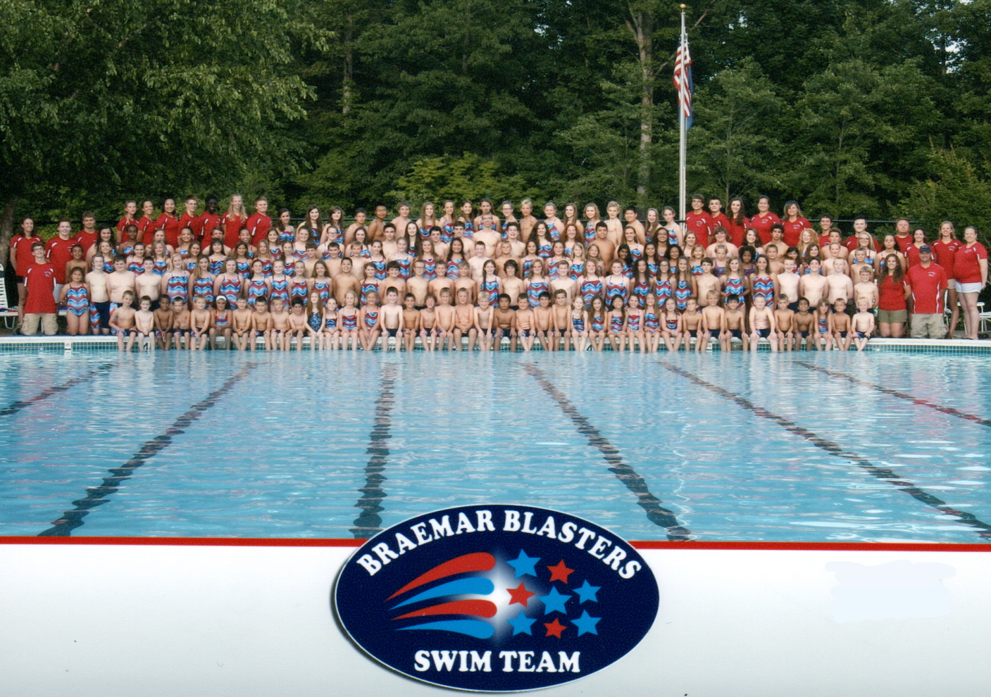

The Braemar Blasters Swim Team is honored to offer you the opportunity to sponsor the Blasters for the 2018 summer season.

The Blasters Swim Team is an IRS 501(c)3 nonprofit organization located in the community of Braemar in Bristow. Our team is comprised of over 320 children ranging from 4 - 18 years of age from the Braemar community as well as other surrounding communities. We are an organization run by parent volunteers with a mission to provide a healthy and fun summer team for our swimmers. Your generous contribution will help to promote fitness, teamwork, sportsmanship, and community building.

We are seeking local sponsors so that we can better provide for our young swimmers by paying coaches, purchasing team equipment, funding team spirit and community social events, and awarding trophies and ribbons for personal achievements. All donations go directly towards helping all children on the team.

Sponsorship is a great way to give back to the community and advertise your business. No matter what level of sponsorship you choose, we will list your company logo and contact information at www.braemarblasters.com and we will add your company logo to our Braemar Blasters meet heat sheets which are distributed to hundreds of people at all of our home meets. Sponsorship runs May 1, 2018 to April 30, 2019. See reverse side for levels of sponsorship.

Braemar Blasters Swim Team - Summer 2018
Sponsorship Tiers:

Reach for the Stars: $1000
- Team photo plaque
- Full-page advertisement in all home meet heat sheets
- Full-page advertisement in the Divisional meet heat sheets
- Company logo and hyperlink listed on www.braemarblasters.com
- Company provided banner to be displayed at all home meets.
- Sponsorship announced at all home meets
- Team Sponsored banner to be displayed at all away meets
- Team polo shirt

Red Sponsor: $500 +
- Team photo plaque
- Half-page advertisement in all home meet heat sheets
- Half-page advertisement in the Divisional meet heat sheets
- Company logo and hyperlink listed on www.braemarblasters.com
- Company provided banner to be displayed at all home meets
- Sponsorship announced at all home meets
- Team Sponsored banner to be displayed at all away meets
- Team T-shirt

White Sponsor: $250+
- Team photo plaque
- Quarter-page advertisement in all home meet heat sheets
- Company logo in the Divisional meet heat sheets
- Company logo and hyperlink listed on www.braemarblasters.com
- Company provided banner to be displayed at all home meets
- Sponsorship announced at all home meets
- Team Sponsored banner to be displayed at all away meets

Blue Sponsor: $100+
- Business card advertisement in all home meet heat sheets
- Company logo and hyperlink listed on www.braemarblasters.com

We welcome gift certificates, coupons, or other donations that can directly support the team. The Braemar Blasters Swim Team is a 501(c)3 nonprofit organization. A portion of your sponsorship may be tax deductible.
The Blasters thank you for your support!

For additional information or questions, please contact Erin Eisenhower @ 571-217-0890 or ike0608@gmail.com

If you would like to be a Blaster sponsor, please return this form with payment to
Braemar Blasters Swim Team, 10302 Bristow Center Dr. PMB 13 Bristow, VA 20136

Sponsor Level (circle one) Reach for the Stars Red White Blue

Company Name:

Contact Name:

Address:

Phone: Email:
Shirt Size (circle one) SM MED LG XLG

