The Dominion Valley Sharks are excited to host the Red Divisional Championship ~ July 30, 2016

Important Dates to Mark on your Calendar:

July 10, 2016 | T-Shirt Pre-Orders Due to Gail Davis apparel@dvsharks.com
July 26, 2016 | Meet Entries due to computers@dvsharks.com
July 26, 2016 | Officials Referees, Starters and Stroke & Turns due to officials@dvsharks.com
July 26, 2016 | Volunteer names due to volunteers@dvsharks.com Including Timers & Recorders names
July 27, 2016 | Volunteer shift breakdown (Volunteer Coordinators)
July 26, 2016 | Preferred Parking and Handicap space request due to president@dvsharks.com
July 30, 2016 | Red Divisional Championship at DVCC

ABOUT DOMINION VALLEY SWIM TEAM SHARKS
The Dominion Valley Swim Team pool is located at 5350 Tournament Drive, Haymarket VA 20169. Our website is www.dvsharks.com; click on ‘about us’ for more information.

DIRECTIONS: To get to our pool from the Linton Hall corridor, take Linton Hall Rd. to north on Rt. 29. Take exit onto 66 west. Go 3 miles on I-66 West to Exit 40 and make a right onto Route 15 North. Go 1.5 miles to a left onto Dominion Valley Drive. Make a left at the first traffic light, through the gate, onto Tournament Drive. Our pool is on the immediate right. We always have a fun filled Divisional meet and we are looking forward to another with some new friends!

POOL LAYOUT DIAGRAM/TEAM SETUP
NEW FOR 2016... There will be NO personal tents inside the pool area. Only chair seating will be allowed. All personal tents must be set up outside the gates, in the grassy area. However, coach’s areas may be tented and teams may utilize their space for a team tent.

Swimmer traffic flow is depicted by the yellow arrows, starting at the yellow circle in the gray space. In the past, some teams have requested to have their own separate clerk of course tent set up, because this is how they organize their little ones. The kids gather at the yellow circle and flow to the right across the pavilion, seated on a series of bleacher benches. They flow down the stairs at the right of the pavilion to three rows of chairs (seated by heat) at the curved arrow. From there the swimmers move to the start area where there are a series of chairs seated 4 heats deep.

The only areas roped off to spectators are the areas of the start from left of the visiting coaches, around to the left of the starter setup.

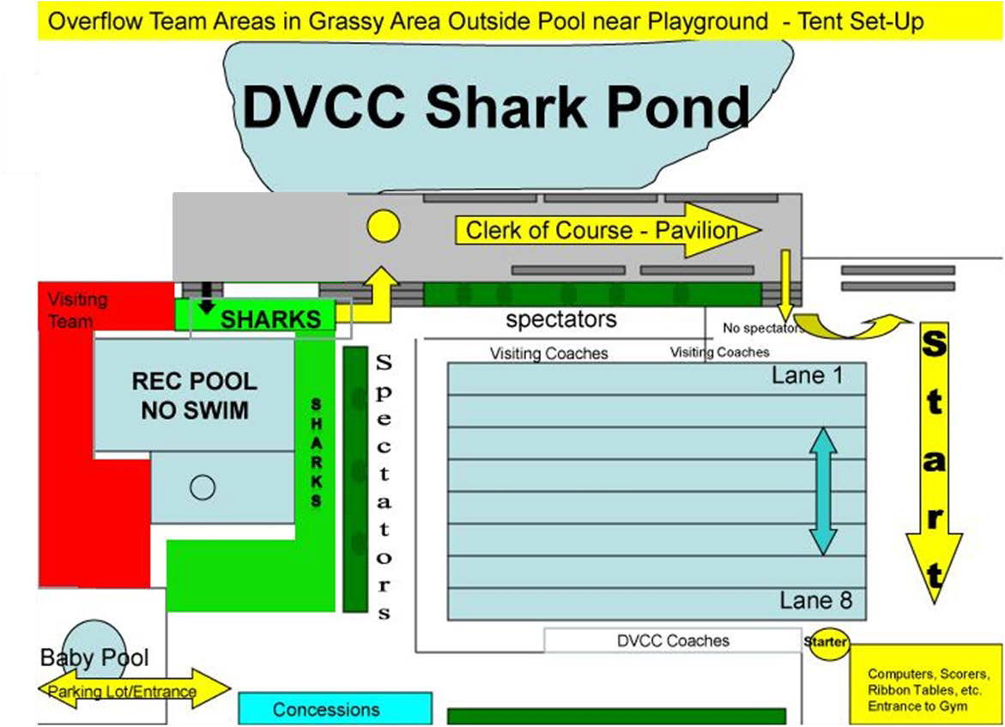

PARKING: Our HOA restricts access and limits the number of entrances to the community. For Divisionals we can only allow passes for four cars (President, Volunteer Coordinator, Computer Representative and Head Coach) for each visiting team, Ashland and Kingsbrooke.
- Please send an email to president@dvsharks.com and “CC” rules@dvsharks.com with the names of the four drivers and we will leave their names with the gatehouse. Please let those drivers know they will need to show an ID and tell them to arrive early as parking is limited.
- Handicap Parking please send an email to president@dvsharks.com and “CC” rules@dvsharks.com with the names of those in need of handicap parking. Please note they must have a handicap parking pass.
- All other swimmer families will need to park in the Giant Parking lot across from the main entrance. Instead of making the first left once on Dominion Valley Dr., make the first right.
APPAREL: Our apparel person Gail Davis (apparel@dvsharks.com) is working with UnRuly Sports to firm up the deadline for the Red Division Championship t-shirt pre-orders. Each team will be provided the order form once final proof has been received and final cost established. The tentative timeline is set for July 10, 2016 (to be confirmed TBC).

- Pre-order forms will be provided to each team.

- Each team will need to designate a t-shirt representative responsible for collecting order forms and payments. They will also serve as the liaison for any question that parents may have. Please provide names and email addresses to apparel@dvsharks.com and president@dvsharks.com.
- Each team will handle their own t-shirt pre-sales. (Each team will keep proceeds from t-shirt sales from their own team).
- Each t-shirt representative will be responsible for collecting order forms and payments and coordinating with DV Sharks apparel person.
- Sunday July 10, 2016 orders will be coordinated and submitted to Gail Davis. T-Shirt orders will be placed first thing on Monday morning.

HEAT SHEETS/MEET PROGRAMS
DV will not sell or provide heat sheets to patrons. DV will provide heat sheets to all meet officials, and put any balance at the concessions stand for parents to pick up.
In the past Kingsbrooke and Ashland did not sell or provide heat sheets.

Regarding ads in the heat sheets – we will need to get the computer reps together to discuss and coordinate through them. What has been done in the past the computer reps have added to their own meet program their sponsors and distributed to their team – this will be the same again this year.

SWIMMER ENTRIES: Please email the list of your swimmers / entries to our computer rep, Margaret Schroeder at computers@dvsharks.com or schroeder7647@aol.com.
- Following the last meet before the Divisionals, Tom Howe (PWSL) will provide the host team computer rep with a times report for the Division.
- DV Sharks Computer Rep, will create a database of all the teams and will redistribute it to all the Computer Reps.
- All divisional entries must be submitted to DV Sharks computer rep by Tuesday, July 26th @ 7:00pm.
- All teams bring their computer gear.
- Please see computer support further in the letter for more information.

COACH & PARENT RELAYS: At the end of the meet coach and parent relays will be run. Please provide ‘A’ and ‘B’ teams, names of swimmers. Relays will be

Event #
68 | Coach Mixed | 100 M Medley Relay
69 | Parent Mixed | 100 M Medley Relay
70 | Coach Mixed | 100 M Free Relay
71 | Parent Mixed | 100 M Free Relay

SENIOR or LAST SWIMS: Please provide the computer representative computers@dvsharks.com and president@dvsharks.com the names of your team seniors and or last swims. Please include first name, last name, last event swimming at divisionals, and anything notable. The Head Officials will be notified of seniors and last swims and the names of the swimmers will be announced by the DJ.

MEET TIMELINE – Warm Ups: The meet timeline is as follows:

Timeline
5:30 – 5:50 AM | Coaches (open to all teams) | All Lanes
5:50AM - 6:10 AM | Sharks warm-ups | All Lanes
6:10AM - 6:30 AM | Kingsbrooke Sea Lions’ warm-ups | All Lanes
6:30AM – 6:50 AM | Ashland Piranhas’ warm-ups | All Lanes
6:20 AM | Referee and Starters meeting | Gym
6:30 AM | Stroke and Turn Officials' meeting in the gym at the far end of the main building | Gym
6:45 AM | Timers' and Recorders' meeting near scorer’s table | Near Scorer’s Table
6:50 AM | Clear the pool.
6:50 AM | Relays Assemble in team areas and move to proper lanes to prepare for start of meet.
6:55 AM | National Anthem is sung
7:00 AM | Meet Starts  Note: In the roped off areas – only racing swimmers, coaches, and working volunteers should be on deck.

OFFICIALS: Bring all that you have.

Official Referee(s), Starter(s) and Stroke & Turns, please send your list to our DV Sharks Official at officials@dvsharks.com by July 26, 2016.

STARTER & REFEREES
Events | Team | Starter - Referee | Alternate Referee
66-67, 1-19 | Dominion Valley
20-37 | Kingsbrooke
38-57 | Ashland
58-65 | Dominion Valley

STROKE & TURN SHIFT(s)
The Stroke & Turns will rotate clockwise. If there are enough S&T Officials we will have outs; at the Start end (officials enter at Lane 1) and outs at the turn end (officials enter in at Lane 8). In short, note the following:

Shift 1
Events 66-67, 1-37 | Lanes 1 & 2 | Lanes 3&4 | Lanes 5&6 | Lanes 7 & 8
Starting End | Ashland | Dominion Valley | Kingsbrooke | Dominion Valley
Turn End | Kingsbrooke | Ashland | Dominion Valley | Ashland
Rotational Outs
Start End  Comes in at Lane 1 | TBD | TBD | See explanation above for rotation.
Turn End  Comes in at Lane 8 | TBD | TBD | See explanation above for rotation.

RELAY CONFIRMATION JUDGES
Events 66 – 67, 1-9, 58 – 65
Starting End | Off Duty Referees/Chief Judges and/or Stroke & Turn Officials
Opposite End | Off Duty Referees/Chief Judges and/or Stroke & Turn Officials

Relay Lane Assignment
Lane 1 | Lane 2 | Lane 3 | Lane 4 | Lane 5 | Lane 6 | Lane 7 | Lane 8
 | AST B | KBSL A | DV A | AST A | KBSL B | DV B
- When Relay Event has 1 heat of 6 or less A&B teams competing the above lane assignment applies. (excerpt from PWSL Bylaws Section V. Divisional Championship Meets)

VOLUNTEERS NEEDED:
We will be running 3 Shifts. Exact split of the shifts for volunteers will be determined as the meet is seeded and submitted on Tuesday night.
Dominion Valley volunteer coordinators are: Robyn Burns and Michelle Natysin at volunteers@dvsharks.com. They will follow up with all teams on the specific volunteer shift breakdown on Wednesday, July 27, 2016.
Tentative Timeline
• Shift 1: 6:50 a.m. - 9:15 a.m.
• Shift 2: 9:15-11:30
  - Shift 3: 11:30 - End Of Meet

Volunteers Checklist: | - Clerk of Course  - Head Timers  - Heat Ribbons  - Officials… As many as you can bring!  - Recorders  - Ribbon  - Runners  - Runners  - Scorers  - Starting Blocks  - Timers  - Verifiers

CLERK OF COURSE: 2 per shift, per team.

Relay Lane Assignment
Lane 1 | Lane 2 | Lane 3 | Lane 4 | Lane 5 | Lane 6 | Lane 7 | Lane 8
 | AST B | KBSL A | DV A | AST A | KBSL B | DV B

HEAT RIBBONS: Each team provides one per assigned shift, working 4 lanes.
Shift 1: DVCC and Ashland
Shift 2: Kingsbrooke and Ashland
Shift 3: DVCC and Kingsbrooke

RIBBONS: 1-2 per shift, per team (we do not have room for more). They will be located next to the gym or if extremely warm in the gym.
RUNNERS: Each team provides two per assigned shift. Our scorer and computer table is located next to the gym (or if extremely warm in the gym).

Shift 1: Ashland and Kingsbrooke
Shift 2: Kingsbrooke and DVCC
Shift 3: DVCC and Ashland

STARTING BLOCK: 1 per shift, per team. This position is just to cover the 10 and under swimmers while they are on the final block under the big tents, to keep them moving up in line.

TIMERS, RECORDS AND HEAD TIMERS
- Each Team is responsible for staffing their respective assigned lane(s) during the Divisional Meet.
- DO NOT leave your assigned lane until your replacement is on deck and ready to rotate. It may be necessary for you to stay on duty for a short time in the beginning of the next shift. We do not want to slow the meet down waiting for replacements. Notify the Head Timer and a replacement WILL be found as soon as possible.
- Completed Timer/Recorder Schedule must be sent to Robyn Burns and Michelle Natysin at volunteers@dvsharks.com by
Tuesday, July 26, 2016.

Timers, Records and Head Timers Schedule
SHIFT 1
Events 66-  67, 1-19 | Lane 1 | Lane 2 | Lane 3 | Lane 4 | Lane 5 | Lane 6 | Lane 7 | Lane 8
Timer | DV | DV | DV | DV | DV | DV | DV | DV
Timer | KBSL | KBSL | KBSL | KBSL | KBSL | KBSL | KBSL | KBSL
Timer | AST | AST | AST | AST | AST | AST | AST | AST
Recorder | DV | KBSL | AST | DV | KBSL | AST | DV | KBSL
Head Timer
 | DV
 | KBSL

SHIFT 2
Events 20-  47 | Lane 1 | Lane 2 | Lane 3 | Lane 4 | Lane 5 | Lane 6 | Lane 7 | Lane 8
Timer | DV | DV | DV | DV | DV | DV | DV | DV
Timer | KBSL | KBSL | KBSL | KBSL | KBSL | KBSL | KBSL | KBSL
Timer | AST | AST | AST | AST | AST | AST | AST | AST
Recorder | AST | DV | KBSL | AST | DV | KBSL | AST | DV
Head Timer
 | KBSL
 | AST

SHIFT 3
Events 48-  65 | Lane 1 | Lane 2 | Lane 3 | Lane 4 | Lane 5 | Lane 6 | Lane 7 | Lane 8
Timer | DV | DV | DV | DV | DV | DV | DV | DV
Timer | KBSL | KBSL | KBSL | KBSL | KBSL | KBSL | KBSL | KBSL
Timer | AST | AST | AST | AST | AST | AST | AST | AST
Recorder | KBSL | AST | DV | KBSL | AST | DV | KBSL | AST
Head Timer
 | AST
 | DV

STARTING BLOCK: 1 per shift, per team. This position is just to cover the 10 and under swimmers while they are on the final block under the big tents, to keep them moving up in line.

SCORERS & VERIFIERS
SHIFT 1
Events 66-  67, 1-19 | Scorer 1 | Scorer 2 | Scorer 3 | Scorer 4
Scorer | DV | AST | DV | KBSL
Verifier | KBSL | AST

SHIFT 2
Events 20-  47 | Scorer 1 | Scorer 2 | Scorer 3 | Scorer 4
Scorer | AST | DV | AST | KBSL
Verifier | KBSL | DV

SHIFT 3
Events 48-  65 | Scorer 1 | Scorer 2 | Scorer 3 | Scorer 4
Scorer | KBSL | AST | KBSL | DV
Verifier | DV | AST

COMPUTER SUPPORT
Each team computer representative is requested to be available throughout the meet for computer support. Each team's computer rep must be available during the opening and closing relays in case additional information (i.e. swimmer names) is needed. Data entry will take place by one team per event according to the following schedule:
Opening Relays: Dominion Valley (DVS) computer team
Freestyle: Ashland (AST) or Kingsbrooke (KBSL) computer team
IM: Dominion Valley (DVS) computer team
Backstroke: Ashland (AST) or Kingsbrooke (KBSL) computer team
Breaststroke: Dominion Valley (DVS) computer team
Butterfly: Ashland (AST) or Kingsbrooke (KBSL) computer team
Closing Relays: Dominion Valley (DVS) computer team

When it is your team's turn to enter data, the team’s computer representative will have the chair. When it is not your team's turn, please respect the right of the serving team to step away to watch a swim. This is a different protocol than many meets; however, the hope this removes the need for competing for the "data entry seat". When your computer team is not assigned to data entry, you can help with verifying, ribbons or posting data, or take some time to watch the meet and/or get some refreshments.
Ashland (AST) or Kingsbrooke (KBSL) computer team will assist by doing ribbons throughout the meet. This can be decided online or at pre-Divisionals meetings.

NOTE:
- Team Areas: Kingsbrooke will have the half of the above Visiting Team area closer to the baby pool and Ashland will have the other half closer to the pond.
- Each team has space for a team tent inside the pool area.
  - The club will not allow us to remove the fencing in the visiting team area leading to the playground.
  - All space in the playground and in the grassy areas to the left of the visiting team area is open to anyone and is first come first serve for tent space.
- Coaches seating: DV coaches will be seated at the near side of the pool, middle, closest to the clubhouse. KBSL and AST coaches will both be seated on the direct opposite side of the pool, dividing the allocated space in half. There is plenty of room for visiting coaches to set up tents.
- The baby pool area will be location for posting of results.
- Apparel Tables: KBSL and AST are welcome to set up Apparel Tables if requested, location to be determined.

OTHER ITEMS

BATHROOMS
It has rarely been an issue in the past, and we are sure it wouldn’t be an issue, but please gently remind your kids to treat the bathrooms inside of the facility as if it was their own home. We raise this because the club is pretty tough on the swim team in regard to the care of the bathrooms during meets. It is the swim team’s responsibility to clean them and in the past have been charged to clean it. Much appreciated!

USE OF THE BABY AND SHALLOW POOL
Use of the shallow and baby pool is prohibited during swim meets. The club provides no life guard for this pool during the meet, hence, we must keep all children out of the pools.

Dominion Valley Sharks Swim Team Contact Information
Please contact our PWSL Representative with any questions or issues.

PWSL Rep.: | Ray Nash  Dominion Valley Sharks Swim Team  rules@dvsharks.com
Volunteer Coordinator | Robyn Burns and Michelle Natysin  Dominion Valley Sharks Swim Team  volunteers@dvsharks.com
President | Woody Woodson  president@dvsharks.com

