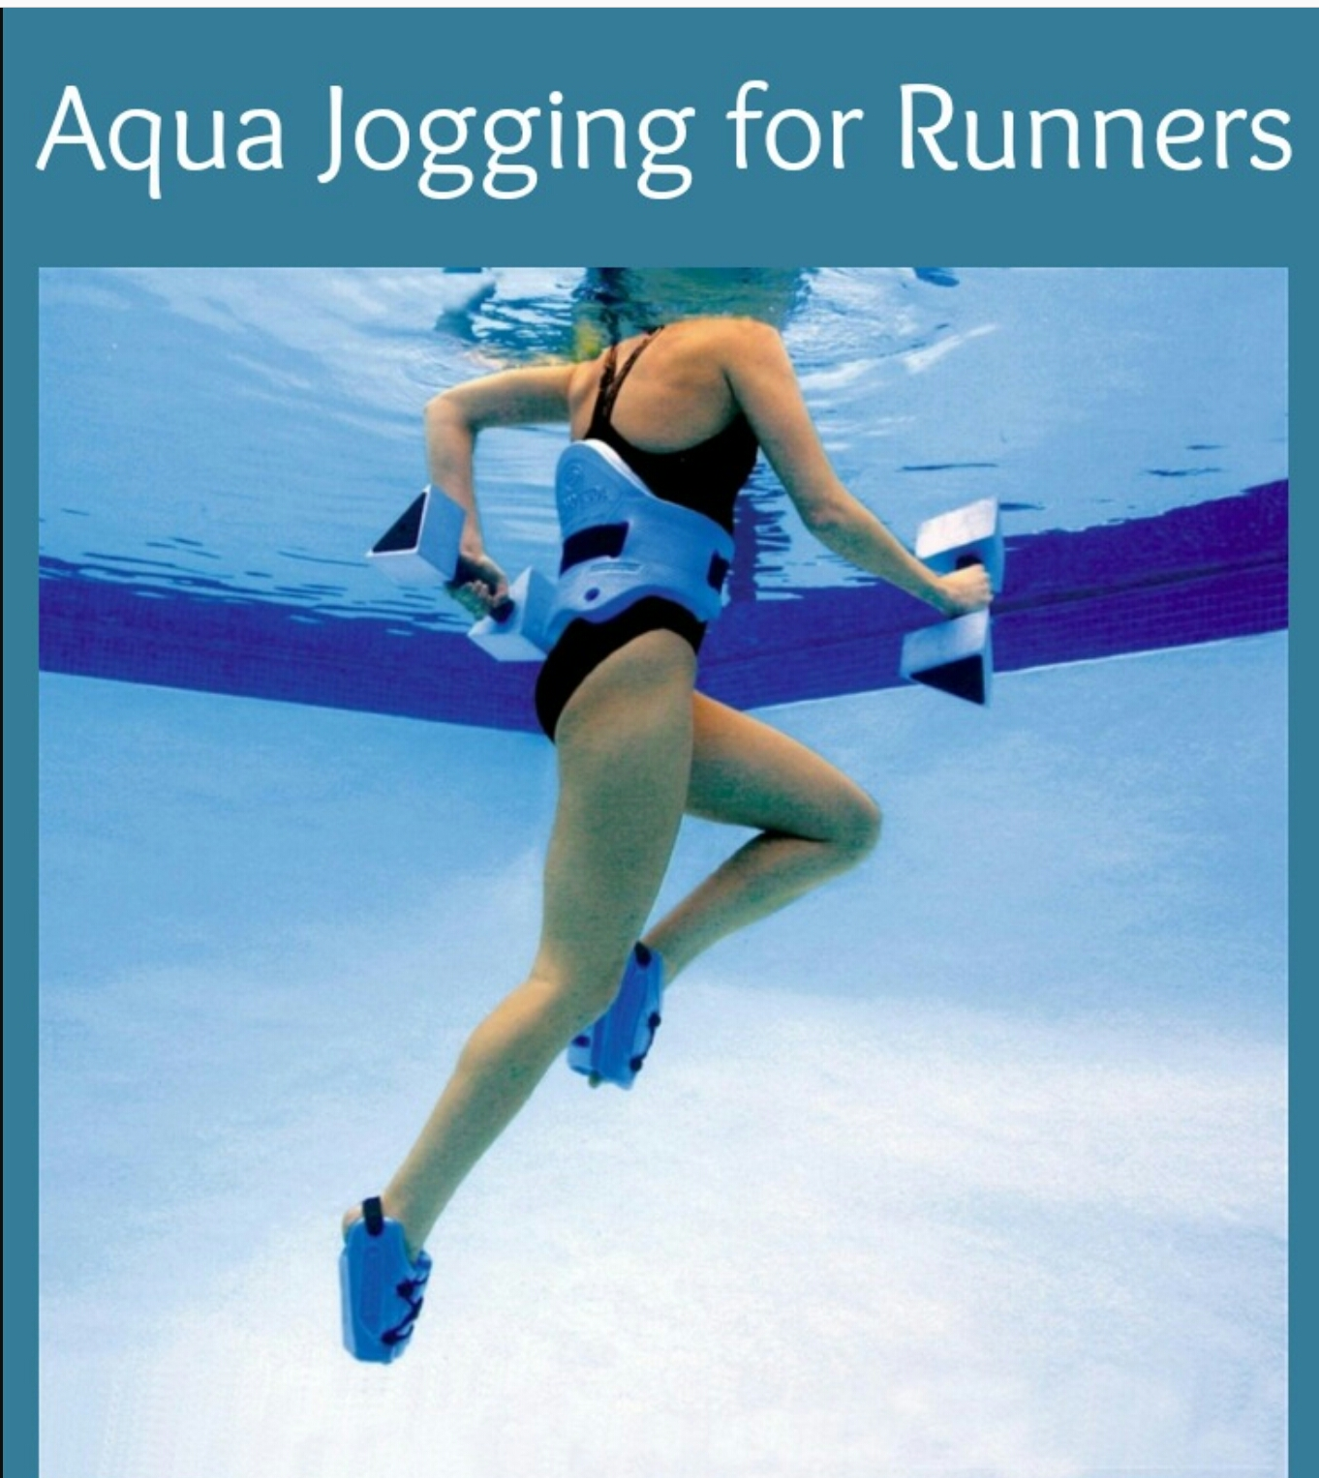

Lake Ridge Lancer Swim Team Sponsored

Aqua Jogging for High School Athletes

Attend a Clinic & Try It For Free on Tuesday, June 20
5:30-6:30 pm
If you like it, purchase a punch pass right after the clinic.
Clinic Presenter: Colgan’s XCTF Coach Dave Davis

@ Lake Ridge Swim Club
12640 Harbor Dive
Lake Ridge, VA 22192
(across the street from Patient’s First and Taco Bell at Tackett’s Mills)

Aqua Jogging will be held every Tuesday & Thursday evening
5:30-6:30 pm
June 20 – July 27

$5 drop-in fee for HS Students
or
Purchase an 8-punch pass for $32

Questions??? Please email ks_misencik@yahoo.com
cash or checks accepted
(please make checks payable to Lake Ridge Lancer Swim Team)

