 | PWCS Aquatics Center - At Colgan HS  Sundays  4:00-5:00 pm – Level 1 & 2  5:00-6:00 pm – Level 3 & 4 | Kids Choice Sport Center Pool  Wednesdays  4:30-5:30 pm – Lil’ Lancers, Level 1 & 2  5:30-6:30 pm – Level 3 & 4
September  2016 | 9/11, 9/18, 9/25 | 9/7, 9/14, 9/21, 9/28
October  2016 | 10/2, 10/9, 10/16, 10/23, 10/30 | 10/5, 10/12, 10/19, 10/26
November  2016 | 11/6, 11/13, 11/20 | 11/2, 11/9, 11/16, 11/30
December  2016 | 12/4, 12/11,12/18 | 12/7, 12/14
January  2017 | 1/1, 1/8, 1/15, 1/22, 1/29 | 1/4, 1/11, 1/18, 1/25
February  2017 | 2/5, 2/12, 2/19, 2/26 | 2/1, 2/8, 2/15, 2/22
March  2017 | 3/5, 3/12, 3/19, 3/26 | 3/1, 3/8, 3/15, 3/22, 3/29
April  2017 | 4/2, 4/23, 4/30 | 4/5, 4/19, 4/26
May  2017 | 5/7, 5/14, 5/21 | 5/3, 5/10, 5/17, 5/24
 | Sunday only Fee structure | Wednesday only Fee Structure  (Includes Lil Lancers) | Both Sun and Wed
Monthly payments | $50/month | $53/month | $103/month
Pay in Full | $384 | $408 | $792
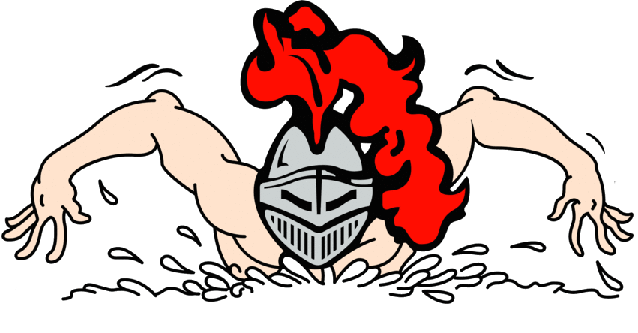
Lancer Off-Season Conditioning Program

Payment for the entire month is due at the beginning of each month.
No partial month payments, please.

