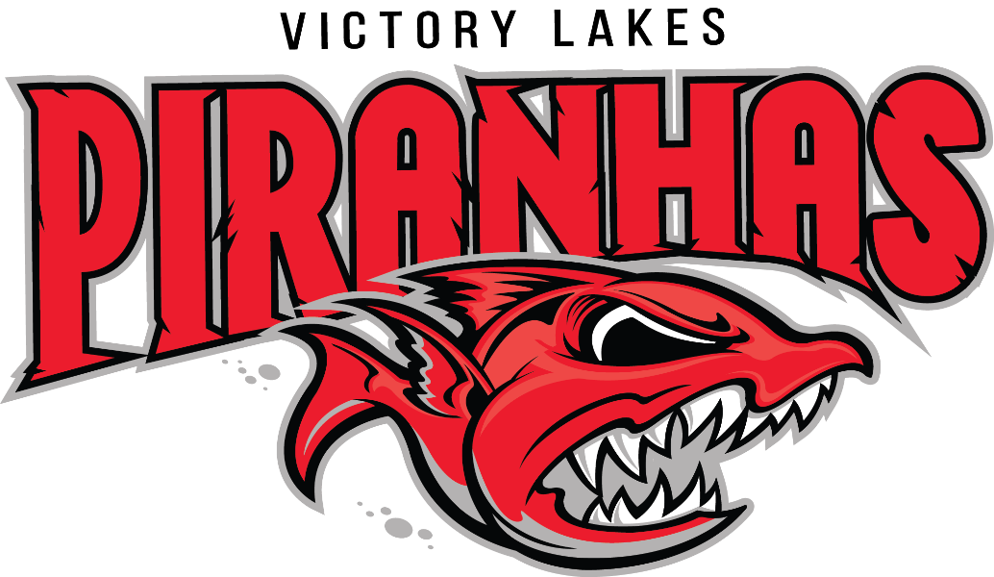
Dear Valued Community Leader,
The Victory Lakes Swim Club is excited to begin its 14th summer swim season! We are located in the community of Victory Lakes in Bristow and are a member of the Prince William Swim League (PWSL). Our team is comprised of over 200 swimmers ranging from ages 5-18 years of age. We are an organization run by parent volunteers with a mission to make swimming a fun experience for our kids. Our Board of Directors and coaches work very hard to instill the benefits of hard work and sacrifice, the traits of good sportsmanship, the seeds of leadership and the joy of community spirit within our club.
We are looking for sponsors to form relationships with as we continue to grow and expand our team. Sponsorships greatly help defray the cost of running such an organization and go towards items such as equipment, Piranha of the Week awards and team social events.
Sponsorship provides your business with an excellent opportunity to show your support of local families and athletics. In addition to the satisfaction of giving back to the community, the increased consumer loyalty of the team and creating an ongoing business partnership, becoming a Victory Lakes Swim Club sponsor provides advertising opportunities outlined on page 2.
We understand the current economic climate has created trying times for many, so whatever you can do to support the Victory Lakes Swim Club is greatly appreciated. If you have any questions or would like additional information, please email sponsorship@vlpiranhas.com.
Thank you in advance for your consideration,
Alison Johanson President, Victory Lakes Swim Club

Victory Lakes Piranhas Sponsorship Opportunities - Summer 2017
Sponsorship Tiers:
Bronze: $150 -$299 Business card sized advertisement in Piranhas Bytes e-newsletter (June, July & August) Business logo posted in display case at the Victory Lakes Pool , Business logo and hyperlink listed on www.vlpiranhas.com and Sponsorship announcement at all home meets
Silver: $300-$499 Quarter-page advertisement in our Piranhas Bytes e-newsletter (June, July & August) Half-page advertisement posted in display case at the Victory Lakes Pool, Business logo and hyperlink listed on www.vlpiranhas.com , Sponsorship announcement at all home meets Distribution of approved advertising flier to all team families, Team photo plaque , Team t-shirt
Gold: $500 - $599 Quarter-page advertisement in our Piranhas Bytes e-newsletter (June, July & August) Full-page advertisement posted in display case at the Victory Lakes Pool ,Business logo and hyperlink listed on www.vlpiranhas.com Sponsorship announcement at all home meets. Distribution of approved advertising flier to all team families , Team photo plaque, Team t-shirt , 2.5’ x 5’ vinyl color banner with business logo displayed at all home meets, Business logo included on the back of our registration (commitment by 5/1/17) and end of season banquet shirts
Platinum: $600+ For businesses interested in sponsorships of $600 or greater, you would receive all of the benefits of a Gold Sponsor. In addition, your business logo would be displayed (along with the Piranhas logo) on durable equipment used by the team year after year. Display possibilities include team and/or coach pop-up tents, tear-drop display flags, directional signs, etc.

Victory Lakes Piranhas - Sponsorship Form
Name of Business: ____________________________________________________________________ Contact Person: _______________________________ Sponsorship Level (see above): ___________ Email: _______________________________________ Phone #: ______________________________ Address: ____________________________________________________________________________ T-shirt Size (if applicable - Silver, Gold & Platinum Sponsors ONLY): _____________________________
If you would like to be a Piranhas sponsor, please complete this form and return with payment (check made payable to VLSC) to Alison Johanson, 12007 Lake Dorian Drive, Bristow, VA 20136. If you have any questions, please email sponsorship@vlpiranhas.com.

