***The Sign up Deadline for swimmers to Declare or decline is Every Tuesday at Midnight. don’t forget***

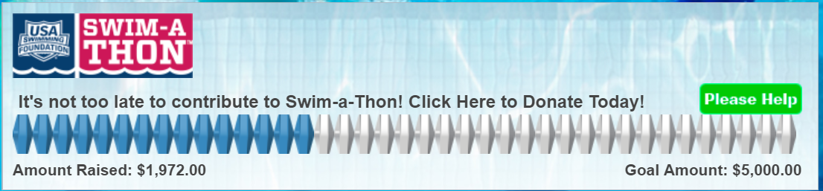

### **Volunteers**

### Please [sign up to volunteer](https://www.teamunify.com/EvJobSignup.jsp?team=recpwvpstva&event_id=1061546) for the upcoming swim meet **While you’re there, please also take a shift or two for the Divisionals Meet at Montclair-most roles have 3 shifts.**

### Review the [volunteer tracker](https://www.teamunify.com/SubTabGeneric.jsp?team=recpwvpstva&_stabid_=169684) of shifts worked and let us know of any discrepancies!

**End of the Year Celebration 3-9pm, Sunday July 28th**- We will host an awards ceremony, pot luck and pool party to celebrate the end to our awesome season. Pot luck is first. Then awards with the pool opening at 6:30pm for all Marlins families. [Link](https://www.signupgenius.com/go/10C044CA4AC2EA20-awards) to sign up for pot luck. The team will supply the burgers, hot dogs and cake and drinks!

**We are still accepting donations from the Swim a Thon. Let’s make one final push!**

**Meet Recap: July 20 against Brookside**

**Brookside Hurricanes: 2,895**

**Veterans Park Marlins: 1,865**

[Final Meet Score](https://www.teamunify.com/recpwvpstva/UserFiles/Image/QuickUpload/vpst-vs-blst---meet-score_028596.pdf)

[Top 25 Times](https://www.teamunify.com/recpwslva/__doc__/top25wk6-2019.pdf)

[Top Relays](https://www.teamunify.com/recpwslva/__doc__/top15relayswk6-2019.pdf)

[Time Improvement Report](https://www.teamunify.com/recpwvpstva/UserFiles/Image/QuickUpload/vpst-time-improvement-report_086698.pdf)

###### Next: Orange League Divisionals @ Montclair

**Date: 07/27/2019**

5:15 AM – Tent City Opens

6:30 AM – Warm ups for Marlins

6:57 AM – National Anthem

7:00 AM – Meet begins

End of Meet—Finish @ or before 1pm



Spirit Week is underway as we head towards the finish line with our Divisional Meet at Montclair on Saturday, July 27th.

**Tuesday:** Baked Sweets & Treats Night - Families can bring baked items (no peanuts or nuts) such as brownies, cookies, muffins, etc to share with the team.

**Wednesday:** Slides, Boards & Fun Swim

**Thursday:** Pizza Party Night -Pizza and drinks are provided to all swimmers

**Friday Morning:** Greased Melons & Fun Relays. This is the last practice of the season. Practice is from 7:00 AM - 9:00 AM and will feature several fun and entertaining relays and the annual greased watermelon polo!

2020 Marlins Executive Board Election- The 2019 Board of Directors election is now underway to fill the board positions for next season. We have three excellent nominees for President, Computer Representative and Secretary. The Board and team are grateful for the many sacrifices, time, and efforts that our current Secretary, Katie Smith, and Computer Representative, Geoff Weber, have given to our team! Your contributions are appreciated and we thank you for your service!

Please review the nominees below and vote [here: 2019 Board Election](http://www.easypolls.net/poll.html?p=5d3507b8e4b027365670169e)

Cheer Grams Available for Divisionals Meet Program: Give a shout out to your teammates • Cheer on your swimmer • Congratulate your seniors • Advertise your business.

Prices: Full page ad: $50 Half page ad: $30 Quarter page ad: $15 Business card size ad: $5 To purchase, please send a check payable to “Montclair Seahawks” to John Avelis, 4313 Fallstone Pl., Montclair VA 22025(Please include your name/business name and team name on the check or an enclosed note - enough information to indicate which submitted ad you’re paying for)

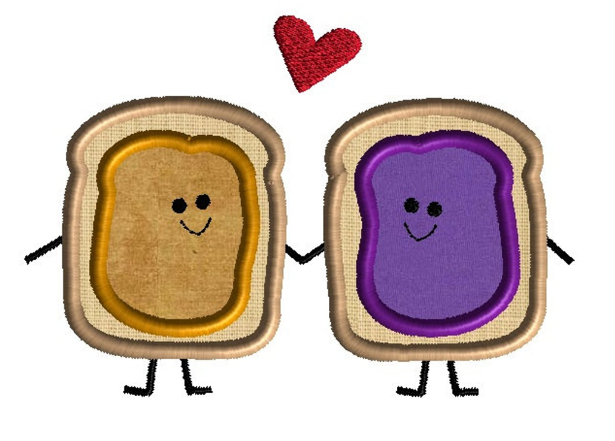During Spirit Week, the team will be collecting donations for ACTS of Prince William County. ACTS (Action in Community Through Service) fosters hope, provides relief and promotes self-sufficiency for our Prince William area neighbors in crisis. ACTS is in need of peanut butter and jelly. The team will collect unopened jars of peanut butter and jelly this week at practice to support the ACTS food pantry.