Welcome to Team Fernandina Stingrays 2018

Team Philosophy: TFS coaches and staff seek to provide a safe, team experience for swimmers as they develop swimming skills, set and attain personal goals, learn self-discipline and practice good sportsmanship. We think of ourselves as a “family.” We have fun, enjoy each other’s company and, hopefully, win some meets in the process. The team culture that we’ve created for over 20 years is based on the 3 Fs:

FUN! It's all about the kids! Our number 1 focus is for the kids to be safe and have fun.

FITNESS! TFS keeps your kids moving with fundamental activity. Swimming keeps kids in shape and teaches basic fitness principles that last a lifetime.

FRIENDS! Ask any of our returning swimmers and many will tell you that what they love most about TFS are the friendships they've made. Whether it's car pools to practice, hanging out at the end of the lane, or cheering each other on at meets, TFS swimmers build long lasting friendships.

Team Organization: We are an independent 501 tax-exempt entity. We are not affiliated with the City of Fernandina Beach, but we are a member of the River City Swim League of NE Florida. All coaches and board members serve on a voluntary basis – we do not have paid staff members. Coaches, board members, and parents are responsible for running every aspect of the swim team.

Communication: Check your email daily! It is your responsibility to check (and respond if needed) to any communications promptly. We also communicate via our Facebook page. For urgent messages, we send out text alert messages. Make sure you have registered your email and cell phone number in the system to receive messages. Visit our website frequently! We update our website weekly with news and events. Visit the website often to keep informed of what’s going on. www.swimtfs.org

Team Rules - For the protection and safety of our swimmers, it is very important that all TFS swimmers obey these team rules:
(1) All team members MUST remain within the pool area (the fenced pool and the locker rooms). The Rec Center is allowing us to rent this area and there is no reason for any of our members to “roam” the grounds or use other areas.
(2) No glass containers are permitted anywhere on Rec Center grounds.
(3) No swimmers in the lifeguard stand at any time.
(4) No running on the pool deck; no pushing or horseplay anywhere on the Rec Center grounds.
(5) No diving into the pool unless under a COACH'S supervision.
(6) All trash must be placed in the proper trash receptacles.
(7) Swimmers are expected to practice appropriate lane etiquette during practice. Passing is done by moving to the center of the lane and gently tapping the foot of the swimmer in front. Swimmers being passed should move to the side as much as possible, but not stop. Swimmers passing other swimmers may never grab, strike, or pull the swimmer they are passing in any way.
(8) Rough-housing, pushing, pulling, kicking, etc. on deck, in the pool, or in the lockerrooms IS NOT tolerated. Parent will be called and swimmer may be asked not to return to practice for a period of time determined by the coach.
(9) Parents are expected to refrain from hovering over the pool during practice times. Parents are welcome to stay on deck and watch during practices but need to allow coaches the space to coach. We find that swimmers actually perform better when parent's aren't hovering. If parents have any concerns they should talk to a coach or TFS board member. For those parents who chose to leave the pool area during practices, it's important to ensure that the coach on duty has your cell phone number. This is in case someone needs to reach you.
Team Rules for ALL Swim Meets:
These team rules should be followed for ALL meets:
(1) Use the website’s meet attendance declaration system to let us know the meets your
swimmers are going to attend or miss. Even if your swimmer(s) will not attend a meet, you still need to make the appropriate declaration on the website.
(2) A parent or family member from each participating family is REQUIRED to volunteer a minimum of one volunteer shift per meet attended. Sign up online to volunteer for each meet.
(3) Arrive at all meets at least 10 minutes prior to start time for warm ups and to allow the coaches to verify their line-ups.
(4) Swimmers are expected to participate in all relays entered by the team, unless excused by the coaching staff. Check with your coach before you leave a meet if the relays have not yet happened. Scratched relays due to unanticipated swimmer absence is unfair to the swimmers who stayed for the duration of the meet and may result in that swimmer not participating in future relays.
(5) Treat your teammates, coaches and parents with respect and exhibit good sportsmanship. This includes cleaning up!
(6) NO SMOKING OR CONSUMPTION OF ALCOHOL ON POOL DECK DURING A PRACTICE OR MEET. For our purposes, this means anywhere on the Rec Center grounds and applies to everyone.

Our children look to us to set the example for them. Any TFS swimmer or parent found to be willfully violating TFS rules will be subject to disciplinary action by the team which may include a probationary period or suspension from the team.

Parental Responsibilities: TFS is a team effort in every sense of the word, including parental involvement. Our swim meets cannot be held without the help of ALL parents. We require a parent from each family to volunteer for 1 shift at each meet (there are 2 shifts per meet and each shift lasts about 2 hours). You must register for your volunteer assignment for each meet using our online system on our website. Log on to your account and click on the events page to get started. If you need help, just ask one of our board members. We do not accept compensation in exchange for exemption from volunteer duties simply because we cannot afford to do so. It takes approximately 70 people to run a meet, so please do your part to make every meet a success. Volunteer hours are logged. If we determine that a particular family has not pulled their weight throughout the season, your swimmer may not be allowed to join the team again.

All swimmers are expected to participate in meets. If you have a younger swimmer who is not ready to compete just yet, s/he should still come to the meets to cheer on his/her teammates.

Meet Check In:
All parents must check in with the TFS meet coordinator at the check-in table located by the front gate.
All swimmers must check-in at the swimmer check-in table located toward the back right hand side of the pool.
Parents –be ready when your shift is called. We have an outstanding reputation around the league for hosting great meets. Please do your part to maintain our reputation so other teams want to travel to swim meets in Fernandina Beach (so we won’t have to travel away)!

Please see our website and click on “FAQs” then “New Parent Corner” for much more information on swim meets, meet schedules, stroke rules and reasons for disqualifications. Please visit our website and click on the “membership” page then click “meets” link for more helpful information and swim meet tips from a veteran swim mom.
Team Fernandina Stingrays Volunteer Job Descriptions
You must register for your volunteer assignment for each meet using our online system on our website. Log on to your account and click on the events page to get started. From the events page, select the event (meet) and click on the “job sign up” tab to get started. If you do not register for a volunteer assignment by the day of the meet, one will be assigned to you (and it may not be the one you want, so make sure you sign up online)!!

Meet Setup: Parents of swimmers age 6 and under are assigned to help set up for the meet on Friday evenings. This includes preparing the pool area, hanging signs, setting up tables and chairs. Set up takes place on Friday evenings at 7 pm and lasts about an hour. Your kids are welcome to join you for set up as long as they help. They are not allowed in the pool.

50/50 Raffle Ticket Sales: Sell 50/50 raffle tickets during first shift of the meet. Make multiple rounds of the pool deck to sell to spectators.

Meet Announcer: Must be trained and preapproved. Primary job is to keep all swimmers informed and instructed. Announce information on the status of warm-ups, check-in, messages to teams and coaches. Play national anthem at the start of the swim meet.

Head Timer: Supervises the timers. Provide timer backup. Watch for raised hands of lane timers to provide assistance. Head timer should check all timing devices to make sure they are operating properly and should set up clipboards, timing devices, and sheets for each lane. Head timer will conduct a brief 10-minute review prior to each session with timers from other swim teams to (1) Confirm lane assignments and (2) Clarify questions about timing.

Lane Timer: Use stop watch and record times for swimmers.

Stroke and Turn Official: Must have attended either live training or online training for stroke and turn judges. Stroke and turn officials help to qualify swimmers for championships by providing feedback in the form of DQ (disqualification) slips during meets. DQs during meets give feedback to the swimmer regarding what to work on to help improve technique.

Clerk of Course - Deck Marshal: Maintains order on pool deck. Sets-up swimmers to start.

Clerk of Course – Table: Check in swimmers for events - hand out time cards.

Clerk of Course – Tent: Organize children for events and heats.

Runners: Collect completed timer sheets from the deck and deliver them to the computer team.

Ribbons: Work at ribbon table in air conditioned office. Receive results labels from computer results desk and place labels on ribbons; this is a second shift position.

Data specialist: Enter swimmers' times into the computer system. Sit in air conditioned office with flexibility to watch swimmer events.

Hospitality: Serve water to coaches, officials and timers throughout the meet.

Clean-up: CLEAN UP IS EVERYONE’S RESPONSIBILITY!! AT THE END OF THE MEET DO NOT LEAVE WITHOUT HELPING TO CLEAN UP!! Clean up the pool area, bullpen, and concession area; put all the chairs and tables away, and make sure everything is back in order after the meet. Make sure restrooms are in order. Coaches and veteran parents will help guide new parents on what needs to happen during clean up.
DECLARING YOUR SWIMMER(S) FOR MEETS AND VOLUNTEER JOB SIGN UP:
You must RSVP to all swim meets either so the coaches will know if your swimmer is attending the meet or not. Even if your swimmer will not be at a meet, you still need to RSVP. One parent/guardian is required to sign up for one volunteer job for each meet.

1) Go to www.swimtfs.org and sign in to your account
2) Click on “Team Events”
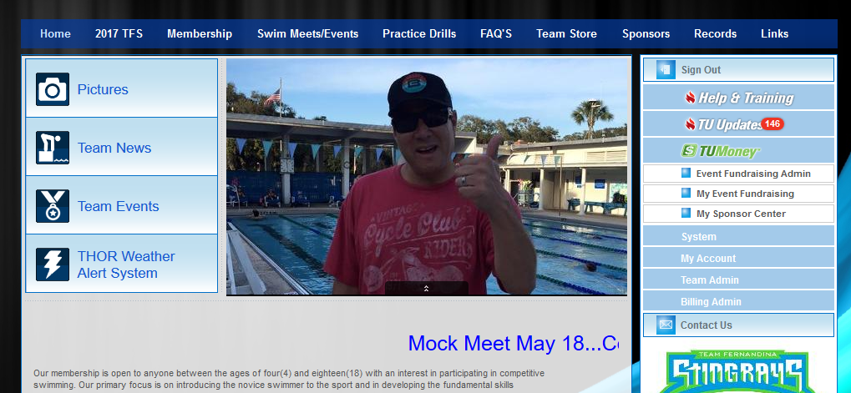

3) Find the event and click “Edit Commitment”
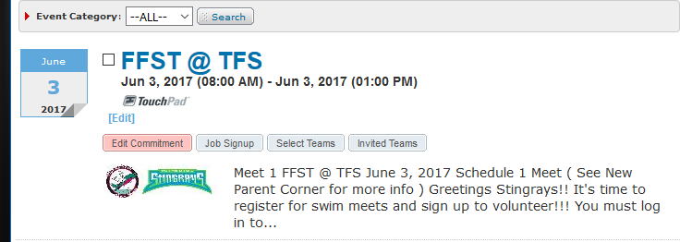

4) Select the swimmer (if you have more than one, repeat steps 4-6 for each swimmer)
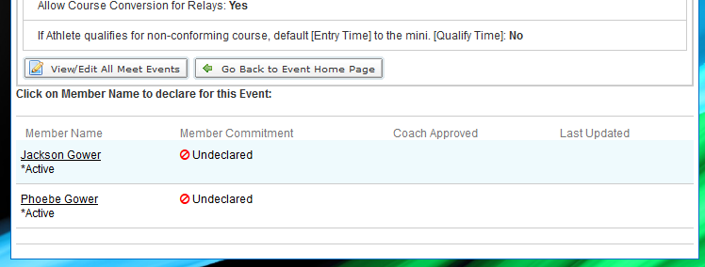

5) Click the “Signup Record” drop down and select either the “yes” or “no” option
6) Check off the Days/Sessions box and then click “Save Changes”
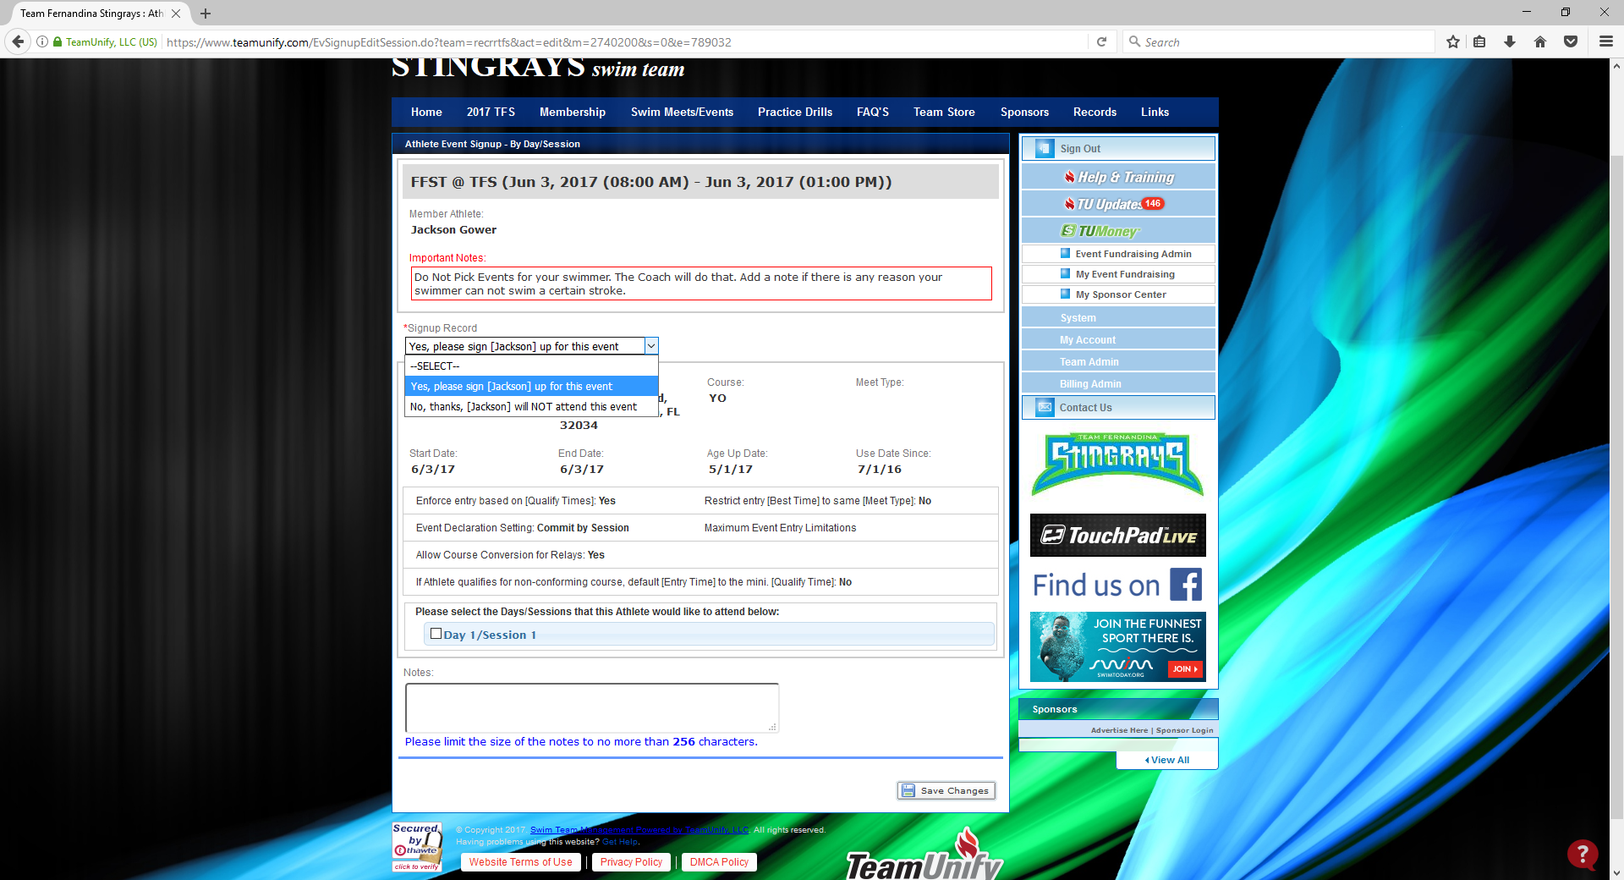

7) Click on “Go Back To Event Home Page” to sign up for your volunteer job
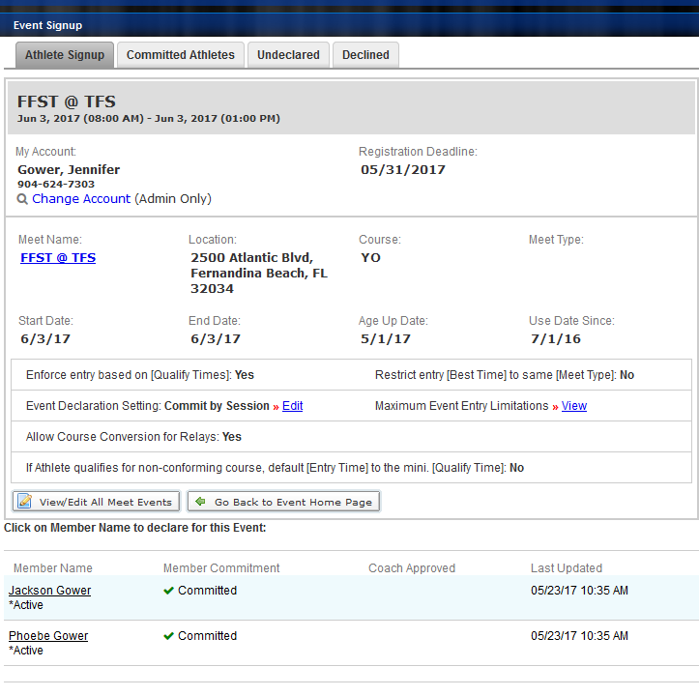
8) Click on “Job Signup”
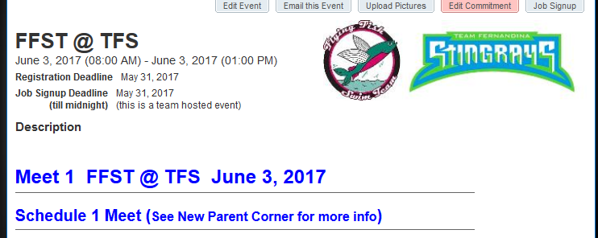

9) Scroll to the job you want and then click on one of the empty boxes



10) Scroll down to the bottom of the page and click on “Signup”
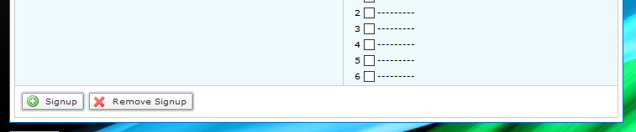

11) If someone other than yourself is filling the selected position, enter his/her name as the “Optional Contact” and then click “Sign Up” and you’re all done!
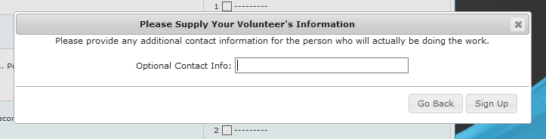

NOTE: You can also access the Job Signup menu from the home page by clicking Team Events and then selecting the event you want to sign up for.

