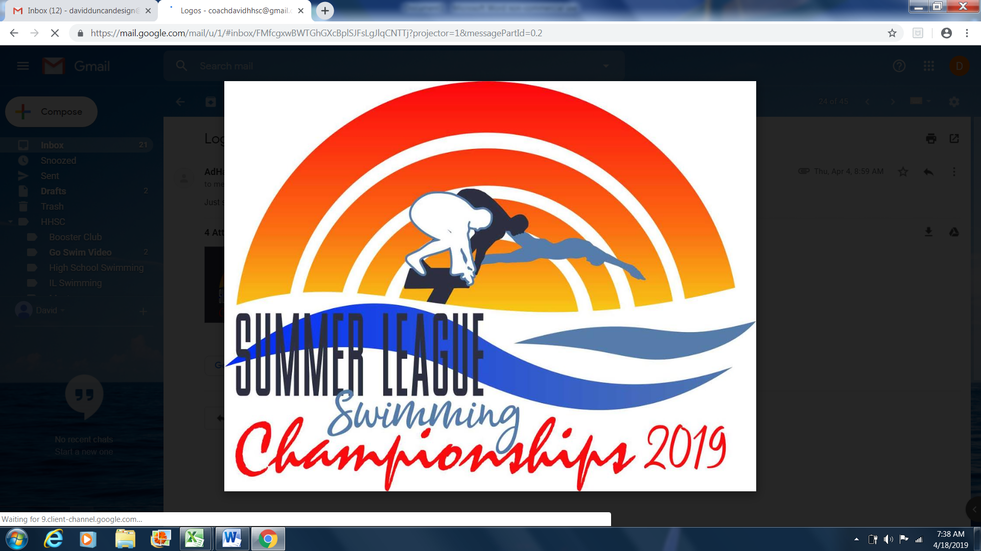

**EFFINGHAM SWIM TEAM**

***SUMMER LEAGUE SWIMMING CHAMPIONSHIPS*August 3, 2019**

**Meet Director:** Elizabeth Braunecker[ebraun70@frontiernet.net](mailto:ebraun70@frontiernet.net) 217-690-3540

**Meet Referee**: Eric Bandy

**Location:** Richard E. Workman Sports and Wellness Center in Effingham, Illinois. 1301 N Maple St.

**Facility:** 8-lane, 25-yard pool with non-turbulent lane lines, Daktronics Timing Systems with touchpads at the start end. Starting blocks at dive end, depth is 7 feet at the wall and 4 feet at the turn end of the pool. Raised spectator seating for 300 and a crash area in the gym accessible through a wet hallway. 3-lanes available in the recreation pool for continuous warm-up/down. Ample parking on site.

Parents and swimmers shall behave with honesty, respect and good sportsmanship. Music playing devices should be accompanied by headphones. No flash photography in the pool area; no cell phone or photography in the locker rooms or behind the blocks.

**Swimmers age as of the first day of June will determine age group for the meet**.

**Eligibility:  
Swimmers must finish in the top eight places in at least one individual event at their respective conference swim meet. Swimmers may then enter up to four individual events. These events may, or may not, be the same events the swimmer swam at their conference meet.**

**Entries:**  Swimmers are permitted to swim 4 individual events for the meet and one relay. There will be a limit of 400 swimmers. Entries can be submitted beginning Monday, July 22 at 9:00a. Entries will be accepted until the meet is full or until a deadline of **Tuesday, July 30 at 9:00p**.

Please mail entries to ebraun70@frontiernet.net

**Entry Procedures:**  All entries are to be submitted through a Hy-Tek compatible format via email. Team entry lists and an invoice will be emailed to the entry contact person for review by 12:00p Wednesday, July 31,2019. Any corrections, change and updated times can be submitted until Thursday, August 1 at 9:00p. Changes after this will be subject to deck entry fees.

Entry fees must be submitted before the first session begins, or before the first session your swimmers compete in. Mail and make check payable to: **Effingham Swim Team** ATTN: Elizabeth Braunecker 1301 N Maple Effingham, IL 62401

**Entry Fees:**  $5.00 per individual event, $0.00 per relay event, $2.00 per swimmer surcharge in lieu of admission fees. If space allows and at the discretion of the meet director, deck entries will be accepted at a charge of $8.00 per individual event.

**Deck Entries:**  Any events entered after the Thursday, August 1 at 9:00p. deadline will be charged a deck entry fee. Deck entries will only be permitted if they do not create additional heats.

**Heat Sheet: Seeding:**  Heat sheets will be posted around the facility, online and made free on Meet Mobile

**Format:** Saturday, August 3, 2019: Timed finals  
**Warm-up**: 8:00a **Session Start**: 10:00a

**Awards:**  Custom medals will be awarded for 1st -3rd in all events. Double Ribbons for 4th-8th place. Single ribbons for 7th-16th place. No awards will be given for relay events. High Point trophies will be awarded to the top 3 high point finishers in each age division.

**Concessions: Vendor:** Full concessions will be available.

Meet t-shirts will be available on site through Ad Hatters. See attached order form.

Swimville USA will be onsite selling all of your swimming needs.

**Timers/Officials:**  Each team is expected to provide timers. Timing/lane assignments will be posted to the host team website event page. Each team is encouraged to provide certified stroke judges for each session.

**Results:**  Event results will be posted outside the locker rooms. Complete results will be available at the conclusion of the meet as well as on the event page of the Effingham Swim Team website.

**Warm-up Procedure:** General Warm-up. Lane assignments will be posted on deck

**Safety Guidelines:** ***Use of audio or visual recording devices, including a cell phone, is not permitted in changing areas, restrooms or locker rooms.  
***No flash photography or behind the blocks photography allowed. ***Except where venue facilities require otherwise, changing into or out of swimsuits other than in the locker rooms or other designated areas is prohibited.

2019 Summer League Swimming Championships

Conference Name: _______________________________ Conference Representative:_______________________________________________ Phone#: ________________________ Email: _______________________________ Entry Contact: ________________________________________________________ Phone#: ________________________ Email: _______________________________

Entry Summary:  Facility surcharge/Number of Athletes Entered: _____x $2.00=___________________ Entry Fee/Number of Individual Events Entered: _____ x $5.00 = _________________ NO ENTRY FEE FOR THE RELAYS Total amount enclosed: _______________________

Please make your check payable to:

Effingham Swim Team 1301 N Maple Street. Effingham, IL 62410

Release

It is understood and agreed that Effingham Swim Team, The Workman Sports Complex, The Central Illinois Swim Conference, USA Swimming, and Illinois Swimming shall be free and held harmless for any liabilities or claims for damages arising by reasons of injuries to anyone during the conduct of the event. I certify that all individuals in the submitted entry files are registered athlete members of USA Swimming, and are eligible to participate in this event. I further certify that proper registration applications and fees have been submitted for entrants prior to completing this form and prior to the entry deadline.

Signature: _____________________________ Title: __________________________________ Date: _________________________________

