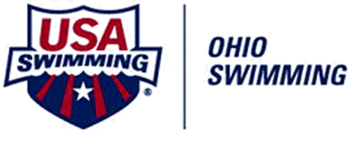

5020 B College Corner Pike
Oxford, OH 45056
513-673-3326 (office)
513-282-4090 (fax)
www.swimohio.com

MEDICAL AUTHORIZATION TO RETURN TO PLAY WHEN A STUDENT HAS BEEN REMOVED DUE TO A SUSPECTED CONCUSSION

Ohio State Law requires an athlete who exhibits signs, symptoms or behaviors associated with concussion to be removed from a practice or competition and not permitted to reenter practice or competition on the same day as the removal.
Thereafter, written medical authorization from a physician (M.D. or D.O.) or another licensed medical provider, who works in consultation with, collaboration with or under the supervision of an M.D. or D.O. or who is working pursuant to the referral by an M.D. or D.O., is required to grant clearance for the athlete to return to participation.
This form shall serve as the authorization that the physician or licensed medical professional has examined the athlete, and has cleared the athlete to return to participation. The physician or licensed medical professional must complete this form and submit to the Ohio Swimming Permanent Office prior to the athlete’s resumption of participation in practice and/or competition. To reiterate, this student is not permitted to reenter practice or competition on the same day as the removal.

I, _________________________________________, M.D., D.O. or ________ (other licensed medical provider) have examined the following athlete, ________________________________________________ from____________________________ (name of club), who was removed from competition / practice (circle) due to exhibition of signs/symptoms/behaviors consistent with a concussion. I have examined this athlete, provided an appropriate return to competition/practice regimen, if necessary, and determined that the athlete is cleared to resume participation in practice and competition on this date__________________.

Signature of Medical Professional ______________________________________________________
Date: ____________________

Please forward to the Ohio Swimming Inc. Permanent Office

Email: concussion@swimohio.com or Fax (513) 282-4090

