**One-Week Myrtle Beach, SC vacation ($500 cash out option)**

**$10 PER TICKET; 6 for $50**

**Tickets sold Sunday 7/28/19 at Chinese Auction Area or go to** [**www.wickliffewaterdevils.com**](http://www.wickliffewaterdevils.com) **to buy tickets in advance**

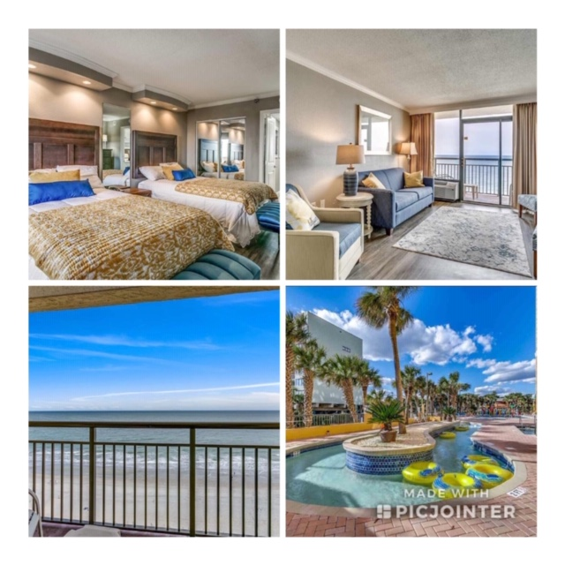

**Winner will get a One Bedroom, One Bathroom Ocean Front Unit that sleeps 6 located at the Caravelle at 6900 N. Ocean Blvd; Myrtle Beach, SC. from 5/31/2020 – 6/7/2020 or can take a cash out option of $500!** [**https://www.thecaravelle.com/rooms/caravelle-resort-ocean-view-suite1/**](https://www.thecaravelle.com/rooms/caravelle-resort-ocean-view-suite1/)

**Amenities include:**

**Indoor/outdoor Pool, Hot Tubs, Lazy River, Kid Splash Zone, Tiki Hut, Arcade, Pizza, Ice Cream Shoppe, Santa Maria Restaurant on property, covered parking & coin Laundry.**

**Proceeds to benefit the Wickliffe Water Devils Swim Team**