The South Riding Stingrays would like to extend a warm invitation to your teams for our White Divisional Meet on Saturday, July 21, 2018. Below is some information to help the meet run smoothly.

Address: The South Riding Center Pool is located at 42420 Unicorn Drive, South Riding, VA 20152

Parking
- Parking at the pool will be limited due to teams being set up in the parking lot
- Parking attendants - will assist with the flow of traffic, please follow their directions
- Parking Passes - 2 parking passes will be given to each visiting team for the Head Coach and Team Rep.
- Carpooling - strongly encouraged, especially within families
- Reserved Parking - only available to those with a parking pass (or handicapped)
- Swimmer Drop-off - around the back side of the pool, on Pelican Drive. From Riding Center Drive, head Southeast on Ulysses Street, turn right on Pelican, and swimmer drop off will be at the parking lot entrance where the team areas are set up. Please follow these directions so that swimmers are safely dropped off without having to cross the road.
- General Parking – There are parking lanes all along Riding Center Drive and these are the preferred areas for parking. There will be overflow parking continuing West down Riding Center Drive at Freedom High School (25450 Riding Center Drive, Chantilly, VA 20152), about a 7 minute (0.3 mile) walk.

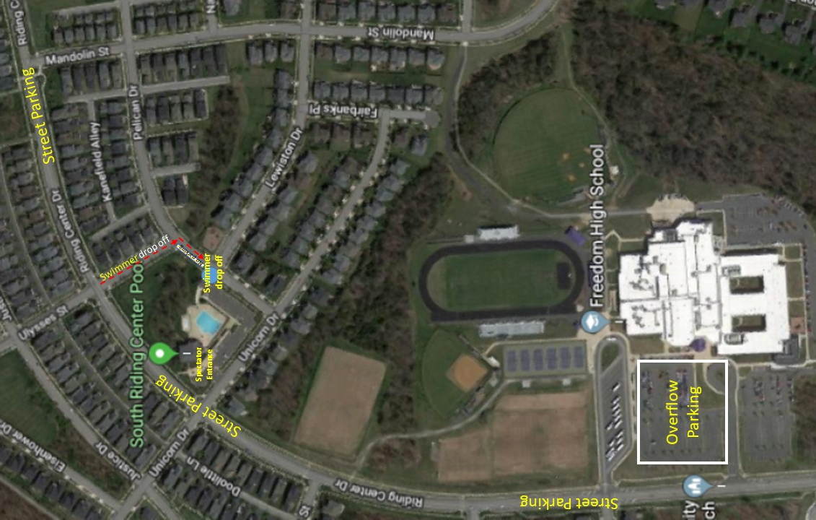
Schedule
Warm Ups Session 1: 6:50 – 7:10am
Warm Ups Session 2: 7:10-7:30am
Warm Ups Session 3: 7:30-7:50am
Officials Meeting: 7:30am – In the area reserved for coaches and officials, near the swimmer entrance
Team Reps Scratch Meeting: 7:25am – bottom floor on the northeast side of the pool house, entrance by the gazebo
Timers Meeting: 7:45am – In the area reserved for coaches and officials, near the swimmer entrance
National Anthem: 8:00am
Meet Start Time: 8:05am

Facility
We have an 8-lane, 25-meter pool. The 6 center lanes will be used for events and 8 lanes will be used for warm ups. Backstroke flags are set at 5 yards from the ends of the pool. Both ends of the pool are 60" deep at the wall. Timers will switch ends for the 25-meter events. The clerk of course will be immediately outside the pool area, on the ramp at the end of the parking lot/team areas. This area must be kept clear of parents and spectators.

Warm-ups for Free/Back/Breast
Swimmers should be ready to go to their assigned lanes a few minutes prior to their scheduled times in order to make full use of their allocated time. Please allow sufficient time for parking/traffic congestion to have your swimmers in their team areas prior to warm ups.

Time | Lane 0 | Lane 1 | Lane 2 | Lane 3 | Lane 4 | Lane 5 | Lane 6 | Lane 00
6:50-7:10 | SRD | SRD | SRD | SRD | AF | AF | AF | AF
7:10-7:30 | ABF | ABF | ABF | ABF | MG | MG | MG | MG
7:30-7:50 | AKC | AKC | AKC | AKC | FM | FM | FM | FM

Trophy Presentation/Award Ceremony
There will be a break after the breaststroke for the Girls/Boys Overall awards and the Division Championship trophy presentation. Age Group trophies will be presented during the meet. The awards area will be in the grassy area next to the Clerk of Course. Please ensure that you share the schedule below so that your swimmers and coaches are ready to receive their awards at the designated times.

8&U Age Group Trophies to be presented immediately following 8&U Freestyle events
11-12 Age Group Trophies to be presented immediately following 11-12 Freestyle events
15-18 Age Group Trophies to be presented immediately following the 15-18 Freestyle events
9-10 Age Group Trophies to be presented immediately following 9-10 Backstroke events
13-14 Age Group Trophies to be presented immediately following 13-14 Backstroke events

Overall Girl and Boy Team Awards and the Division Championship Trophy will be presented prior to Fly & IM warmups.

Warm-ups for Fly & IM
Warm-ups after the award ceremony will be for 20 min. for individuals swimming butterfly and IM only. The two end lanes (0 and 00) will be sprint-only lanes for this warm-up period and will be shared by all teams. Swimmers must exit at the turning end and walk back to the starting end of the pool during sprints.
Lane | Team Warm-Ups for Butterfly & IM
0 | Sprints only
1 | Ashburn Farm
2 | AKC
3 | Manorgate
4 | South Riding
5 | Fort Myer
6 | Armfield Farm
00 | Sprints only

POOL / TEAM AREA MAP

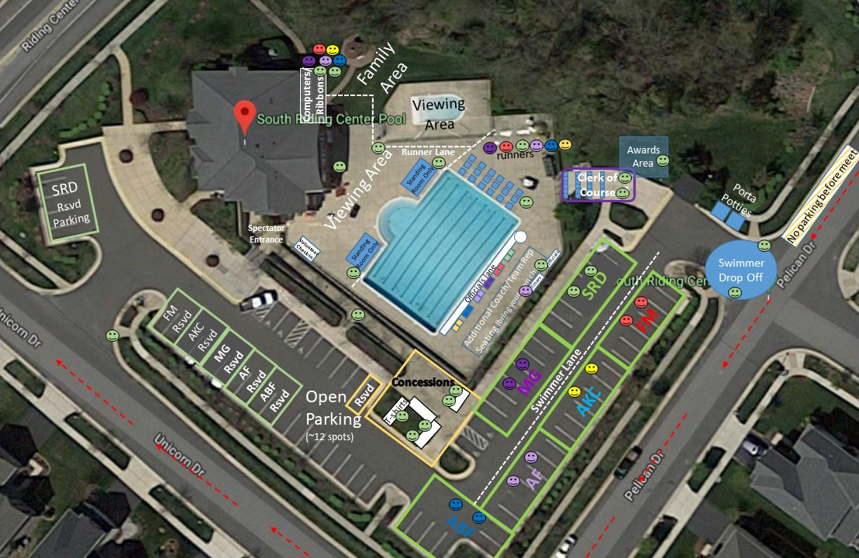

Coaches/Team Rep Seating
Two seats will be provided for each team (1 coach and 1 team rep) in the designated area on the southeast side of the pool next to the officials’ area (see diagram above). The first row will be available for head coaches and team reps and will contain assigned seats. Additional seating will be available for two assistant coaches/additional team reps per team – please bring portable chairs.

Team Areas:
- Signs and maps will be posted for each team area (see diagram above)
- Please assign one parent to walk the swimmers to the clerk of course
- You may also want to assign another parent to the team area to keep kids from migrating to the playground which is immediately across the street
- Bring canopies to shade your swimmers, and encourage them to bring chairs to keep them off the hot pavement
- Swimmers exiting the pool may go either direction back to their team area

Spectator Seating
There will be designated areas available for spectator seating along the pool deck, in the baby pool area, and the gazebo area immediately outside the pool. There will be two standing room only areas at both the start and finish to provide a clear view for parents and fans to watch their swimmer’s race and snap a great photo. Marshals will ensure that these areas stay fluid and people are not camping out. These areas will be marked by tape or rope, and no chairs will be allowed. Marshalls will also keep key areas clear, please help them by keeping the following areas clear: walkways, areas behind timers (at both ends of the pool), runner path, officials/coaches, computers, and the clerk of course.

Team Volunteer Requirements
Most volunteer positions below will work one shift (e.g. Free/Back/Breast OR Fly/IM). If a volunteer fills both shifts of the same role for your team, please be sure to sign up for both shifts in Signup Genius. We have requested different roles for each team. Each team should plan to provide:
- 2 Clerk of Course/Team Area Parent: Responsible for getting your team's swimmers to the Clerk of Course for their scheduled events.
- 6 Timers: Each team should bring 3 watches. Shifts will be assigned.
- 1 Computer Lead: Should be your most experienced computer person. Shifts will be assigned.
- Two of the following 3 roles – assigned to teams in shifts:
  - 1 Ribbon Volunteers: Shifts will be assigned.
  - 1 Deck Marshals: Monitor the deck area to help ensure that swimmers and coaches’ areas and walkways remain clear.
  - 1 Card Runner: Run cards from timers to computer table and DQ slips from officials to computer table. Shifts will be assigned.
- Officials have been requested separately and selected officials will be notified separately

Volunteers should check-in at the volunteer desk just inside the spectator entrance.

Please signup for volunteer spots using the following link: https://www.signupgenius.com/go/30e0b4fa4a92ca02-2018

Food and Tees
Divisional T-shirts: $15 (cash or check-made out to SR Stingrays). There will be no pre-orders, so please come early for best size selection! T-shirt design is below.

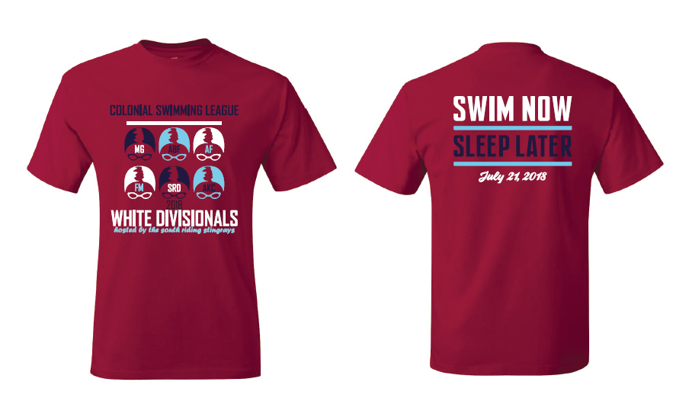

Concessions/Snack Bar: Breakfast and lunch items will be served. Concessions tickets are $1 each, or 11 tickets for $10. Cash or check (made out to SR Stingrays). Please be kind and bring smaller bills - it is hard to make change for large bills, especially at the start of the meet.

Entries
Please send your entries to Robb Harrington at robb@gostingrays.com no later than 12pm Monday July 16th. **The Hy-Tek events file should be sent directly to you and your computer leads in a separate email from the league**
Meet Sheets: Meet sheets will be available online the night before the event (www.gostingrays.com).
Meet Mobile: Will be available for results only, following the completion of each event. (White Divisional @SRD).

Inclement Weather Plan
- Make-up date: Sunday, July 22, 2018 @ 8.00 am

Meet Contact Information: Erin Walter, South Riding Team Rep, 215-990-3097, cslteamrep@gostingrays.com

